Names:_______________________________________________________ Period:______
EARTH SYSTEMS
LAB: Finding the Epicenter

Earthquakes are caused when accumulated stresses in the Earth’s crust causes it to rupture along a fault. Vibrations called seismic waves travel away from the focus (point of origin) in all directions. Two of the main kinds of seismic waves are called P and S waves. Due to the different properties of P and S waves, the distance to an earthquake epicenter can be calculated. In this lab you will use the seismic recording of P and S waves to determine the epicenter of an earthquake.
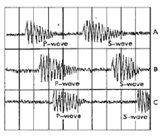

Part 1: Practice Reading Seismograms:
To practice what seismologists do, estimate to the nearest half-minute the arrival times of the P- and S-waves, and then calculate the difference for each station. Each vertical line represents one minute.

Difference in arrival time
Time of P-wave arrival Time of S-wave arrival of S- and P-waves

- Station A ___________________ ___________________ ____________________

- Station B ___________________ ___________________ ____________________

- Station C ___________________ ___________________ ____________________

- Which station is closest to the epicenter? ________ Farthest from the epicenter? _________

Part 2: Finding Distance to the Epicenter

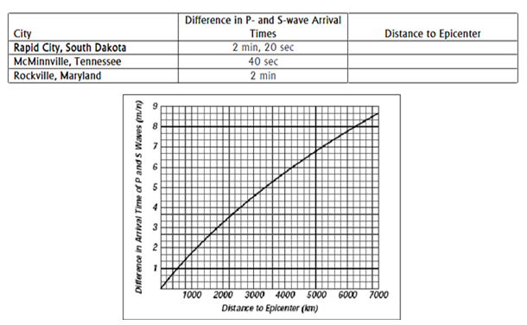
Part 3: Locating the Epicenter on a Map

Use a compass to draw circles from the three cities you have seismograms for to locate the epicenter
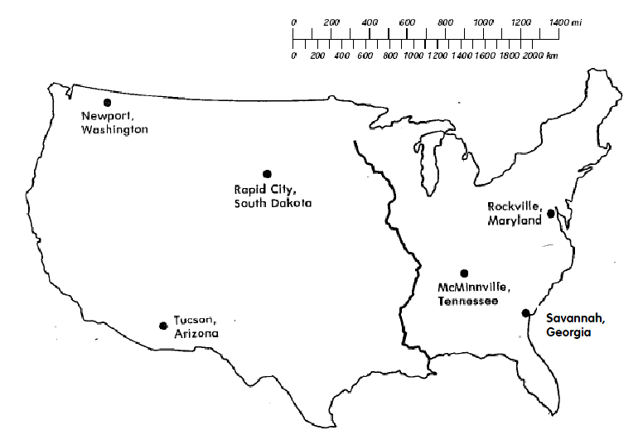
Part 4: Analysis

- Which city on the map is closest to the earthquake epicenter?

- How far, in kilometers, is this city from the epicenter?

- In which of the three cities listed in the data table would seismographs detect the earthquake first?

- In which of the three cities listed in the data table would seismographs detect the earthquake last?

- When you are trying to locate an epicenter, why is it necessary to know the distance from the epicenter for at least three recording stations?

- What happens to the difference in arrival times between P- and S-waves as the distance from the earthquake increases?

