Name:________________________________________________________________ Period:_____

Partner ____________________________________________

EARTH SYSTEMS LAB:
FOSSIL IDENTIFICATION

Purpose: Understand how rock relationships and fossils are used to reconstruct the Earth’s past.

Directions:
- Identify each fossil using the Fossil Identification sheet.
- Provide a detailed drawing of each fossil on the reverse side of this handout.
- Complete the fossil range chart by shading in the area under each geologic period that represents the time period during which the fossil existed. The first one is done for you.
- Draw three additional fossils from the fossil kits at the front of the room that are from each era– one for each era.

Fossil Range Chart:
Era | Paleozoic |  |  |  |  |  |  | Mesozoic |  |  | Cenozoic
Period | Cambrian | Ordovician | Silurian | Devonian | Mississippian | Pennsylvanian | Permian | Triassic | Jurassic | Cretaceous | Tertiary | Quaternary
Shark Tooth
Gastropod
Ammonite

Protozoa Triticites
Trilobite
Crinoid (Stem)
Petrified Wood
Brachiopod
Orthoceras
Pelecypod (clam)
Branch Coral
Analysis:
- According to the fossil record, which organism(s) went extinct at the end of the Paleozoic era?

- Which fossil(s) would make good index fossils? Why?

- Which fossils might you expect to find in a rock dating from the Cambrian period?

- If you find a fossil of a Protozoa Triticites, what era would the rock be from? How do you know?

- You are visiting a museum and see a rock with a fossil of a Trilobite and a Shark tooth. It is labeled as coming from the Jurassic period. How do you know this is wrong? What possible periods could the rock have come from?

FOSSIL IDENTIFICATION ILLUSTRATIONS
Branch Coral | Brachiopod | Protozoa Triticites
Orthoceras | Ammonite | Gastropod
Crinoid (Stem) | Shark Tooth | Petrified Wood
Trilobite | Pelecypod

Additional Fossils:
Paleozoic | Mesozoic | Cenozoic
Name: | Name: | Name:

FOSSIL IDENTIFICATION SHEET
Fossil | Picture | Periods | Info
Branch coral | 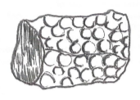 | Devonian - Permian | Branch Corals are from the extinct order of corals called Tabulate, which means flat shelf. The outside appears wrinkled. Branch coral was always colonies of coral
Gastropod | 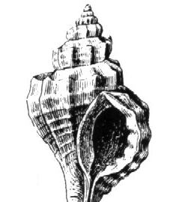 | Cambrian - Quaternary | Gastropods are the most diverse and abundant type of mollusks. Like the snail, most have a single coiled shell.
Ammonite (cephalopod) | 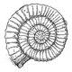 | Silurian – Cretaceous | Ammonites were mollusks with shells and became larger, especially abundant and widespread in the seas of the Jurassic and Cretaceous periods
Protozoa Triticites | 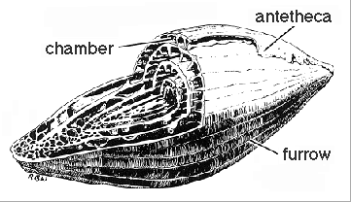 | Mississippian - Permian | These small, single celled marine organisms were common inhabitants of the oceans.
Trilobite | 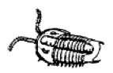 | Paleozoic (Cambrian – Permiam) | Trilobites form one of the earliest known arthropods. There were some 17,000 known species.
Petrified Wood | 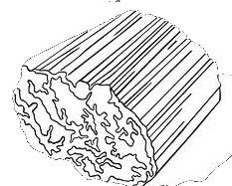 | Devonian - Quaternary | Petrified wood is wood that has turned to stone. It is a fossil of a woody plant preserved by permineralization.

Crinoid (Stem) | 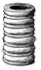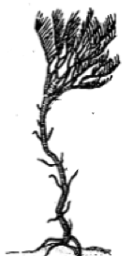 | Ordovician - Quaternary | Because many crinoids resemble flowers, they are often called sea lilies, but are not plants. Crinoids are echinoderms, animals with rough, spiny surfaces and radial symmetry.
Brachiopod (Rhynchonellida) | 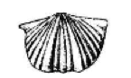 | Ordovician - Quaternary | Marine fossils easily recognized by their strongly ribbed wedge-shaped or nut-like shells
Orthoceras | 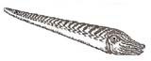 | Ordovician – Triassic | An ancient mollusk that lived more than 400 million years ago. The name means straight horn, referring to the characteristic long, straight, conical shell.
Pelecypod (clam) | 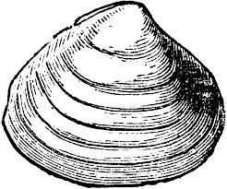 | Cambrian - Quaternary | Clams may be the easiest to recognize because they closely resemble the modern species. Clams are often called bivalves because their shell is composed of two parts called valves.
Shark Tooth | 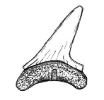 | Devonian - Quaternary | Sharks are cartilaginous fishes. The oldest shark teeth are from the Devonian Period, found in Europe.

