Name:________________________________________________________ Period:_______

Partner ____________________________________________________

EARTH SYSTEMS LAB:
Fossils: Clues to the Environment
Available online at: http://www.smithsonianeducation.org/idealabs/prehistoric_climate_change/index.htm

A team of Smithsonian scientists are studying prehistoric climates and have just returned from a fossil hunt. At two dig sites in Wyoming’s Bighorn Basin, they found bones of mammals that lived in the early Cenozoic era, about 10 million years after the dinosaurs. At Site A were bones of Plesiadapis, an early relative of the primates. At Site B were bones of Hyracotherium, a horse that was about the size of a cat. But the scientists are more interested in something else they found at each site—hundreds of fossils of leaves from prehistoric trees. They know that the primate relative (site A) is about 55.85 million years old and that the horse (site B) is about 55.75 million years old, so they know the age of the leaves at each site. With the leaves, they can actually read the temperature at each of these times using a method called “leaf margin analysis.”
Leaf margin analysis begins when you look closely at the edges of each fossil leaf to see if it has toothed edges or smooth edges. You can tell the average annual temperature of a place, millions of years ago, by the percentage of fossil leaves that have smooth edges. For this to work, scientists must gather leaves from many different tree species. You will be looking at a very small sample of what the Smithsonian scientists found—sixteen leaves from Site A and sixteen from Site B.
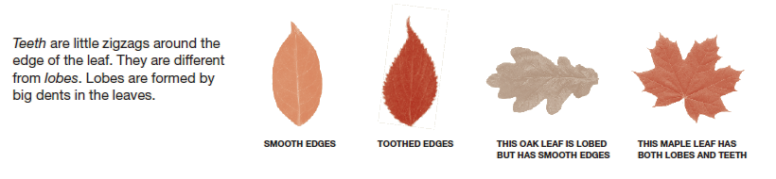
Procedures:

1. Using the “fossils” from Site A, determine which have smooth and toothed edges.
2. Record your findings for Site A by filling in the table with “S” for smooth or “T” for toothed:


3. Total up the number of leaves that have smooth edges: ________
4. Calculate the percentage of your leaves that have smooth edges by dividing the total number of smooth-edged leaves by the total number of leaves (16) and multiplying your answer by 100: _________%

5. Observe the “fossils” from Site B. Again, determine which have smooth edges, and which have toothed. Record in the data table:
6. Total up the number of leaves that have smooth edges: ________
7. Calculate the percentage of your leaves that have smooth edges by dividing the total number of smooth-edged leaves by the total number of leaves (16) and multiplying your answer by 100: _________%
8. Determine the average annual temperature of each site using the graph shown below and place your answers in the table below:
 | 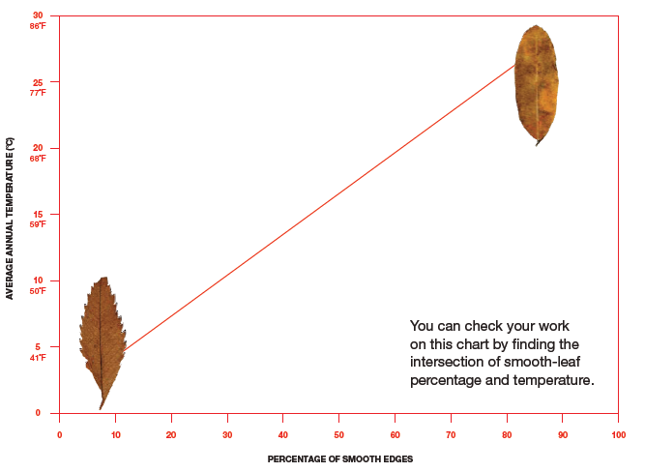
  Site A  smooth % | Site B smooth %
  Site A Temp. | Site B Temp.
Analysis:

1. How much hotter did it get in the 10,000 years between the two dates?

2. How can analyzing leaves tell you about climate and how it changes over time?

3. Examine the leaf fossils. What can you tell about the climate they lived in?

