Name:__________________________________________ Period ______

Partner ________________________________________________

EARTH SYSTEMS LAB
FOSSILS: Reconstructing the Past

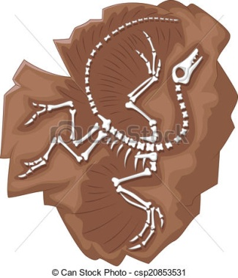 | Purpose: To reconstruct a skeleton of a mystery fossil from the Jurassic Period and make inferences about what the animal looked like, what food it ate, and its environment.  Materials:  Fossil handout (Scaphognathus crassirostris)  Glue, scissors  Metric ruler  Blank paper

Procedures:
- Cut out the life-size pictures of the mystery fossil’s bones. These are the actual size of the bones – not a scaled model.
- Use our knowledge about vertebrates and skeletons to reassemble the bones by laying them out on a sheet of plain paper. Some guidelines include:
  - Begin with the head – both the jaw and the skull (both have teeth).
  - Lay out the bones of the neck, chest, hip and tail.
  - Add smaller leg bones to the hip. The thigh bone fits into the hip bone.
  - A single leg bone connects with the thigh.
  - The small, 4-toe feet connect with the leg bones.
  - The larger upper arm bones connect with the shoulder blades.
  - The lower arm bones are composed of two fused bones, to which the hand connects at the wrist.
  - The fifth finger of each hand of the fossil is almost as large as its entire body.
- When you think you have the bones laid out correctly, glue them down on the paper.

Analysis:
- How tall was the animal? Measure in centimeters. _______________cm

- How wide was it when spread out? Measure in centimeters. _______________cm

- What do you think was the function of the huge finger on each hand? Why?

- What modern animal do you think this looks most like? Why? What are the similarities?

- What do the teeth in the skull and jaw tell you about the feeding habits?

- The bones appear to be hollow for this species. Knowing that, observing the large, open spaces in the skull and the large finger bones, how do you think this animal moved around? Why?

- Based on what you’ve discovered so far, what do you think the environment was like where this creature lived? WHY?

- Compare your reconstruction to two others in the class. How are they similar? Explain.

- Why do you think you and others had similar reconstructions?

- In the space below, give your fossil some flesh. Draw what you think Scaphognathus crassirostris looked like in its environment.

Turn in the fossil reconstruction stapled to this handout.
Fossils from Scaphognathus crassirostris
Life-size drawing as drawn by Georg August Goldfuss, 1820

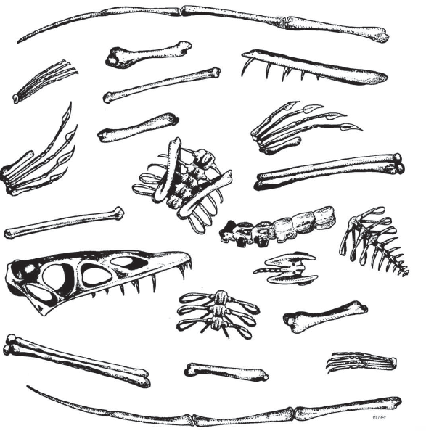

Activity adapted from:
Adventures in Paleontology @2006, NSTA Press

