Name _________________________________ Period ___ Date _________________

Partner _______________________________________

LAB: GAS PRESSURE

Purpose: Observe the effect of increase pressure on the volume of a confined gas.
Graph the pressure to volume relationship
Describe the pressure to volume relationship in mathematical terms.

Background: The volume of a gas depends on three factors: 1.) The number of moles of the gas; 2.) the temperature at which the volume is measured and; 3.) the pressure. For measurements at constant temperature, there is a simple mathematical relationship between the volume of a gas and the pressure. This relationship is known as Boyle’s Law in honor of Sir Robert Boyle, the British chemist who first recognized it about 300 years ago. This activity's purpose is to discover the relationship between pressure and volume of a gas.

Materials: metric ruler pipet 8 same size books

Procedure:
- Form a hypothesis to explain what would happen to the volume of a gas as the pressure is increased or decreased. Start with “As the pressure on the pipet increases, the volume of the gas will -----“. Write this in INK.

The Experiment:
- Place two equal-sized books on the bulb of the pipet. The stem of the pipet should be visible as shown in the diagram.
- Measure the column length of the trapped air in the stem of the pipet in millimeters (watch significant figures when measuring) and enter this measurement in your data table.
- Place another book on top of the first two, and measure and record the length of the air column again.
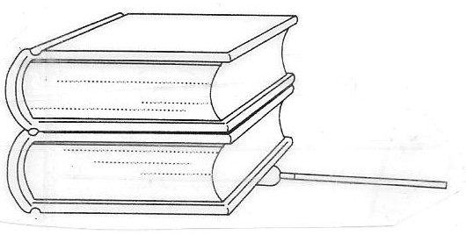
- Continue to add the remaining books to the stack one-by-one until you have a total of eight. Measure and record each new air column length in data table.

Data and Observations

Pressure (books) | Air Column Length (mm) | Pressure (Books) | Air Column Length (mm)
2 |  | 6
3 |  | 7
4 |  | 8
5

Analysis and Conclusions:
- Plot your data on the first graph grid on the other side. Use the pressure in books as the X variable and the length of the column of air in millimeters as the Y variable. Be sure to put a title on your graph, start at zero, and use the WHOLE graph! Is the relationship between gas pressure and volume linear? (circle one) YES NO

- Was your hypothesis correct? Explain why or why not.

- Calculate the inverse of the pressure, 1/pressure in books (i.e. ½, ¹/3, ¼). NO FRACTIONS – convert the numbers!!! Use the length of air column from your data table. Enter in table below.

1/Pressure 1/Pressure | Air Column Length (mm) | 1/Pressure | Air Column Length (mm)

- Plot the second graph on the other side. Use the inverse, 1/pressure, as the X variable and the length of the air column as the Y variable. Be sure to put a title on your graph, start at zero, and use the WHOLE graph! Is the relationship between
1/pressure and the volume of gas linear? YES NO

- What generalization can you make about the effect of increased book pressure on the volume of the confined gas?

- Write a mathematical equation for the relationship between pressure and volume of a gas as constant temperature. Use P for pressure, V for volume, and K for any necessary constant. Start with “K =”.

- What would happen to a gas under extremely high pressures or extremely low temperatures?

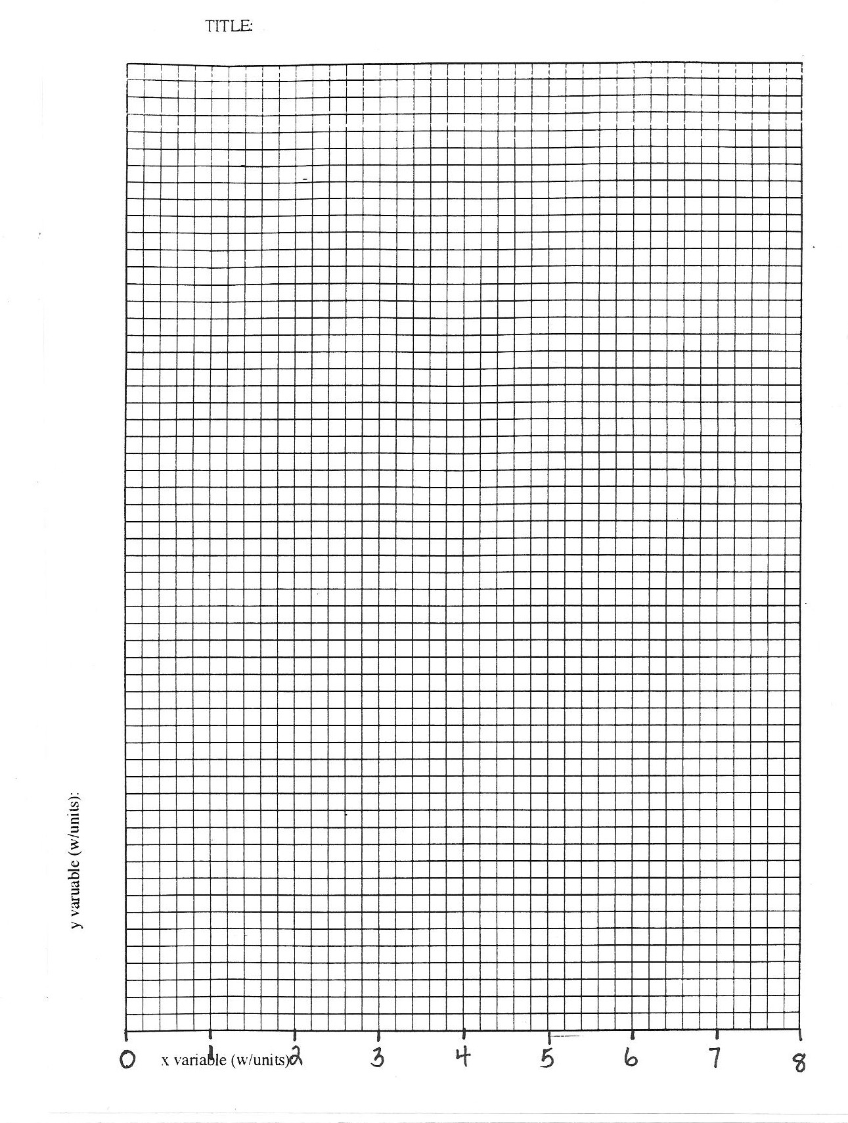
- If a pressurized gas is released from a vessel, ice can be seen forming on the outside of the vessel. Why does this happen?

