Name _____________________________________________________ Period ________

Graphing Trends in the Periodic Table

Graph #1 - Atomic Radii as a Function of Atomic Number 3-20
- Fill in the atomic radii for elements 3-20 using the info sheet given by your teacher.

Atomic # | 3 | 4 | 5 | 6 | 7 | 8 | 9 | 10 | 11
Atomic Radii
Atomic # | 12 | 13 | 14 | 15 | 16 | 17 | 18 | 19 | 20
Atomic Radii
2. For elements 3-20, make a graph of the atomic radius as a function of atomic number below
a. Plot atomic number on the X axis and atomic radius on the Y axis.
b. Title the graph and label the Y axis.

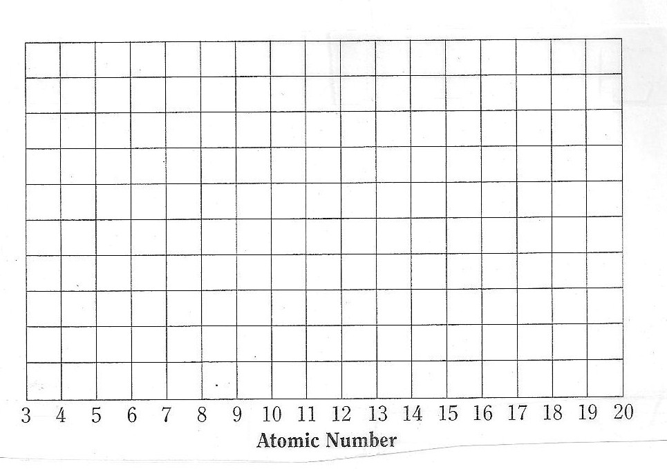
Graph #2 - Atomic Radii for Groups 1 and 2 and a function of Atomic Number
- Fill in the atomic radii for elements in Family 1A and Family 2A using the info sheet given by your teacher.

Atomic # | 3 | 11 | 19 | 37 | 55
Atomic Radii
Atomic # | 4 | 12 | 20 | 38 | 56
Atomic Radii
- For the elements in Group 1 and 2, make a graph of atomic radius as a function of atomic number below.
a. Plot atomic number on the X axis and atomic radius on the Y axis.
b. Plot Family 1A in one color and connect the dots.
c. Plot Family 2A in a second color and connect the dots.
d. Title the graph and label each axis.

3 | 4 |  |  | 11 | 12 |  |  | 19 | 20 |  |  | 37 | 38 |  |  | 55 | 56

Graph #3 - Ionization energy as a function of Atomic Number
- Fill in the atomic radii for elements 3-20 using the info sheet given by your teacher.

Atomic # | 3 | 4 | 5 | 6 | 7 | 8 | 9 | 10 | 11
Ionization Energy
Atomic # | 12 | 13 | 14 | 15 | 16 | 17 | 18 | 19 | 20
Ionization Energy

6. For elements 3-20, make a graph of the first ionization energy as a function of atomic number.
a. Plot the atomic number on the X axis; ionization energy on the Y axis
b. Make sure the scale is uniform and covers the range of the numbers plotted.
c. Title the graph and label the Y axis.
Before turning in, make sure of the following:
- Your graphs each have a title and the axes are labeled.
- The atomic number is on the X-axis; the other variables are on the Y-axis.

ANSWER THE FOLLOWING.
- Some of the properties listed on each card are periodic properties, others are not. Name one property that is periodic and one that is not.

PERIODIC:

NON-PERIODIC:

- The elements in the modern periodic table are arranged in order of increasing atomic number (instead of increasing atomic mass). Why didn’t Mendeleev use atomic number to arrange his elements?

- There are certain trends in the properties of the elements, both within a column (from top to bottom) and across a row (from left to right) in the periodic table. On the arrow for each property, write the word increases or decreases to describe how that property changes.

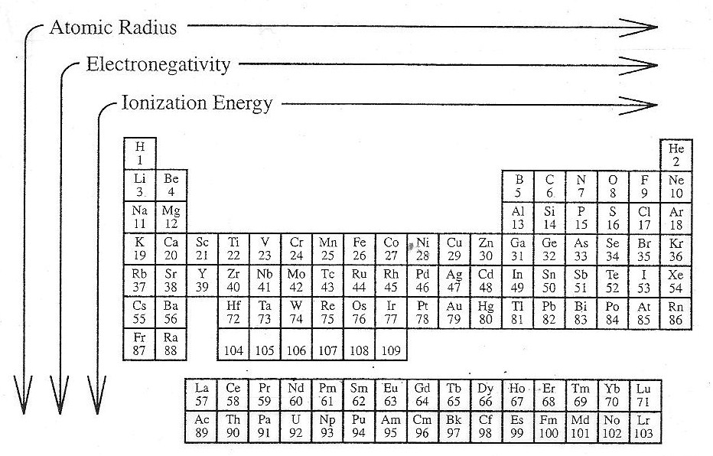

- On the outline of the periodic table below, locate and write in the following: group numbers, period number, noble gases, alkali metals, alkaline earth metals, and halogens.

- On the outline of the periodic table below, color the following: metals, nonmetals, and metalloids. Do them in different colors. Make a key.

- On the outline of the periodic table below, color the following: transition elements, inner transition elements, and representative elements. Do them in different colors. Make a key.

PLEASE RETURN THIS TO YOUR TEACHER ONCE YOU HAVE PUT THE DATA IN YOUR DATA TABLES.

ATOMIC RADII
(picometers)

Atomic Atomic Atomic

No. radii No. radii No. radii
Li 3 123 F 9 64 P 15 110
Be 4 89 Ne 10 67 S 16 104
B 5 80 Na 11 157 Cl 17 99
C 6 77 Mg 12 136 Ar 18 98
N 7 70 Al 13 125 K 19 203
O 8 66 Si 14 117 Ca 20 174

Rb 37 216 Cs 55 235
Sr 38 191 Ba 56 198

FIRST IONIZATION ENERGIES
(kilojoules per mole)

Atomic 1st Ion. Atomic 1st Ion.
Element No. Energy Element No. Energy
Lithium Li 3 520.2 Aluminum Al 13 577.5
Beryllium Be 4 899.5 Silicon Si 14 786.5
Boron B 5 800.6 Phosphorus P 15 1011.8
Carbon C 6 1086.5 Sulfur S 16 999.6
Nitrogen N 7 1402.3 Chlorine Cl 17 1255.5
Oxygen O 8 1313.9 Argon Ar 18 1520.6
Fluorine F 9 1681.0 Potassium K 19 418.8
Neon Ne 10 2080.7 Calcium Ca 20 589.8
Sodium Na 11 495.9
Magnesium Mg 12 737.8

