Name:____________________________________________________ Period:_____

EARTH SYSTEMS LAB:
INTERPRETING GEOLOGIC HISTORY

Use the Box Model to answer these questions:

- Which layer is the oldest? _________  - Which is the youngest? _________  - Put the layers that are visible from the top in order from oldest to youngest:  Oldest ______________________________ Youngest | 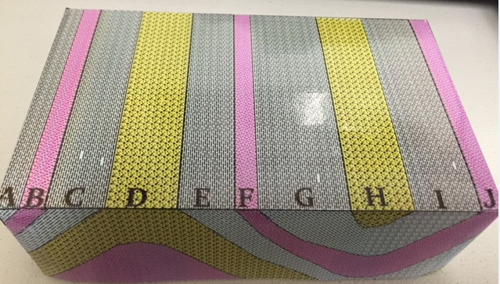

- What type of rock is each layer and what type of environment does it represent?
Rock | Environment | Rock | Environment
A |  | F
B |  | G
C |  | H
D |  | I
E |  | J
- Which pairs of layers on the top are actually the same layers?

- Why are the layers sloped on the long side (not the top)?

- Why isn’t there ANY slope on the short side?

- If you JUST looked at the top, how would you know “D” is a result of uplifting?

- If you JUST looked at the top, how would you know that “H” is a basin?

- What information can you observe in the cross section that you can’t observe from the map view?

- Below draw in the box what the cross section (long side view) would look like if deposition started to build up new layers on top of the existing layers. Draw a red line on the unconformity that would be created and label what type of unconformity it is.

BOX MODEL:
