Names:__________________________________________________ Period: _____
Each partner should write on this lab, initialing next to the questions that he/she wrote the answers to.

EARTH SYSTEMS LAB:
MASS EXTINCTIONS
What is the biological significance of mass extinctions?

Evidence suggests that five mass extinctions have occurred throughout the history of the Earth—the most famous of which led to the extinction of the dinosaurs. Scientists are still studying the causes of these catastrophic events. What can we learn from mass extinctions, and what is their impact on the diversity of life forms found on Earth?

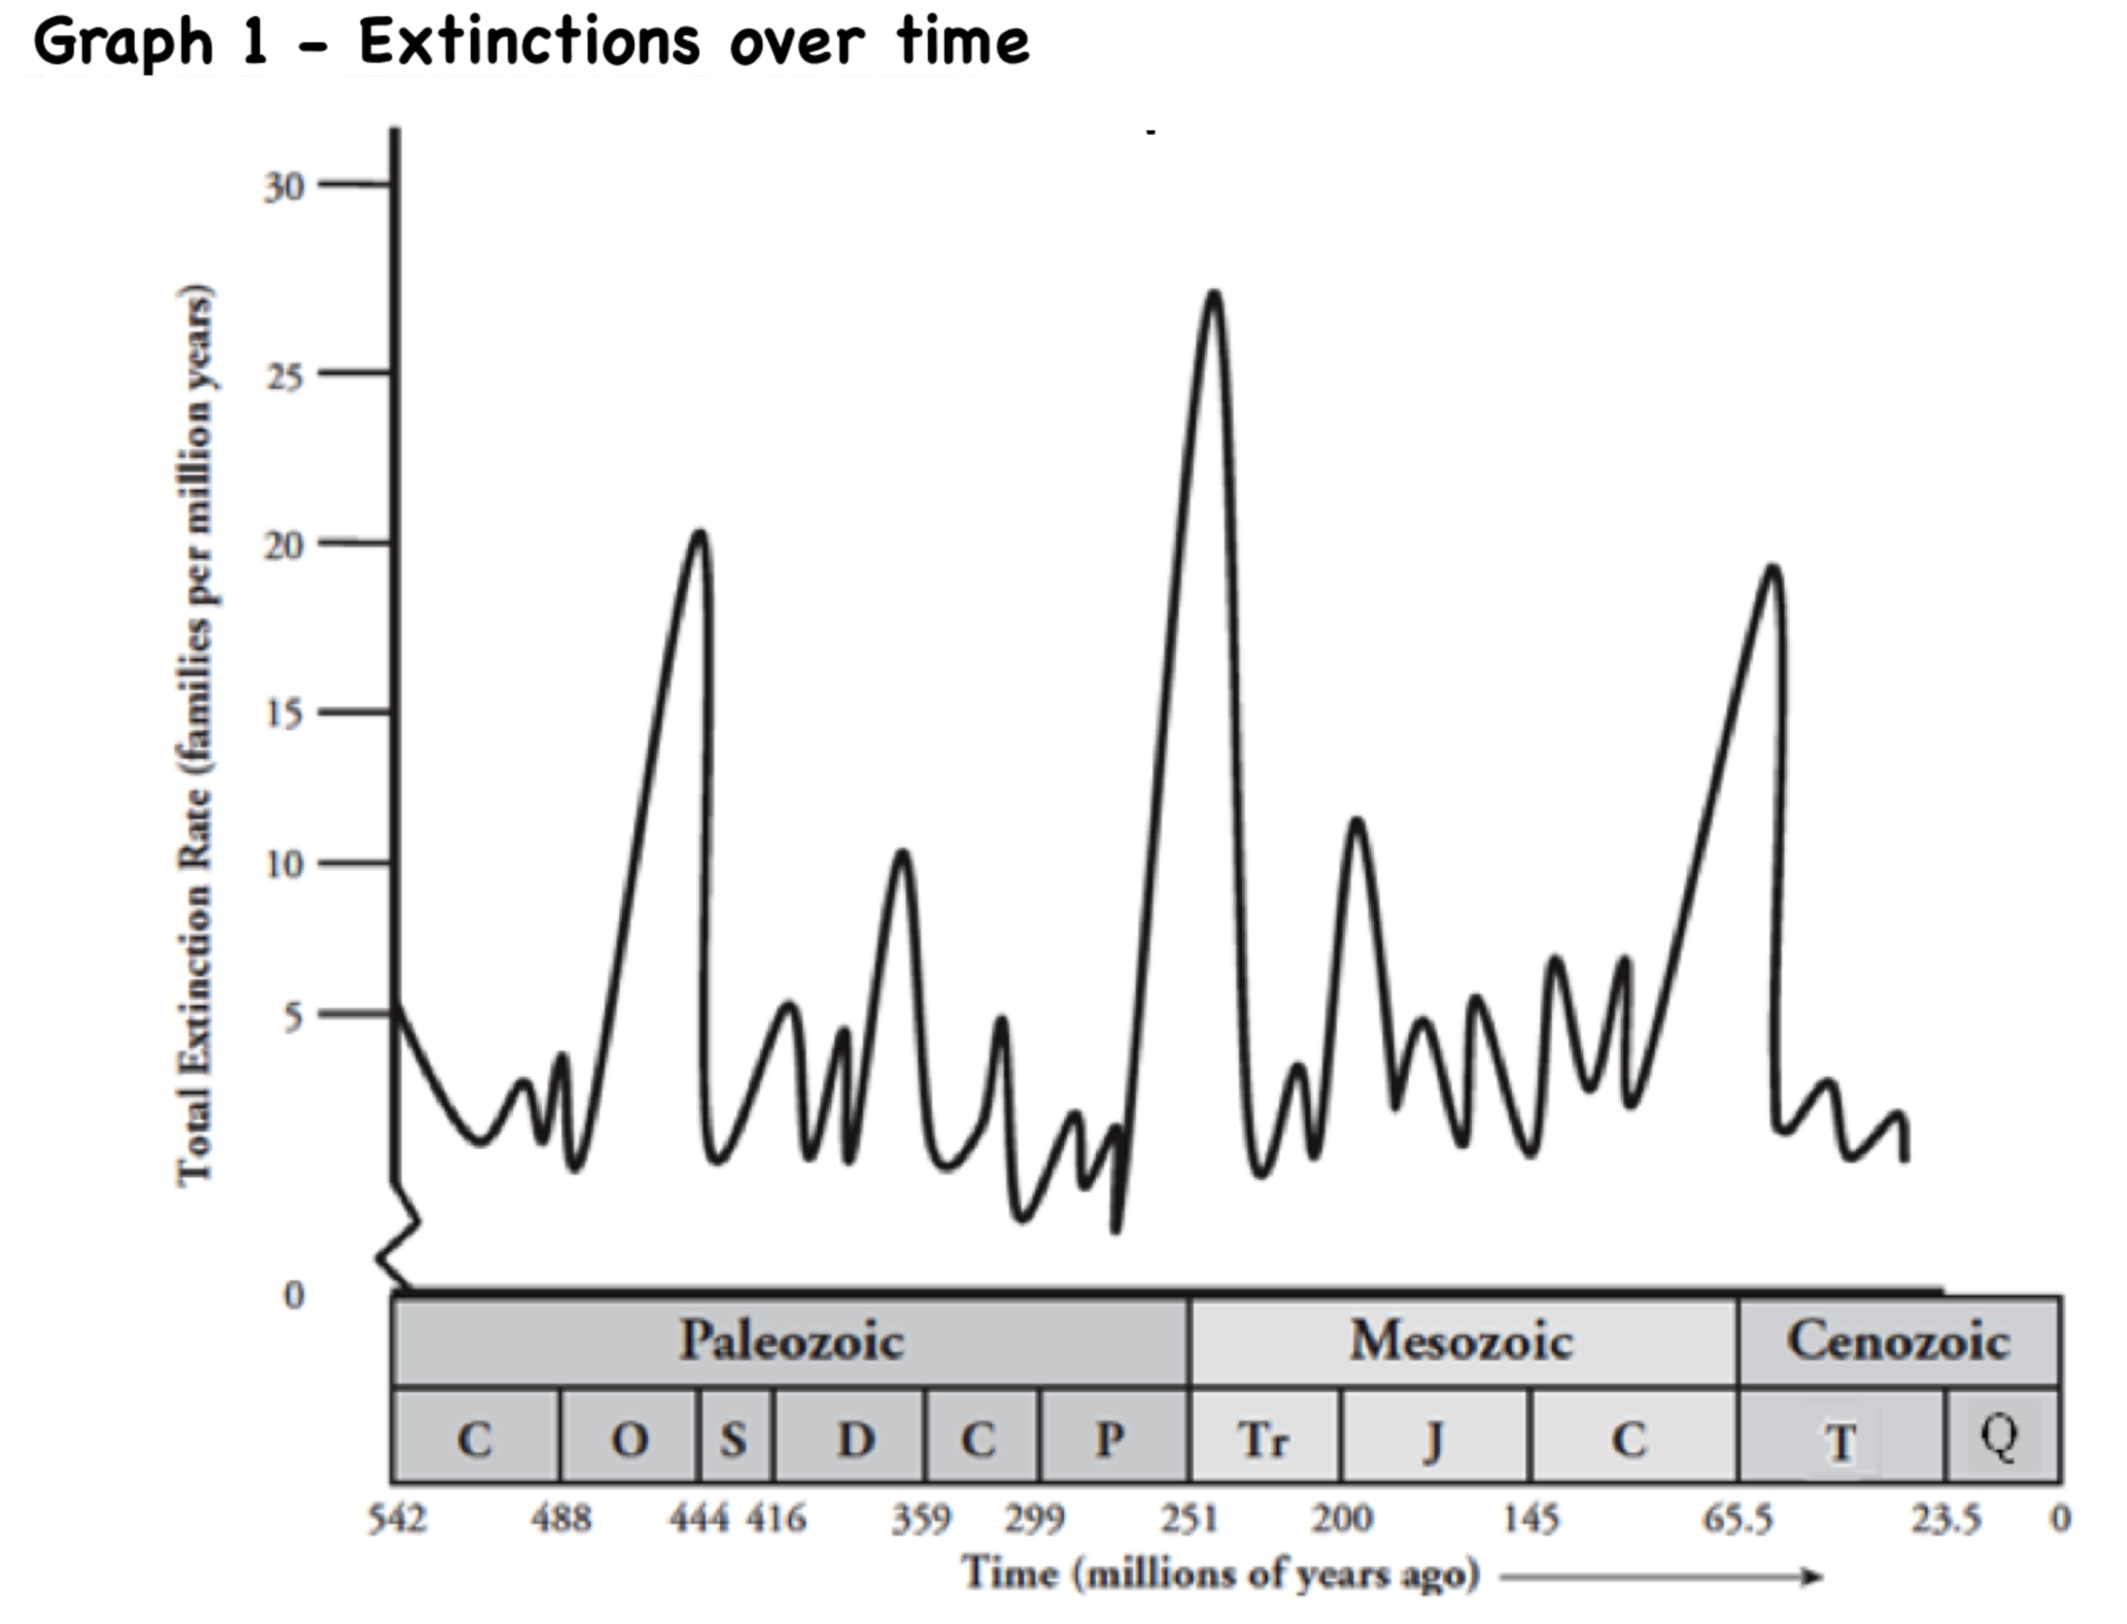

1. What are the three ERAs identified on the x-axis in Graph 1?

2. What is on the Y-axis? Include the unit of this variable.

3. According to Graph 1, approximately how long did each of these eras last?
a. Paleozoic
b. Mesozoic
c. Cenozoic
4. Put an X on Graph 1 where EACH of the five Mass Extinction Events occurred.

5. The letters below each era on Graph 1 refer to discrete time periods that are listed in the table below. Complete the columns to indicate the approximate length of time each period lasted.
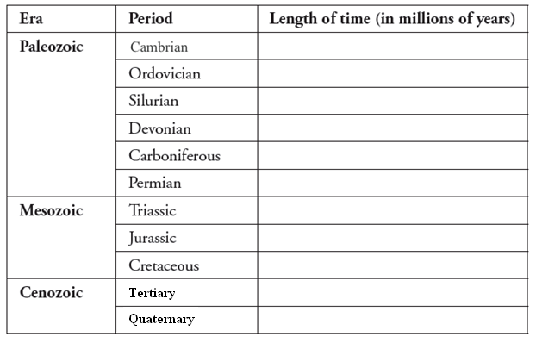
6. Scientists name mass extinctions using the name of the time period during which the extinction occurs. Using this information, name each of the five mass extinctions.
1 –

2 –

3 –

4 –

5 -

7. The line on the graph is never flat. What does this tell you about the rate of extinctions over time?

8. The line never reaches zero. What does this tell you?

9. Species may become extinct for many different reasons. Brainstorm and list five different factors that might cause a large number of species to become extinct. List those below:

10. During the Permian extinction, 96% of all marine animal species became extinct. One suggested explanation for this is a series of massive volcanic eruptions that produced enough CO₂ to warm the global climate by approximately 6°C. The leading theory for the Cretaceous extinction (which led to the disappearance of dinosaurs), is that a large extraterrestrial object collided with the Earth and resulted in a cloud of debris that disturbed the global climate. Look at your answers to Question 9. Were any of the explanations mentioned here also match your list? If so, which ones?

Names ______________________________________________________________
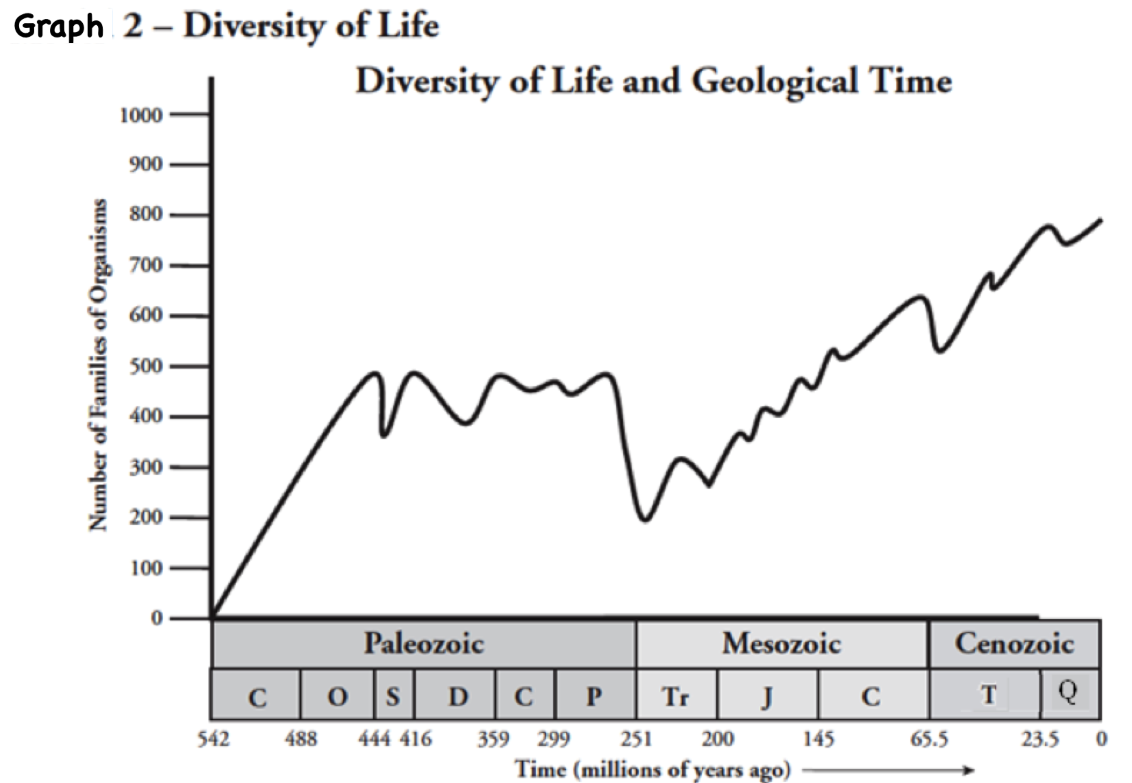

11. How is the dependent variable shown on the y-axis in Graph 2 different from Graph 1?

12. The number of families of organisms is an indicator of biodiversity. Looking at the graph, what can you conclude about the biodiversity on Earth over the time period shown?

13. On the graph in Graph 2, mark the location of the five mass extinction events depicted in Graph 1 with arrows.

14. What is the immediate effect of mass extinctions on the number of families of organisms?

15. Using Graph 2 as a model, estimate how long it takes for the number of families to recover after a mass extinction.

READ THIS! Mass extinctions leave behind niches in ecosystems that can be filled by new or existing species that exhibit adaptations allowing them to survive in those spaces. This process is called adaptive radiation. For example, the fossil record shows that mammals living more than 65.5 million years ago were mostly small, rodent-like, burrowing creatures without much diversity. After the Cretaceous mass extinction, however, there was a dramatic increase in the number and types of mammals.

16. Propose an explanation for why small rodents were able to survive the Cretaceous mass extinction.

17. How did the extinction of the dinosaurs allow the rise of mammals to occur?

18. Predict what would have happened if all of the early mammals living 66 million years ago had died out in the Cretaceous mass extinction?

19. Many biologists propose that we are currently in a sixth major extinction. If this is true, this mass extinction event may be the first caused by one of the Earth’s inhabitants—humans. What human actions do you think may be the cause of the increased rate of extinction today? List at least three.

20. If we are in the midst of a sixth mass extinction event, what would the fossil record likely show 100 million years from now?

