Name:___________________________________________________ Period:_____

Mass Wasting Review

1. What force is responsible for Mass Wasting?

Match each type of mass movement with its description:

_____ 2. Material separates along a curved surface and forms a crescent shaped scar called a “scarp.”  _____ 3. Soil flows slowly downslope over permafrost.  _____ 4. Rock is dislodged and suddenly falls down a slope, creating a talus slope.  _____ 5. The top layers of soil slowly move over lower layers. Objects start to lean over.  _____ 6. Saturated soil and debris slide rapidly downhill. | A. Creep  B. Slump  C. Solifluction  D. Rockfall  E. Mudslide

Identify and describe each of the following types of mass wasting.
 | Image | Description | Fast or Slow? | Wet, Dry or Both?
7. | 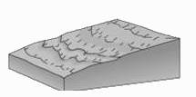
8. | 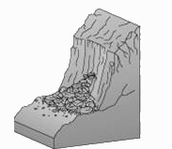
9. | 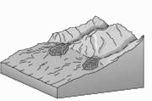
10. | 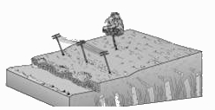
11. | 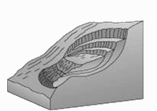
Name:____________________________________________________________ Period:_____

EARTH SYSTEMS LAB:
Mass Wasting: Angle of Repose

In this activity you will measure the maximum slope at which grains are stable (angle of repose). You will explore how different properties of the sediment influence slope stability and lead to different slope failures (mass wasting).

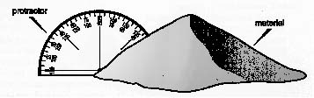 | Materials  - Tray and Styrofoam® cup  - Sediment samples: dry sand, rice, aquarium stones, and wet sand  - Protractor  - 100 mL graduated cylinder and water
Procedure:
1. Put the Syrofoam® cup upside down on top of the tray so the cut out bottom is on top.  2. Fill the cup with the material at the station.  3. Carefully lift the cup so that the sand falls out.  4. Measure the angle of repose of the material. Repeat for a total of three trials. Enter all your data into the table below.  5. Average all your results. | 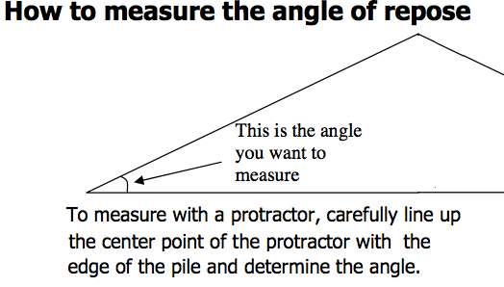
6. Repeat the experiment with the rice, aquarium stones, and wet sand conducting three trials for each.

Data:
Material | Trial 1 | Trial 2 | Trial 3 | Average
Dry Sand
Aquarium Sand
Wet Sand
Rice

7. Make one additional pile using wet sand. Take a 100 mL graduated cylinder and fill it with water. Slowly pour the water over your sand pile until it collapses. Record the amount of water added to the wet sand. Do this by subtracting the amount left in the graduated cylinder from 100mL. | Amount of Water:  ___________________mL

Analysis:
1. What is the relationship between particle size and the angle of repose?

2. How did the angle of repose compare for wet and dry sand?

3. What happened to the angle of repose when the sand was saturated (Step 7)?

4. Suppose a house is built on a slope made of sediment. The slope is slightly greater than the angle of repose. Is this house at risk from mass movement? EXPLAIN.

5. How did adding additional water to the sand affect the stability of the sand pile?

6. Which had the higher angle of repose, sand or rice? Explain why.

