Name:__________________________________________________ Period:_____
EARTH SYSTEMS LAB:
Weathering and Wind Abrasion

Introduction: The force of the wind can change the surface of the Earth in a small way by removing materials and wearing down rock surfaces. Rocks that are made of soft minerals are broken down when they are hit by wind-blown pieces of sand or smaller particles of rock. Each impact can break off small pieces of the larger rock. In this activity you will explore how the size of rock carried by the wind affects the weathering of a larger rock.
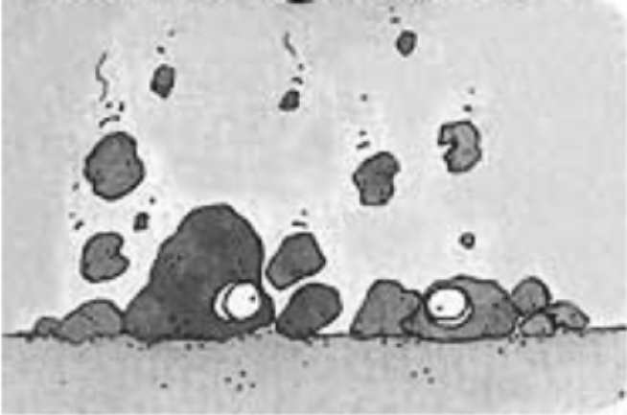 | Materials:  - Plastic jar with lid  - 6 Sugar cubes  - Fine-grained and coarse sand paper  - Hand lens  - Electronic balance  - Timer  - Cup for waste  - Piece of paper
Procedure:
1. Line the jar with a piece of the coarse sandpaper.
2. Measure the mass of one sugar cube on the electronic balance and record its mass in the data table. Draw what it looks like in your data table on the back side of this paper.
3. Start the stop watch and gently swirl the jar for one minute (enough so the cube inside gently hits the surface).
4. After one minute, open the jar and gently pour the sugar pieces onto the piece of paper.
5. Measure the mass of the weathered cube (not the “dust” of sugar) and record this information in the data table. Draw what it looks like now in your data table on the back side of this paper.
6. Put the weathered sugar cube and the pieces on the paper into the waste cup.
7. Repeat steps 2 – 6 two more times for a total of three trials.
8. Remove the coarse sandpaper and replace it with fine-grained sandpaper.
9. Repeat steps 2 – 6 with the fine-grained sandpaper for a total of three trials, recording the masses in the table each time.
10. For each trial calculate the amount of the cube that “weathered” by finding the difference between the un-weathered and weathered cubes.
11. Calculate the average amount of weathering for each type of sandpaper.

Data Table:
Trial | Coarse Sandpaper |  |  | Fine-Grained Sandpaper
Trial | Before | After | Amount of Weathering | Before | After | Amount of Weathering
1
2
3
Average

Observations:
Draw what you observe for each process:

Un-weathered Cube | Weathered Cubes
Un-weathered Cube | Coarse Sandpaper | Fine-Grained Sandpaper

Analysis:
1. Describe the relationship between the size of the sandpaper and the weathering of the cubes.

2. What type of weathering does the shaking represent? Circle the correct choice.

MECHANICAL CHEMICAL

3. Which sandpaper was most effective in breaking down the sugar cubes the fastest? Why?

4. What would happen if you shook the jar harder? Why?

5. What would happen if you shook the jar longer? Why?

6. Where might you see a similar type of weathering in nature?

