EARTH SYSTEMS LAB
POROSITY AND PERMEABILITY
DIRECTIONS

Activity One: Finding Porosity
 | Materials:  - 9 ounce (266 mL) clear, plastic cup  - 100 mL graduated cylinder  - Second cup to hold water  - Water | - Large marbles  - Small marbles  - BBs  - Permanent marker

Procedure:
1. Measure out 100 mL of water in the graduated cylinder.
2. Pour the 100 mL of water in your clear plastic cup and use the marker to mark carefully the level on the outside of the cup.
3. Pour the water back into the graduated cylinder.
4. Fill the same cup with large marbles up to the mark you drew.
5. Pour the 100 mL of water slowly into the cup of large marbles. Stop when the water level just reaches the line you marked. Pour carefully so that you do not spill any of the water.
6. Record the amount of water left in the graduated cylinder in the “Volume Remaining” column of the data table.
7. Repeat the experiment, this time using the small marbles.
8. Repeat the experiment again, this time using the BBs.
9. When finished, be sure to place the marbles and BBs back in their containers.

Activity Two: Measuring Permeability
 | Materials:  - 9 ounce (266 mL) clear, plastic cup  - 100 mL graduated cylinder  - Second cup to hold water  - Water  - Nail | - Large marbles  - Small marbles  - BBs  - Timer  - Bin to catch the water
Procedure:
- Use the nail to make a small hole in the bottom of your cup – must be smaller than the BBs.
2. Fill the cup to the top with large marbles.
3. Get a timer ready. Hold the cup over the sink or a bin to catch the water.
4. Pour the entire 100 mL of water quickly into the cup of marbles. Start recording as soon as the water hits the marbles.
5. Stop timing as soon as the first drop of water comes out of the hole in the bottom.
6. Record how many seconds it takes for the water to reach the bottom.
- Repeat steps 1-5 with the small marbles and BBs.
- Conduct one more trial – this time using a mixture of all three particle sizes.
- When finished, place your marbles and BBs on paper towels to dry. Roll them around on the paper towels to help them dry faster.

Name __________________________________________ Period ______

EARTH SYSTEMS LAB
POROSITY AND PERMEABILITY

Data Table – Activity One and Two:
Sediment | Total Volume | Volume Remaining in Cylinder | Permeability (in seconds)
Large Marbles | 100 mL
Small Marbles | 100 mL
BBs | 100 mL
Mixture of materials | ------------- | -------------------

Analysis
1. Calculate the pore space by subtracting the amount left in the graduated cylinder from the
original 100mL. Record this volume in the “Pore Space Volume” row below.

 | Large Marbles | Small Marbles | BBs
Pore Space Volume (volume poured)

2. Calculate the percent porosity and record in the table below. Use this formula:
porosity = pore space volume/total volume (100mL) x 100

 | Large Marbles | Small Marbles | BBs
Percent Porosity

Conclusion
- Which material had the highest porosity? Explain why.

- Which material had the highest permeability (fastest time)? Explain why.

- Which material had the lowest porosity? Explain why.

- Which material had the lowest permeability (slowest time)? Explain why.

- What do you think causes the difference in time that it takes water to pass through the
different materials? Use the terms porosity and permeability in your answer.

- In what type of ground would you recommend locating a drinking water well? Explain why.

- What happened to the permeability when you mixed all three sizes of particles?

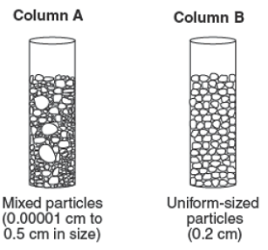
- Compare the permeability of both the tubes shown to the right with supporting explanations.

Extension (for those who want a challenge):

READ: Porosity and permeability are related properties of any rock or loose sediment. Most oil and gas has been produced from sandstones. These rocks usually have high porosity, and are usually high permeability. Porosity and permeability are absolutely necessary to make a productive oil or gas well. In the last 10 years, an increasing amount of US gas production is coming from shale gas wells. Shale has a lot of porosity (much more than sandstone), but extremely low permeability. That means shale has historically been a poor producer of hydrocarbons. One of the things that changed the situation and allowed for increased shale gas development is Hydraulic Fracturing (fracking). This new technique allows for oil and gas operators to render low-permeability shale reservoirs more permeable, by drilling into the rock and fracturing it apart with a mixture of chemicals and water using high pressure. | 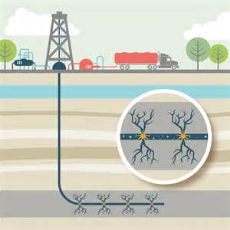

Essay – Think & Respond: How does fracking affect the porosity and permeability of the rock? What are the benefits of the process? What are the possible problems that could occur when a layer of sedimentary rock has been altered in this way? How can you use what you learned in this lab on porosity and permeability to better understand what happens in fracking and its significance? Submit this on a separate piece of paper.

