Name:__________________________________________ Period:____

Partner ______________________________________________

EARTH SYSTEMS LAB
Rates of Weathering – Exposure

Surface area is the measure of how much exposed area an object has. When physical weathering breaks down rock, a larger surface area of the rock is exposed, and the more weathering (physical and chemical) can occur. In this lab you will model the chemical weathering process and observe how the rate of weathering changes when surface area is increased.

 | Materials:  Graduated cylinder  Cup  2 Alka-Seltzer tablets  Room temperature water  Index card  Timer
Procedures:
1. Pour 50 mL of water into your cup.
2. Get your timer ready. You will need to record the time it takes for each Alka-Seltzer tablet to completely dissolve.
3. Place the first tablet in the water. Measure the time it takes to COMPLETELY react. You will know it has completely reacted because there will be no more bubbling. Record the time in the data table.
4. Empty the cup, rinse it and refill with 50 mL of water.
5. Break up the second tablet on the index card.
6. Pour the broken tablet into the cup. Measure the time it takes to COMPLETELY react. Record the time in the data table.
7. Obtain data from two other teams.
8. Average the results to find out the average time for the broken and whole tablets to dissolve.

Data Table: | Time for Unbroken Tablet to completely react | Time for Broken Table to completely react
Your Data
Comparison Data
Group #1
Comparison Data
Group #2
Average Time

Analysis:
1. What differences in reaction rates did you observe between the two samples?

2. How did your data compare to the two other groups’ data?

3. Which tablet had the greatest surface area exposed to the water, the unbroken one or the broken up one?

4. What type of weathering did breaking up the tablet represent, mechanical or chemical? Explain!

5. What type of weathering did the tablet in the water represent, mechanical or chemical? Explain!

6. What is the relationship between surface area and reaction time? Complete the following sentence by circling the correct choice of increase or decrease:

When surface area INCREASES DECREASES, the reaction time INCREASES DECREASES.

Use the chart to answer the questions:  7. What type of weathering will most likely occur in hot, humid environments?  8. Atlanta has an average temperature of 16°C and average annual precipitation of 125 cm. What is the major type of weathering affecting Atlanta? | 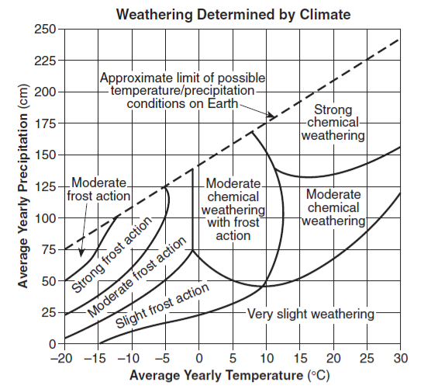
9. What is the highest temperature you can have and expect strong frost action weathering?

10. What type of weathering would you expect in a desert climate? Why?

