Names:____________________________________________________ Period:_____

________________________________________________________________________________
EARTH SYSTEMS LAB:
READING A GEOLOGIC MAP, Part One

Part 1: Use Image 1 from the Geology Images Card to answer the following questions:
1. What does each type of rock tell you about the environment at the time the sediment was deposited? Energy of each?
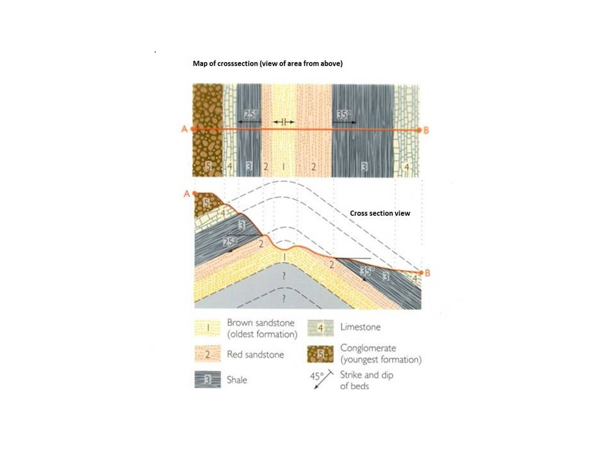
ROCK | ENVIRONMENT | ENERGY
Sandstone
Limestone
Shale
Conglomerate

2. What does the order tell you?

3. Why do the layers slope?

4. Why are there missing sections of rock?

IMAGE ONE

