Name:____________________________________________________ Period:_____

EARTH SYSTEMS LAB:
READING A GEOLOGIC MAP, PART TWO

Use Image 2 from the Geology Images Card to answer the following questions:
- Which is the oldest rock layer?
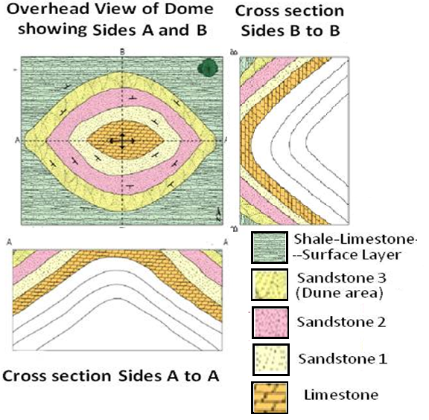

- How can you tell?

- How do you know it is a dome in the center and not a basin?

- Why do you think there are two different sandstones shown? How would you know the difference?

- What would the presence of fossils tell you in each layer?

- Why are the layers sloped?

- How were the layers originally deposited?

IMAGE 2:

