EARTH SYSTEMS LAB:
Renew-a-Bean

In this activity you will work in groups of two to explore how renewable and nonrenewable energy resources are used over time. You will also explore how conservation measures and increased use of renewable resources can slow the depletion of fossil fuels. While you will share bean resources, each person MUST complete and submit his/her own worksheet. Be sure to write your lab partner’s name on top!

Materials:
- Bag containing 100 beans of two colors: 92 of one color, 8 of another.
This represents the current ratio of nonrenewal energy to renewable energy use in our country.
- Extra beans of both colors: 10 of the first, 40 of the second.

Rules:
- Each turn represents a decade.
- When nonrenewable energy beans are pulled, they cannot be returned to the bag. They are “used up”.
- When renewable energy beans are pulled, they are returned to the bag after each turn.

Procedures:
- PART ONE:
  - Draw 10 beans from the bag. Record the number of renewable and nonrenewable beans on the data table. Remember that each turn represents a decade. Put the nonrenewable beans aside after each turn, but return the renewable beans to the bag before the next turn.
  - Repeat - Draw 10 more beans from the bag. Record the number of renewable and nonrenewable beans on the data table. Put the nonrenewable beans aside after each turn, but return the renewable beans to the bag before the next turn.
  - Do this for a total of twenty times (or until you run out of beans – whichever comes first).
  - After you complete all your turns, count the number of beans remaining in your bag, then return ALL the beans to the bag for the next simulation.
  - Construct a line graph using the data for the renewable and nonrenewable energy use. (Use different colors for renewable and nonrenewable on the same graph.) Be sure to give me a key so I know which color shows which resource.
- PART TWO:
  - Draw 10 beans from the bag. Record the number of renewable and nonrenewable beans on the data table. Remember that each turn represents a decade. Put the nonrenewable beans aside after each turn, but return the renewable beans to the bag before the next turn.
  - Repeat Step A for round 2.
  - In round 3, increase energy use by drawing 11 beans from the bag.
  - Repeat step C for round 4.
  - In round 5, increase energy use by drawing 12 beans form the bag.
  - Repeat Step E for round 6.
  - In round 7, increase energy use by drawing 13 beans form the bag.
  - Repeat Step G for round 8.
  - In round 9, increase energy use by drawing 14 beans form the bag.
  - Repeat Step I for round 10.
  - In round 11, increase energy use by drawing 15 beans form the bag.
  - Continue drawing until you reach round 20 (or you run out of beans), drawing 15 beans each time putting nonrenewable aside and renewable back in the bag.
  - After you complete all 20 turns, or run out of beans completely (whichever comes first) count the number of beans remaining in your bag, then return all the beans to the bag for the next simulation.
  - Construct a line graph using the data for the renewable and nonrenewable energy use. (Use different colors for renewable and nonrenewable on the same graph.) Be sure to give me a key so I know which color shows which resource.
- PART THREE:
  - Draw 10 beans from the bag. Record the number of renewable and nonrenewable beans on the data table. Remember that each turn represents a decade. Put the nonrenewable beans aside after each turn, but return the renewable beans to the bag before the next turn.
  - Repeat Step A for round 2.
  - In round 3, decrease energy use by drawing 9 beans from the bag.
  - Repeat step C for round 4.
  - In round 5, decrease energy use by drawing 8 beans form the bag.
  - Repeat Step E for round 6.
  - In round 7, decrease energy use by drawing 7 beans form the bag.
  - Repeat Step G for round 8.
  - In round 9, decrease energy use by drawing 6 beans form the bag.
  - Repeat Step G for round 10.
  - In round 11, decrease energy use by drawing 5 beans form the bag.
  - Repeat Step G for rounds 12-20 (unless you run out of beans first).
  - Construct a line graph using the data for the renewable and nonrenewable energy use. (Use different colors for renewable and nonrenewable on the same graph.) Be sure to give me a key so I know which color shows which resource.
- PART FOUR:
  - Draw 10 beans from the bag. Record the number of renewable and nonrenewable beans on the data table. Remember that each turn represents a decade. Put the nonrenewable beans aside after each turn, but return the renewable beans to the bag before the next turn.
  - Before round 2, take out one nonrenewable bean and add one renewable bean. Draw 10 beans from the bag.
  - Before round 3, take out one nonrenewable bean and add one renewable bean. Draw 10 beans from the bag.
  - Repeat step C for a total of 20 rounds or until you run out of beans, whichever comes first.
  - Construct a line graph using the data for the renewable and nonrenewable energy use. (Use different colors for renewable and nonrenewable on the same graph.) Be sure to give me a key so I know which color shows which resource.

PART ONE: Start with 92 Nonrenewable, 8 Renewable, Use 10 Units each turn (decade)
 | 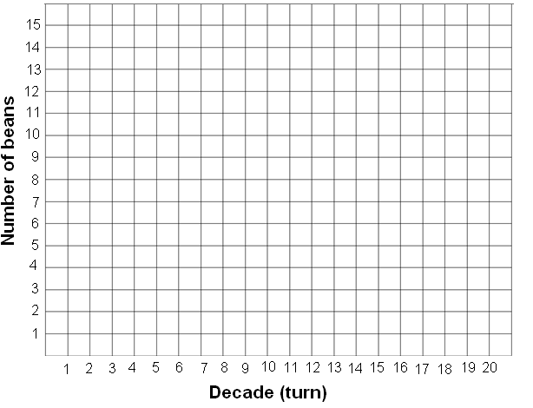  NOTE: Use different colors of pencil for renewable & nonrenewable resources
  Round | # Beans to Draw | Number Renewable | Number Nonrenewable
  1 | 10
  2 | 10
  3 | 10
  4 | 10
  5 | 10
  6 | 10
  7 | 10
  8 | 10
  9 | 10
  10 | 10
  11 | 10
  12 | 10
  13 | 10
  14 | 10
  15 | 10
  16 | 10
  17 | 10
  18 | 10
  19 | 10
  20 | 10

PART TWO: Start with 92 Nonrenewable, 8 Renewable, increase usage by 1 bean every other turn
 | NOTE: Use different colors of pencil for renewable & nonrenewable resources
  Round | # Beans to Draw | Number Renewable | Number Nonrenewable
  1 | 10
  2 | 10
  3 | 11
  4 | 11
  5 | 12
  6 | 12
  7 | 13
  8 | 13
  9 | 14
  10 | 14
  11 | 15
  12 | 15
  13 | 15
  14 | 15
  15 | 15
  16 | 15
  17 | 15
  18 | 15
  19 | 15
  20 | 15

PART THREE: Start with 92 Nonrenewable, 8 Renewable, decrease usage by 1 bean every second turn
 | NOTE: Use different colors of pencil for renewable & nonrenewable resources
  Round | # Beans to Draw | Number Renewable | Number Nonrenewable
  1 | 10
  2 | 10
  3 | 9
  4 | 9
  5 | 8
  6 | 8
  7 | 7
  8 | 7
  9 | 6
  10 | 6
  11 | 5
  12 | 5
  13 | 5
  14 | 5
  15 | 5
  16 | 5
  17 | 5
  18 | 5
  19 | 5
  20 | 5

PART FOUR: Start with 92 Nonrenewable, 8 Renewable but each round replace one of the nonrenewable beans with a renewal bean to demonstrate an increased use of renewable energy
 | NOTE: Use different colors of pencil for renewable & nonrenewable resources
  Round | # Beans to Draw | Number Renewable | Number Nonrenewable
  1 | 10
  2 | 10
  3 | 10
  4 | 10
  5 | 10
  6 | 10
  7 | 10
  8 | 10
  9 | 10
  10 | 10
  11 | 10
  12 | 10
  13 | 10
  14 | 10
  15 | 10
  16 | 10
  17 | 10
  18 | 10
  19 | 10
  20 | 10

Name:_______________________________________________________ Period _____

Lab Partner:__________________________________________________

EARTH SYSTEMS LAB:
Renew-a-Bean

Analysis (answer these questions when you are done):
- In which scenario did you run out of beans the fastest? Why?

- How many years did it take for the nonrenewable energy beans to run out when you increased the rate at which energy was used (Part Two)?

- How was the use of nonrenewable energy resources affected by increasing the renewable resources?

- What happens to the proportion of the renewable versus nonrenewable energy resources that remain available as energy is used over time?

- Which scenario, increasing the amount of renewable resources (Step Four) or decreasing overall energy use (Step Three) was better for making the resources last?

- What did you learn from this simulation?

