Name:_________________________________________________ Period:_____

EARTH SYSTEMS LAB:
Salinity and Temperature Currents Lab

Purpose: Surface currents are swift and driven by the wind. Density-driven currents are slow, and result from changes in seawater density which occurs because of temperature and salinity changes. Surface currents are subject to large deflections due to the Coriolis effect; density-driven currents are less influenced by the Coriolis effect because they are so slow moving. Landmasses can create barriers to the flow of surface currents while the landscape of the ocean floor impedes the flow of deep-water currents. In this lab, you will investigate currents caused by temperature and salinity differences.

Materials: 2 plastic bottles 1 tornado tube water cup
4 spoonfuls salt food coloring paper towels plastic disc

Part One: Exploring Density Currents
Procedures:  1. Fill your two bottles with tap water. Fill one to the very top and leave about an inch of space at the top of the second bottle. BE NEAT!  2. Add approximately four spoonfuls of table salt and six drops of food coloring to the bottle with the space at the top, seal it, and shake well. (This is the SALTY water bottle.)  3. Screw the tornado tube tightly onto the SALTY bottle. Try NOT to squeeze the bottle.  4. Finish filling the SALTY water bottle to the very top of the tornado tube with tap water.  5. Place the plastic disc on top of the fresh water bottle. Carefully turn the FRESH water bottle and quickly place it against the opening of the tornado tube attached to the SALTY water bottle. Remove the plastic disc. Screw the fresh water bottle tightly into the tornado tube without squeezing.  7. Lay the bottles gently on their side OVER THE SINK. Disturb the bottles as little as possible and observe any movement of the colored water. Watch for at least 5 minutes at eye level. | 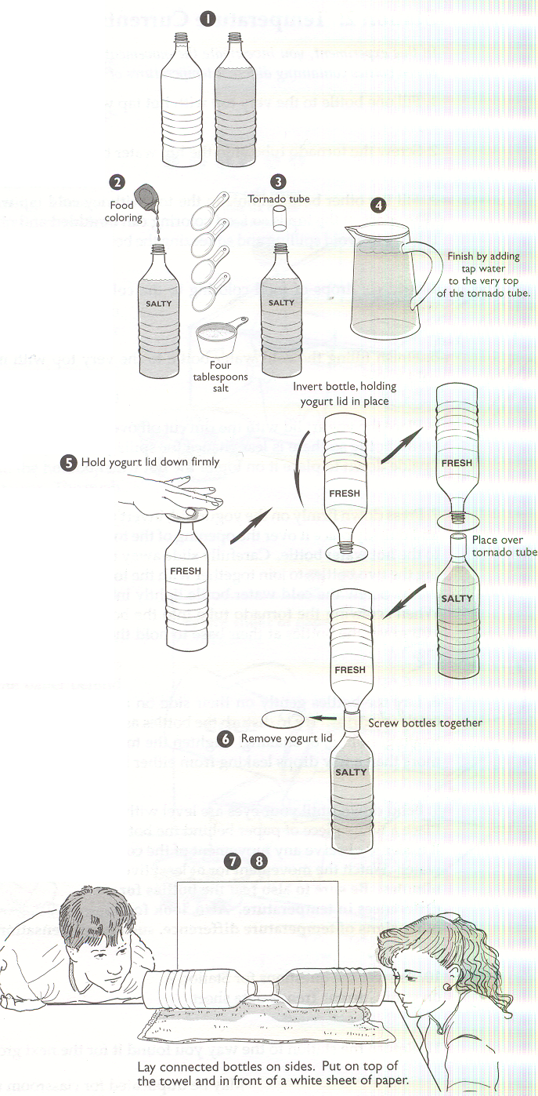

Draw your Results:
BEFORE | 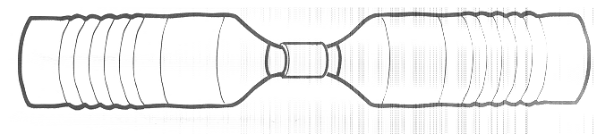
AFTER
Part Two: Exploring Temperature Currents
Procedures:
- Empty your salty bottle and rinse. Take it to the back and fill with warm colored water.
- Empty your non-salty bottle. Take it to the back and fill it with cold non-colored water.
- Screw the tornado tube tightly onto the WARM bottle and finish filling the WARM water bottle to the very top of the tornado tube with tap water.
- Place the plastic disc on top of the fresh water bottle. Carefully turn the COLD water bottle and quickly place it against the opening of the tornado tube attached to the WARM water bottle. Remove the plastic disc. Screw the COLD water bottle tightly into the tornado tube without squeezing.
- Lay the bottles gently on their side OVER THE SINK. Disturb the bottles as little as possible and observe any movement of the colored water. Watch for at least 5 minutes at eye level. Feel the bottles occasionally to feel for differences in temperature. Look for other signs of temperature such as condensation as well.
- Empty your bottles, rinse the colored one, and leave them to dry with the caps off.
Draw your Results:
BEFORE

AFTER

Analysis:
- Describe observations for BOTH scenarios.

- Based on your observations, describe at least one generalization you could make about what happens when waters of different salinities meet.

- Based on your observations, describe at least one generalization you could make about what happens when waters of different temperatures meet.

- Summarize this lab and explain how it demonstrates ocean currents:

