Name:__________________________ Period:_____
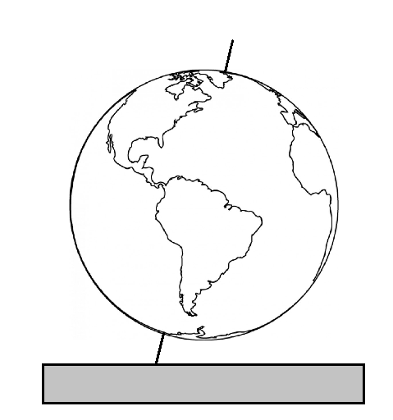
EARTH SYSTEMS LAB:
Seasonal Changes in Weather and Climate

Purpose: To see how the Earth’s tilt and orbit around the Sun combine to produce seasonal variations in weather and climate.

Materials: Globe on a stick Lamp Plastic Bin Thermometer
Metric Ruler Sticker – for Georgia Timer Wooden ball

Procedures:
- You have a lamp and a globe on a plastic bin between your lab table and the one next to you. You are sharing with another lab group.  - Place the Globe-on-a-stick on top of the plastic bin so that the axis is tilted toward the lamp and about 30 cm away from the lamp. Check this distance with your metric ruler. The height of the lamp should be shining straight on the middle of the Globe-on-a-stick. Your lab set up should look something like the one to the right. | 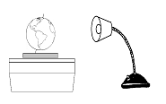
- When North America faces the Sun, the rays should be most direct on North America. This is summer in the northern hemisphere.
- Carefully spin the globe on the stick so that you simulate one day and night. Don’t move the bin or the base – just turn the globe. Observe where the light is most direct as the Earth spins. Observe the sticker’s movement in relation to the lamp’s rays.
- Keep the lamp in place but turn it around so that the light shines at a 180° angle from the original position. Move the box with the globe around so that the lamp faces the opposite globe and the globe’s axis is pointed the same direction as before. Your lab set up should look something like this:  - The lamp’s rays should be most direct on South America. This is winter in the northern hemisphere. | 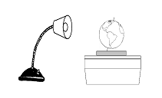
- Again, carefully spin the globe so that you simulate one day and night. Don’t move the bin or the base – just turn the globe. Observe where the light is most direct as the Earth spins. Observe the sticker’s movement in relation to the lamp’s rays.
- Now, move turn the lamp in place halfway between the summer and winter positions. Again, move the box and globe so that the lamp shines on the globe but keep the Earth’s tilt in the same direction.
- Again, carefully spin the globe so that you simulate one day and night. Don’t move the bin or the base – just turn the globe. Observe where the light is most direct as the Earth spins. Observe the sticker’s movement in relation to the lamp’s rays.
- As you spin the globe, you should see that the lamp’s rays are most direct on the equator. There is equal light above and below the equator as the Earth spins. This is the spring or fall position.

As you work through the questions on the back, you will move the globe and lamp set up to different seasons. Make sure that the lamp’s rays are level with the middle of the globe and Earths’ axis is always tilted in the same direction.

Set up the globe and lamp to the SUMMER position for questions 1 – 4.

- Which of the poles – North or South – is always in daylight as you spin the globe?

- Which of the poles – North or South – is always in night as you spin the globe?

- Place the wooden bead on the sticker on your globe. How long is the shadow of the wooden bead pin in millimeters when the lamp is shining directly on Georgia?

- Place the bulb of the thermometer beside the sticker and hold it there for 2 minutes facing the light. What is the temperature?

Set up the globe and lamp to the WINTER position for questions 5 - 8.

- Which of the poles – North or South – is always in daylight as you spin the globe?

- Which of the poles – North or South – is always in night as you spin the globe?

- Place the wooden bead on the sticker on your globe. How long is the shadow of the wooden bead pin in millimeters when the lamp is shining as directly as possible on Georgia?

- Place the bulb of the thermometer beside the sticker and hold it there for 2 minutes facing the light. What is the temperature?

Set up the globe and lamp to the SPRING position for questions 9 - 12.

- Which of the poles – if any – is always in daylight as you spin the globe? Explain.

- Place the wooden bead on the sticker on your globe. How long is the shadow of the wooden bead pin in millimeters when the lamp is shining as directly as possible on Georgia?

- Place the bulb of the thermometer beside the sticker and hold it there for 2 minutes facing the lamp. What is the temperature?

Summary:
- What changes occur in temperature and insolation as Earth orbits the Sun? Use evidence from the lab to EXPLAIN your answer.

