Name:_________________________________________________ Period:_____

EARTH SYSTEMS LAB:
SEDIMENTARY ROCK IDENTIFICATION

Use the dichotomous key below to identify all eight Sedimentary Rocks.

1. Dark colored or “chunky” – Go to 2
Light colored – Go to 3

2. Grains visible, sand size or larger, or feels “gritty” – go to 4
No obvious grains, may be glassy – go to 5

3. Translucent with blocky crystalline shape – Halite
Very soft, easily scratched - Gypsum

4. Grains are larger than gravel – go to 6
Grains are smaller than gravel but still visible – Sandstone

5. Feels gritty but can’t see grains with a microscope, scratches easily - Siltstone
Feels smooth, does not scratch easily, layered – Go to 7

6. Angular gravel grains – Breccia
Rounded gravel grains – Conglomerate

7. Does not scratch easily, layered – Shale
Smudgy, scratches easily, possibly shiny – Coal

Data: Below draw and color each of the following rocks. Indicate the number of each sample.
Drawing
Rock | Halite | Gypsum | Sandstone | Siltstone
Number
Environment | Shallow water, desert lakes | Lake, sea or water | Beach, rivers | Between beach & calmer water
Drawing
Rock | Breccia | Conglomerate | Shale | Coal
Number
Environment | Thallus slopes, young streams | Beach, rivers | Calm water, lakes & offshore | Swamps

Analysis:
1. How are the particles that make up the conglomerate different from those that make up the sandstone, or shale? Describe how they are different!

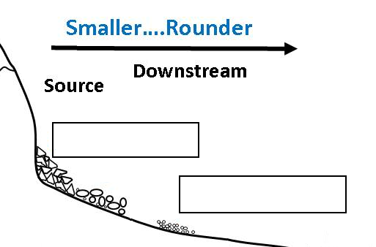
2. Look closer at the Breccia and Conglomerate rocks. Breccia particles are angular and less worn down than the rounded and smooth particles of Conglomerate. Based on your observations and that information, write where each of these rocks would have formed in the boxes on the diagram to the right.

3. Take a closer look at the Sandstone, Siltstone and Shale rocks. The sandstone is grittiest, having been formed from beaches and where sand is deposited. It has the largest particles. Shale, on the other hand, has the smallest particles, which were deposited in calm waters. Siltstone’s particles are between the two. Based on that information write where each of these three rocks would have formed in the boxes on the diagram below:
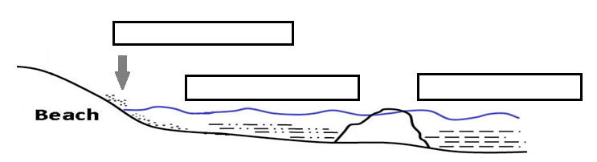

4. What does the particle size of a sedimentary rock tell you about the conditions it was formed under? Think back to what we learned about stream flow velocity and erosion.

5. Write the following terms in the correct order for the formation of sedimentary rocks:
Erosion - Cementation - Compaction - Deposition - Weathering

1: _________________________________
2: _________________________________
3: _________________________________
4: _________________________________
5: _________________________________

