Name:___________________________________________ Period:_____

EARTH SYSTEMS LAB
Sorting and Sedimentation

Purpose: To explore turbidity and observe the way particles are sorted during deposition

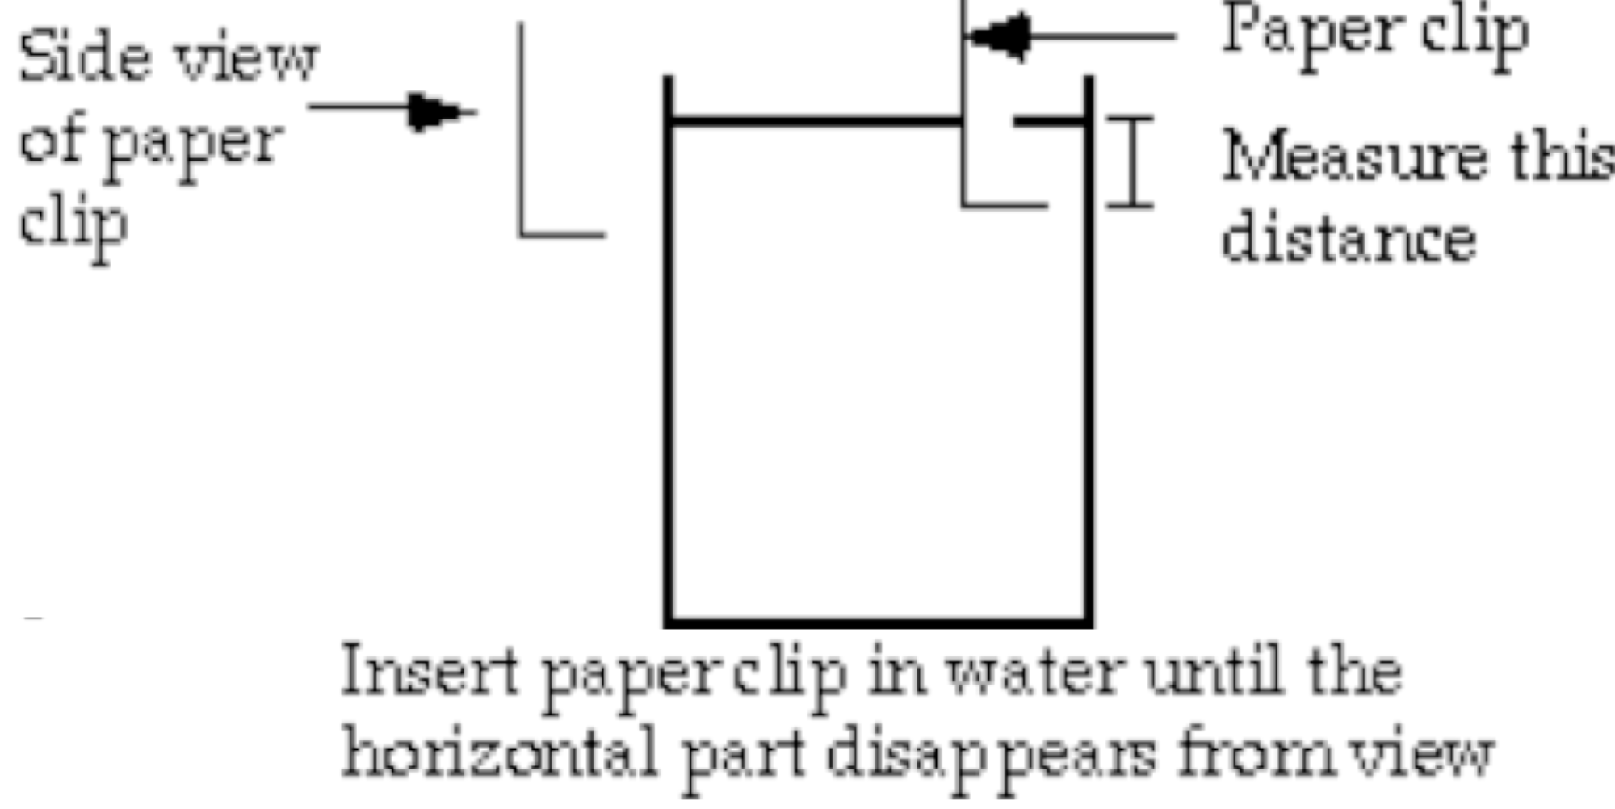 | Materials:  - Clear jar, filled 1/3 full with sediment and filled to the brim with water  - Paper clip - bent as illustrated below with bead on end  - Pencil  - Metric ruler

NOTE: We will begin this lab BEFORE starting the Presentation and stop to collect data every five minutes
Procedures: (see diagram above)
- With lid on tightly, shake jar vigorously.
- Quickly set jar down and open lid.
- Make observations as follows (two people are needed):
- One person lowers a paper clip into water to level where it disappears from view as observed from the top and holds it there. The paper clip must be lowered next to the edge of the jar so it can be seen through the glass.
- The other person measures the depth beneath the water surface in MILLIMETERS at which the paper clip disappears from view as observed from the top.
- Record the observation in the Data Table below.
- Repeat every five minutes for 25 minutes.

Data Table:
Time after Shaking | Turbidity Depth in mm
5 minutes
10 minutes
15 minutes
20 minutes
25 minutes

Analysis:
- Summarize your observation of how the rate of change in turbidity changes with time after shaking.

- What is the relation of grain size to settling rate?

- How does turbidity of a river change with water flow?

- How long would it take for the paper clip to be visible on the surface of the sediment?

- Graph Time after Shaking versus Turbidity Depth on the graph below.
    - Label the X-axis Time after Shaking, seconds
    - Label the Y-axis Turbidity Depth, mm
    - Give your graph a title at the top.

60

50

40

30

20

10

130

120

110

100

90

80

70

0 5 10 15 20 25 30 35

