Name:____________________________________________________________ Period: _____

Partner: ___________________________________________________

EARTH SYSTEMS LAB:
How Do You Stack Up?
Copyright © by Holt, Rinehart and Winston.

We can tell a lot about the Earth’s history with both fossils and the rock layers they are found in. In this activity, you will model what geologists do by drawing sections of different rock outcrops. Then you will recreate a part of the geologic column, showing the geologic history of the area that contains all of the outcrops and make interpretations based on the rock layers and the fossils found in them.

 | Materials:  • metric ruler  • pencil  • colored pencils  • white paper  • scissors  • transparent tape | 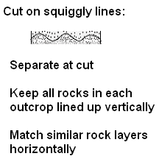
MATERIALS
Procedures:
- Use colored pencils to shade the different layers of each outcrop that have not been colored. Use the key at the bottom of the outcrops.
- Each layer of rock will be colored with specific colors and use dots, dashes, ovals or bricks to differentiate between rock types.
2. Cut out each outcrop. An outcrop is a visible exposure of bedrock or ancient superficial deposits on the surface of the Earth.
- Notice the contact between layers of each outcrop—straight or wavy. Straight lines represent bedding planes, where deposition was continuous. Wavy lines represent unconformities, where rock layers may be missing. The top of each outcrop is incomplete, so it should be a jagged line.
- Note the symbols represent fossils in the layers of your outcrops. Pay attention to the variety of fossil shapes and the layers that they are in.
6. Write the outcrop number on the back of each section in several places.
7. Lay the individual outcrops next to each other on your desk or table.
8. Find layers that have the same rocks and contain the same fossils. Move each outcrop up or down to align similar layers next to each other.
9. If unconformities appear in any of the outcrops, rock layers may be missing. You may need to examine other sections to find out what fits between the layers above and below the unconformities. Leave room for these layers by cutting the outcrops along the unconformities (shown as wavy lines).
10. Eventually, you should be able to make a geologic column that represents all four of the outcrops. It will show rock types and fossils for all the known layers in the area. Note: Even though you may need to cut apart outcrop sections on the unconformities, you will always keep each outcrop section in the order in which it originally appeared, and always in a vertical column.
11. Tape the outcrop sections together in a pattern that represents the complete geologic column to a blank sheet of drawing paper. Then answer the questions.
Analysis:
11. How many layers are in this part of the geologic column you modeled?

12. Which is the oldest layer in your column? Which rock layer is the youngest?
Describe these layers in terms of rock type and the fossils they contain.

Oldest:

Youngest:

13. Draw the seven different fossils in your column from oldest to youngest. Write them along the line from oldest to youngest fossil.

OLDEST ______________________________________________________ YOUNGEST

14. Look at the unconformity in Outcrop 2. What kind of unconformity is it? Which rock layers are partially or completely missing? Explain how you know this.

15. What are the other three types of unconformities? How would EACH one change the appearance of the geologic column? EXPLAIN underneath each name.

- Name ______________________________

- Name ______________________________

- Name ______________________________

Outcrop Cutouts
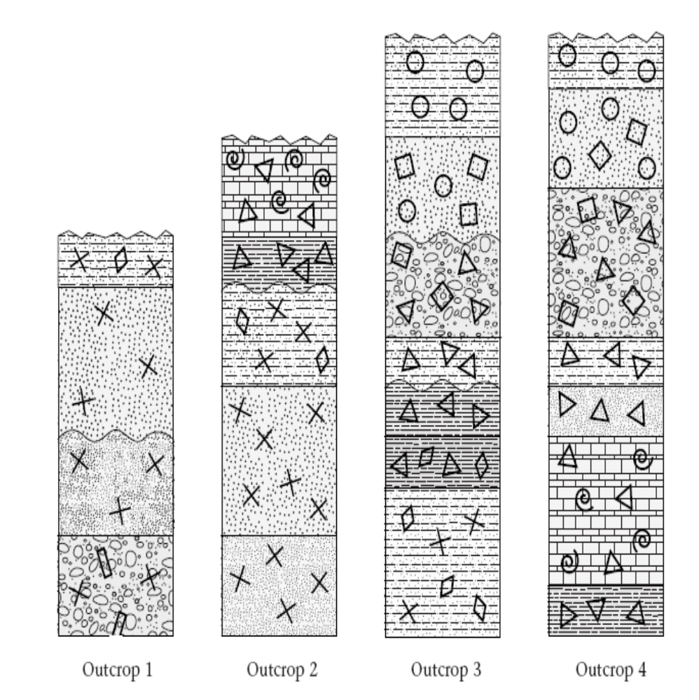
Coloring Key for Rock Types & Fossils:
Dark Green    Ovals with Rectangles and X’s | 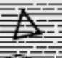  Dark Purple  Dashes with Triangles | 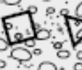  Red Ovals with Squares and triangles
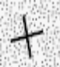  Light Blue  Small Dots with X’s |   Light Purple  Dashes, Triangles & Diamonds | Dark Blue  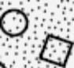  Dots with Squares and Circles
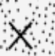  Orange  Large Dots with X’s | 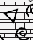  Pink Bricks with Triangles & Curls | 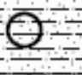  Grey Dashes and Dots with Circles
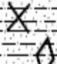  Yellow  Dashes & Dots; Diamonds & X’s | 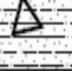  Light Green  Dashes & Dots, with Triangles | 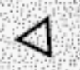  Brown  Dots with Triangles

