Name:____________________________________________________ Period:_____

EARTH SYSTEMS LAB:
Weather Maps

Purpose: Weather maps are created to provide information about current weather conditions. In this activity you will create a station- model map using real-time data.
STATION MODEL
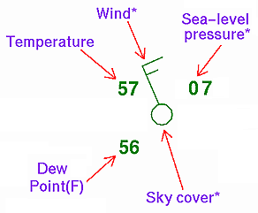
Procedure:
- Go to http://www.intellicast.com/Local/.
- In the top right hand corner search box, Type in Nicholson, GA.
- Look at the current conditions for Nicholson. Create a station model for Nicholson and nine other cities around the United States – no two can be in the same state.
- Create a station model for each city and place it on the map below in the correct state.
- When doing the pressure, you will need to convert the inches reading the millibars. Remember to drop the “10” or “9” at the beginning of the air pressure reading.

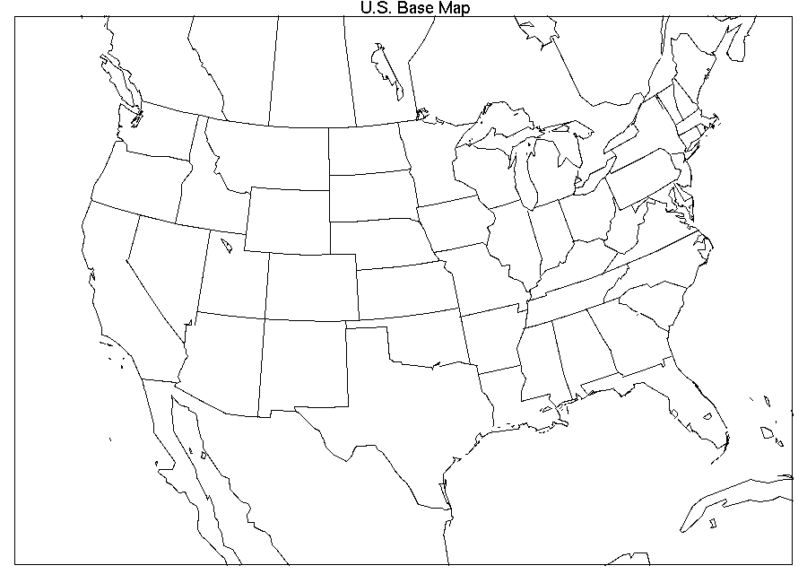

- Based on what your map shows, indicate the areas of High and Low pressure with an “H” or an “L.” Find and map at least one of each.

Use what you learned to answer questions about the following map:
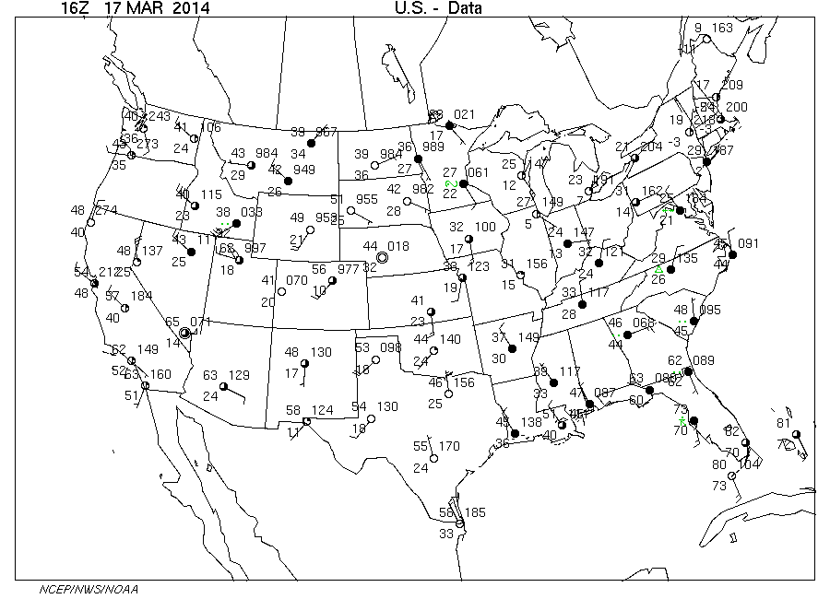
- What was the weather like in Atlanta at the time this map was made:
  - Temperature
  - Dew Point
  - Air Pressure (one decimal place given)
  - Winds (speed and direction)
  - Clouds
- What was the weather like in _____________________ at the time this map was made (pick one):
  - Temperature
  - Dew Point
  - Air Pressure (one decimal place given)
  - Winds (speed and direction)
  - Clouds
- When the temperature and dew point are the same, it is likely to have precipitation. Where was it most likely raining or snowing at the time this map was made? Was it rain or snow? How do you know?

- Mark the most likely places for one High and one Low on this map – remember that air pressures shown are to one decimal place.

