Name:__________________________________________________ Period:_____

Partner: ____________________________________________________

EARTH SYSTEMS LAB
WIND EROSION

During the Dust Bowl, wind acted as an agent for erosion. The soil loss is greater for soil that is bare, called fallow, than for soil that has crop residue covering the surface. In this experiment you will simulate wind erosion on a bare surface and one that has vegetative cover.

Purpose: Wind erosion can be reduced by putting a protective vegetative cover on the surface of soil.

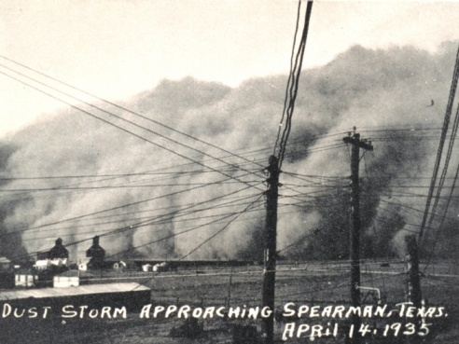 | Materials:  - 2 Styrofoam cups  - Index card  - 2 Drinking straws  - Soil sample  - Craft moss  - Digital balance  - Scissors  - Newspaper  - Tape

Procedure:
- Trace the open end of the cup on your index card. Cut it out.  - Cut the circle you created in half on the card stock.  - Securely tape one half circle over the open end of each cup.  - Make a small hole in the bottom of each cup NEAR THE EDGE. It needs to be big enough for the straw but no bigger. The hold should be on the opposite end of where you taped the card. | 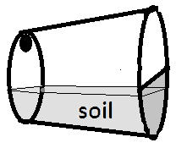
- Hold the cup on the side with the hole at the top and the side with the covered with the on the bottom. Fill each cup about one third full of soil.
- On top of the soil in one cup, apply a layer of craft moss.
- Mass each cup individually and record the initial mass in the data table.
- Insert the tip of the drinking straw into the hole in the bottom end of each cup.
- Lay newspapers over your lab table and place the cup on its side in the middle of the table.
- READ THIS ENTIRE STEP BEFORE PROCEEDING! While holding the cup horizontally with the hole to the top and the drinking straw directed toward the soil, you will exhale a moderate amount to blow across the top of the soil in the cup. Do NOT inhale. You will exhale and blow through the straw across the top of the soil for a total of TEN breaths into each cup. The amount of exhale needs to consistent for each trial. Have a partner hold a piece of paper in front of the open end of the cup so that any dirt blown out of the cup is deflected, falls and ends up on the newspaper.
- Remove the straw and mass each cup again. Record the mass in the data table.
- Repeat the experiment; this time blowing harder. Record the data in the second data table.
- Clean up your mess. Carefully recycle the newspaper with the trapped soil. Return the left over soil in the cups, moss, and your cups to your teacher. Trash your straws.

Data Table – Blowing Moderately:
Cup | Initial Mass | Mass After Erosion | Amount of Dirt Blown Away
Dirt Only
Covered Dirt

Data Table – Blowing Strongly:
Cup | Initial Mass | Mass After Erosion | Amount of Dirt Blown Away
Dirt Only
Covered Dirt

Analysis:
- In the experiment, how much soil was lost to wind erosion blowing moderately?

Cup one: Field that has soil without cover: ____________

Cup two: Field that has soil with cover: ______________

- In the experiment, how much soil was lost to wind erosion blowing strongly?

Cup one: Field that has soil without cover: ____________

Cup two: Field that has soil with cover: ______________

- What was the agent of erosion in the experiment?

- How did the moss affect the rate of erosion? Why?

- How did the strength of the wind affect the rate of erosion?

