UNIT 10 NOTES: AIR POLLUTION

HUMAN SOURCES OF AIR POLLUTION
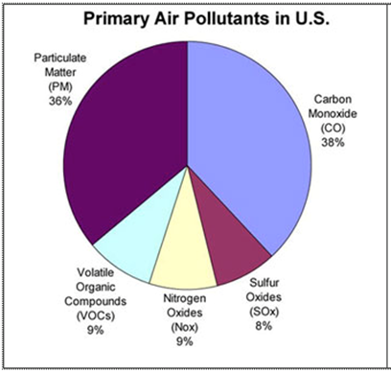
____________ combustion to produce electricity puts out:
- ________ of SO₂ emissions
- ________ of CO₂ emissions
- ________ of NOx emissions
________________ engines put out:
- ________ of CO emissions
- ________ of CO₂ emissions
- ________ of NO emissions
Fossil fuels are the major contributor.

AIR POLLUTION
- Approximately ______________________ metric tons of air pollution are released annually into the atmosphere in the US by human activities.
- Worldwide emissions total around __________________________ metric tons.

AIR POLLUTION KILLS
- 150,000 to 350,000 per year in the United States
- ___________________________ deaths per year world wide
- Mostly in ____________; 750,000 in China

WHAT ARE THE MAJOR POLLUTANTS?
 | MAJOR SOURCES | HEALTH EFFECTS | ENVIRONMENTAL EFFECTS
SO₂ | Industry | Respiratory and cardiovascular illness | Precursor to acid rain which damages lakes, rivers, and trees; damage to cultural relics
NO_{x} | Vehicles / Industry | Respiratory and cardiovascular illness | Nitrogen deposition leading to over fertilization and eutrophication
PM | Vehicles / Industry | Particles penetrate deep in lungs and can enter bloodstream | Visibility
CO | Vehicles | Headaches and fatigue, especially in people with weak cardiovascular health
Lead | Vehicles (burning leaded gasoline) | Accumulates in the bloodstream over time; damages nervous system | Fish and Animal kills
Ozone | Formed from the reactions of NO_{x} and VOCs | Respiratory illness | Reduced crop production and forest growth; smog precursor
VOCs | Vehicles / Industrial Processes | Eye and skin irritation, nausea, headaches, carcinogens | Smog Precursor

GROUND LEVEL OZONE: PHOTOCHEMICAL SMOG
- This is in the _______________________________.
- Reaction of ____________________________ and ____________________________________ (VOCs) in the presence of ultraviolet radiation (sunlight).
- Produced in series of chemical reactions.
- Responsible for ___________________________ in afternoons of sunny days.
- ________________________ as traffic increases in cities with sunny, warm, dry climates.

INDUSTRIAL SMOG
- Combination of ______________________, ________________________, and a variety of __________________ from burning coal and heavy oil.
- _____________________ in coal _______________________ to CO₂ and CO.
- __________________ in coal reacts with oxygen and water vapor (H₂O) to form ______________________________ (H₂SO₄)
- Droplets with ____________ make smog grayish.

ACID RAIN
- ______________________ than normal amounts of _________________ and _____________________________ in the atmosphere.
- __________ deposition:
- Acid rain, fog, and snow
- ___________________________ in atmosphere is reason for ___________ natural ______________________ of 5.6.
  - Reacts with calcium carbonate in limestone, creates caves.

ACID RAIN: FORMATION
- ____________________ of Sulfur and NO_{x} pollutants with water to form __________________ solutions
  - SO₂ forms sulfurous (H₂SO₃) and sulfuric acid (H₂SO₄)
  - NO_{x} forms nitric acid (HNO₃) and nitrous acid (HNO₂)

ACID RAIN DAMAGES ECOSYSTEMS
_____________________________:
- _______________________ into the ground and dissolves plant nutrients (Mg, Ca).
- Releases Aluminum into soil when pH less than 5.
- ____________ fog/mist __________________________________ from leaves and needles and leaves trees susceptible to disease and insects.
________________________ Systems:
- Can ___________ and ______________________, reduce fish populations, eliminates fish species and decrease biodiversity
- Many aquatic species have narrow range of pH tolerance – at pH 5, most fish eggs cannot hatch.

FACTORS AFFECTING AIR POLLUTION
_____________________________:
- Settling out
- Precipitation
- ________________________
- _____________________
- Chemical reactions
_____________________________:
- __________________________________ - slow wind dispersal of pollutants.
- ____________________________ - promote temperature inversions
- ____________________________________ - promote photochemical reactions

TEMPERATURE INVERSIONS
- Often happens in ____________________________ months
- __________________ of pollution _______________________ by a stable layer of warm air above a layer of cooler air nearer the ______________________.

AIR QUALITY STANDARDS
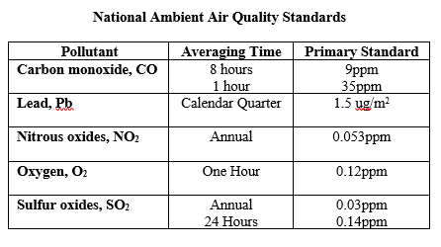

PPM: PARTS PER MILLION
- This is a way of ___________________________________________ of gases in the atmosphere.
- How ______________________ a solution is.

