UNIT 8: Solar Energy: Angle of Insolation

EARTH’S ENERGY COMES FROM THE SUN
- The __________ is the source of _____________________ in atmosphere.
- 30% of energy is __________________________________________ (lost).
- 20% of energy is _______________________________________________.
- 50% of energy is __________________________________________ – land and ocean.
- Energy is ______________________________________ and ____________________ systems.

SOLAR ENERGY IN DIFFERENT WAVELENGTHS
- Produces mostly _________________ (IR) light, __________________ light, and _____________________ (UV) light.
- ________________ in the sun’s core gives off high energy ________________________ but their frequencies are mostly only within the IR/visible light/UV spectrum by the time they reach the Sun’s ___________________.
- During solar flares, the Sun also emits X-rays.
- ___________________ wavelengths get to the Earth’s surface through the atmosphere – some are ___________________ by the ___________ layer and the _______________________.

ENERGY ABSORBED
- The Earth’s surface ______________________ solar energy.
- Absorbed by both _____________ and _________________.

ENERGY RADIATED
- The Earth’s surface ___________________ thermal (infrared, IR) energy.
- Some heat absorbed by land and ocean is radiated back into the ________________________ and also ___________________.
- _______________________________ mostly by the surface.

ENERGY REFLECTED
- Some incoming solar energy is __________________________ back by:
- The ____________________________
- ________________________
- The ____________________ of the Earth

THERMAL INERTIA
- Heating of Earth’s surface is ________________________.
- Time is _________________________________________ solar energy before temperature changes.

- ___________________ Delay:
- There is a delay between Earth's absorption of solar energy and an increase in temperature – this makes the ___________________ part of a ______________________ noon.
- ______________________________ Delay:
- Because of a similar delay in heating and cooling of Earth’s surface, the ___________________ part of the year is __________________________, the ____________________ is late _____________________.

ENERGY DISTRIBUTION
- __________________________:
- _________________________ to the sun’s rays.
- The _____________________ of solar radiation ______________________ a given place.
- _______________________________________: angle at which the sun's rays hit the Earth.
- The _________________ receives ______________________ angle of insolation.
- Sun’s rays are at _______________________.
- The energy is _____________________.
- ______________ receive _______________________ angle of insolation.
- Sun’s rays are ___________________________ degrees.
- The _________________________________________________ over a larger area and is ______________________________________________.
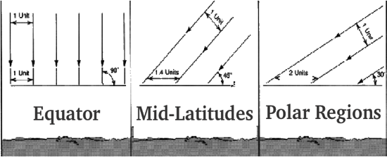

SOLAR ENERGY: LATITUDE
- ________________________ determines ________________________ of solar insolation (energy) __________________________.
- Closest to ________________________:
- Has a ______________________ angle.
- Has ______________ solar insolation.
- Closer to _________________:
- Has a ______________ angle
- Has _______________ solar insolation
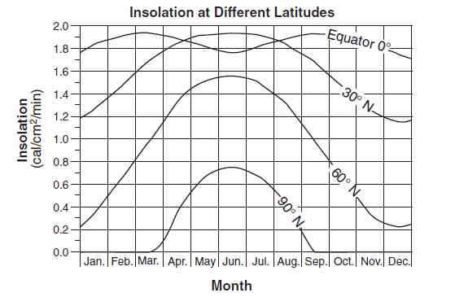
SOLAR INSOLATION: SEASONS
- The Earth’s __________ on its axis ________________________ the amount of Solar Insolation as the Earth ______________ the Sun.
- This is the reason for the Seasons.
- The _______________________ of insolation ____________________ is primarily controlled by:
- _________________________ (Angle of Incoming Solar Radiation)
- _____________ Variation
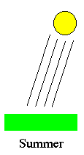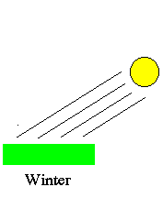
- _________________ Variation
- _________________ Variation
- _____________________ time
- _______________ variation
- ________________________ Variation
- Summer
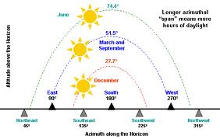
- Sun is _______________ in sky.
- ____________________ angle of insolation.
- Solar path is ____________________.
- _____________ solar energy received.
- Winter
- Sun is ______________ in sky.
- _______________________ angle of insolation.
- Solar path is ______________________.
- ______________ solar energy received

SOLAR INSOLATION: SEASONS AND LATITUDE
- Equator
- Solar path always __________________ east to west.
- More ___________________________________________.
- Mid-latitudes
- Solar path _________________________________.
- Solar path _________________________________.
- The ___________________ north or south of the equator, the _____________________ the change in the solar path and the _________________________ the sunlight.
- Arctic/Polar regions
- Sun’s path _____________________________ on longest day – never overhead
- Summer Solstice receives ________________________________________ all 24 hours.
- ____________________________ or visible Sun during Winter.

OBSERVING ANGLE OF INSOLATION FROM EARTH
- Position of Sun:
- Based on ________________________________.
- ____________________ as the angle of insolation increases and decreases.
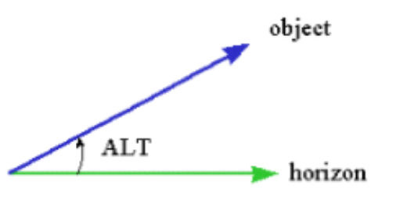
- Altitude: the angular distance of an object above the horizon (how far above your head) – 90° is at the zenith (top).
- Azimuth: the angular distance of an object along the horizon (where along the horizon)
