AQUIFERS and GROUNDWATER

UNDERGROUND WATER
- _________________________________: water beneath Earth’s surface - ___________________ surface then __________________________ through spaces in rock and sediment.
- ________________________: body of rock that stores underground water and allows it to flow.
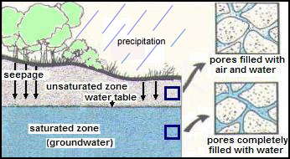
GROUNDWATER MOVES
- __________________ pulls water down – fills __________ in rock - until it hits _______________________________________.
- ______________________ depends on
  - __________________________________ – like streams.
  - _____________________________: the ability of rock to let water pass through its pores.

GROUNDWATER ZONES
- ___________________________ - Level where pore space is completely filled with water.
  - ______________________________ is the water table.
- ____________________________________ - Zone ________________________ water table and surface.
  - Zone of ________________________
- _________________________ - _________________________________ of the zone of saturation
  - It is the level below which the ground is saturated with water.
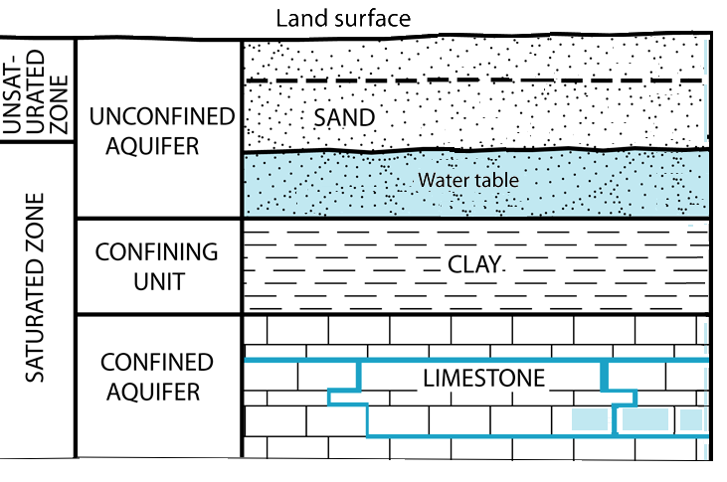

CONFINED VERSUS UNCONFINED AQUIFERS
____________________________________ water infiltrates easily from surface.
____________________________________ – water trapped by impermeable rock or clay –between layers of rock.

AQUIFERS STORE GROUNDWATER
- Aquifers: Underground layers of rock that are ______________________ with water.
- Can be brought to the surface through _________________________________ or by ___________________________.
- _____________ of all drinking water comes from aquifers.

OUR AQUIFER: PIEDMONT AQUIFER - Piedmont and Blue Ridge aquifers
- ___________________ covered with ______________________
- ___________ at top
- _______________________ - chemically weathered bedrock
- Porosity and permeability of bedrock is ___________________due to extreme heat AND pressure.
- Groundwater obtained from (1) __________________ and (2) ___________________ in the rock.
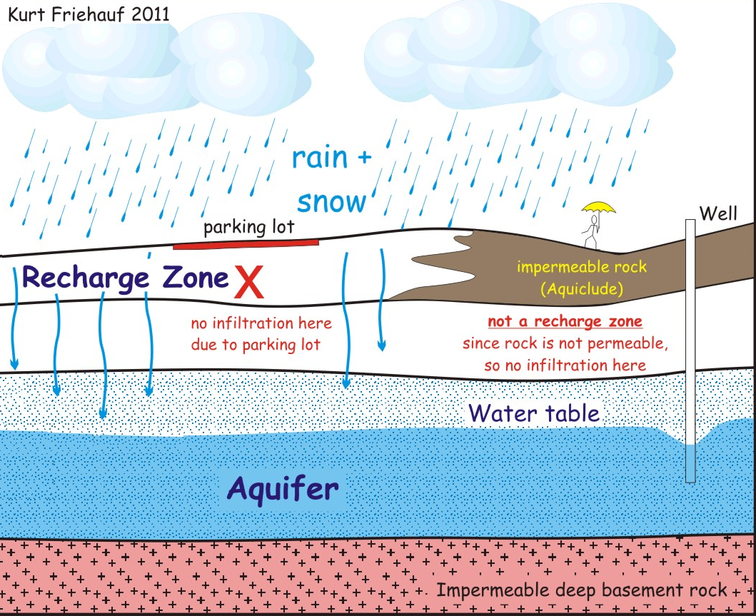
AQUIFER DRAWDOWN
Provide water for:
- ______________________: drinking, cooking, cleaning
- ____________________________
- _____________________________
Withdrawing water can ______________________________.

RECHARGING AQUIFERS
- Recharged by ________________________ of precipitation.
- ________________________________: the area where water from the surface can move through permeable rock to reach an aquifer.
- Recharge zones can be __________________ by impermeable rock and man-made features.

RISK: GROUNDWATER DEPLETION
_____________________________________ long-term water-level declines caused by sustained pumping.
Leads to:
- ____________________ water tables (harder to get to).
- ____________________ cost for consumers.
- ____________________ water in streams and lakes.
- Land __________________________ – loses support sinks.
- ____________________________ of water quality.
- ____________________ intrusion near coasts.

RISK: GROUNDWATER CONTAMINATION
__________________________________________________ is when man-made products (gasoline, oil, road salts, chemicals, etc.) get into the groundwater and cause it to become ___________________________________________________.
Sources include:
- Storage tanks
- Septic tanks
- Landfills
- Hazardous waste
- Industrial discharge

Some areas more _____________________________________________________ than others.

