EARTH’S EARLY ATMOSPHERE NOTES

EARTH’S _____________________ ATMOSPHERE
Early atmosphere came from comets and asteroids impact during the period of heavy bombardment.
- Mostly _______________________ and ______________________________
- Very light gases – low mass.
- _______________________ too weak to hold light gases – escaped into space.
- Blown away by the Solar Wind.

EARTH’S _____________________ ATMOSPHERE
______________________________ from volcanic eruptions:
- Water vapor (H₂O), Carbon Dioxide (CO₂), Nitrogen (N₂), Methane (CH₄), Sulfur dioxide (SO₂), Ammonia (NH₃)
- Some gases broke down.
- Ozone layer formed.

CURRENT ATMOSPHERE
- ____________________________________ primarily responsible for the development of the present percentage of free oxygen.
- Early plants, cyanobacteria used CO₂ and released O₂.
- Buildup of Oxygen in the atmosphere.
- Rapid O₂ buildup 2 billion years ago.
- Current atmosphere 78% ______________________, 21% __________________________.

COMPARE: MARTIAN ATMOSPHERE
- ________________________, less _________________________________ to hold it.
- Not always like this….
- Evidence for water early in Martian history:
- Water in Martian meteorites
- Ancient streambeds
- Rounded pebbles
- Channels and alluvial fans
- Sedimentary deposits
- Where did the water go?
- Small planet cooled ____________________________.
- Magnetosphere lost.
- Solar wind blew away much of atmosphere.
- Too little gravity to hold gases.
- Possible collision could have blown away atmosphere.
- Low atmospheric pressure means water boils at lower temperature.

EARTH THREE ATMOSPHERES
A
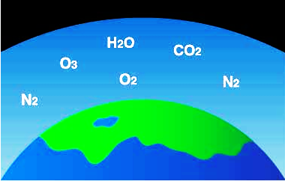
Indicate which picture is which of the Earth’s three atmospheres.

First Atmosphere ________

Second Atmosphere ________

Current Atmosphere ________

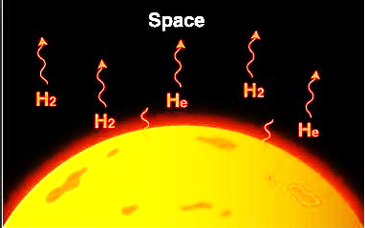
B

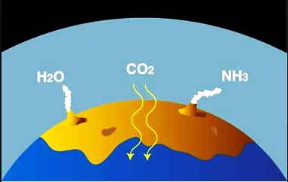
C

