UNIT 8: AIR PRESSURE AND CLOUDS

ATMOSPHERIC PRESSURE
- Air pressure is the __________________________________________________________________.
- Earth's atmospheric pressure is ___________ (pounds per square inch) or ___________ (atmosphere).
- The force on 1,000 square centimeters (a little larger than a square foot) is about a ton!

DIFFERENCES IN AIR PRESSURE
- ________________________________ of Earth’s surface causes _______________________ in air pressure.
  - _____________________________________ than poles.
  - Creates ___________________________.
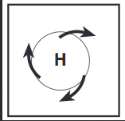
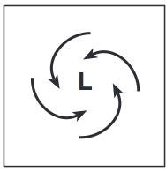

HIGH PRESSURE
- Air that __________ in atmosphere is ________________.
- Air is _________.
- The air cools and ____________________________.
- It then descends or _______________.
- It creates area of _____________________________.
- Moves _____________________________________.
  - Spins ______________________________ due to Coriolis.
- Brings _________________________________ weather at surface.

LOW PRESSURE
- Air _____________________.
- Warm air ______________________.
- Air becomes _______________________ and __________________.
- This _______________________ at surface to replace rising air.
  - Air coming into Low spins __________________________________________ due to Coriolis.
- Air ____________ as it ________________.
- _____________________ form.
- ___________________________ at top of Troposphere.
- Brings _________________________ weather at surface.

WIND
- Wind is _____________________________ due to _______________________________________.
- Air moves from ______________________________ pressure – WIND!
- Atmosphere is __________________________________________________ – equilibrium
- High Pressure – _____________________________________________.
- Low Pressure – _____________________________________________.

RISING AIR
- Adiabatic cooling is the process of _________________________________ through a _______________________________________________ caused by _________________________ _________________________________.
- Air is __________________ and ____________________ – energy input at time of heating only.
- Temperature ______________ because of __________ pressure from air ______________________ – __________________________________________________________.
- ______________________________________ when rising air mass temperature ________________ __________________________ and water vapor condenses.

CLOUD FORMATION
- MUST HAVE
  - _______________________________ and _______________________________.
- Rising air cools.
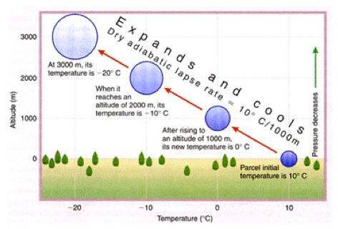
- ________________________________ in air ___________________________.
- ___________________________________________ – solid particles (dust, etc.) in the atmosphere – must be present.
- Water vapor _______________________________ ____________________ of nuclei.

CLOUD FORMATION RELEASES HEAT
- _____________________________ is the energy that is _____________________ in a phase change.
  - ____________________________ at the surface ___________ heat energy.
  - ____________________________ in clouds _______________________________ heat energy.
- Energy is ___________________________ from the _________________________ to the _____________________________ as water evaporates at the surface then condenses to form clouds.

CLOUD TYPES
- ___________________ - High, thin, light ice crystals
- ___________________ - Flat, low, sheet-like; warm, moist air above cold
- ______________________ - Puffy, billowy; rising, moist air cools
- __________________________________ - much larger, taller than cumulus; thunderstorm clouds

