UNIT 9 NOTES: CLIMATE CHANGE

CLIMATE BASICS: EARTH’S SURFACE HEATS THE ATMOSPHERE
- ___________________________ are warmed by _______________________ from Earth then _______________ that heat.

STUDYING PAST CLIMATES
EVIDENCE | WHAT IS MEASURED | WHAT IS INDICATED | LENGTH OF TIME MEASURED
 | Concentrations of gases in ice and melt water | High levels of CO₂ indicate warmer climate, ice ages follow decreases in CO₂ | Hundreds of thousands of years
 | Concentration of ¹⁸O in shells of microorganisms | High ¹⁸O levels indicate cool water, lower ¹⁸O levels indicate warm water | Hundreds of thousands of years
 | Pollen types, leaf shapes & animal adaptations | Leaf shape indicates warm/cool climate | Millions of years  Measure the longest length of time
 | Ring width | Thin rings indicate cool weather with less precipitation | Hundreds of thousands of years

CLIMATE MODELING
- These are _______________________________ models.
- They use ____________ collected from __________________________________ to study climate.
- They apply _____________________________, _________________________________ methods to develop trends and projections.
- They _________________________ the ____________________________ of the atmosphere, oceans, land surface, and ice.
- The models apply data gathered from evidence to ________________________________________ and ___________________________.

EVIDENCE SUPPORTS CLIMATE CHANGE
- _______________________ atmosphere: + 0.8 °C since 1900.
- _______________________ oceans: + 0.302 °F since 1969.
- _______________________ in sea levels: + 6.7 inches since 1900.
- _______________________ of surface ocean waters: + 30% since 1800.
- Ice sheets are _______________________.
- _______________________ in atmospheric CO₂: + from 280 ppm to 379 since 1800.

NATURAL CAUSES OF CLIMATE CHANGE
- _______________________ ______________________
- Change impact of ocean and atmosphere currents.
- ______________________________
- Ash reflects sunlight back to space – leads to COOLING (reduced temperatures).
- ______________________________________
- 11 Year Sunspot Cycle
- Low activity = colder
- Example: Maunder Minimum
  - The ________________________________________ is the name used for the period starting in about 1645 and continuing to about 1715 when sunspots became exceedingly rare, as noted by solar observers of the time.

NATURAL CAUSES OF CLIMATE CHANGE: MILANKOVITCH CYCLES
- ___________________________________________ are cycles of Climate Change:
- 100,000 year variations.
- Smaller variations for 20,000 to 40,000 years.
- Orbital changes produce climate shifts
- _______________________________________ (shape of the orbit)
- ________________________ – varies between 22.2° and 24.5°
- ___________________________________ - _______________________ variations from spin (like a spinning top wobbles).
- NOT ROTATION!

ANTHROPOGENIC CAUSES OF CLIMATE CHANGE
- Anthropogenic means __________________________________________.
- ___________________________________________:
  - Transportation and Electricity Power Plants
  - Releases CO₂ and other greenhouse gases into atmosphere
  - CO₂ greenhouse gas – increases temperature
- ___________________________:
  - CFCs
  - Nitrous Oxides
- ___________________________:
  - Fossil fuels burned to produce and transport crops.
  - Land use changes alter natural cycle.

GREENHOUSE GASES TRAP HEAT
- A ________ in an atmosphere that ________________ and ____________ infrared radiation.
- Absorbs ________________.
- Allows ________________ heat to escape back to space.
- ________________ energy in the ________________ atmosphere.
- Increases in CO₂ and CH₄ are linked most closely to Global Warming and Effects
- Greenhouse Gases: Some _________________________, some _____________________________.

- ____________________________ – CO₂
- ______________________ – CH₄
- ____________________________ – H₂O
- ____________________________ - NO_{x}
- _______________ (Tropospheric) – O₃
- ____________ (Chlorofluorocarbons)
CLIMATE AND CARBON DIOXIDE (CO₂)
- __________________________ CO₂ in atmosphere.
- __________________________ average temperatures.
- ______________ rising to historic highs.
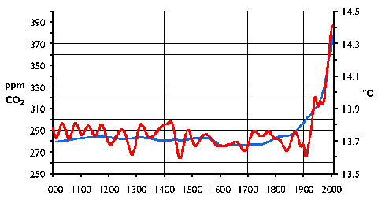

EFFECTS OF CLIMATE CHANGE
- Sea ice _______________________
- Sea level _____________________
- Changes in ocean ____________________________
- ____________________________ changes
- Changes in ___________________________ patterns
- Ocean ____________________________
SEA ICE MELTING
- Since 1979, more than _________________ of the Polar Ice Cap has melted away.

SEA LEVEL RISING
- Sea levels are steadily rising. Data starts in 1880.
- 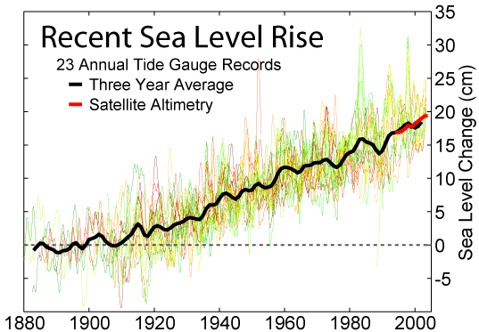
CHANGES IN OCEAN CURRENTS
- Areas heated by warm ocean currents could become colder if ice cuts off currents – heat will be transferred elsewhere.
BIODIVERSITY CHANGES
- If the Earth warms, the climate zones and thus the biomes will change.
CHANGES IN WEATHER PATTERNS
- Changes in evapotranspiration patterns result in more ______________________________.
- Environments becoming more ________________ subject to greater _________________________.
OCEAN ACIDIFICATION
- Carbon Dioxide in atmosphere is _____________________________ by ocean water.
- Chemical reactions take place producing _______________________________.
- Ocean acidity up ___________ since 1850.
- _________________________ corals and other life forms.

CARBON CYCLE: OCEANS STORE CARBON
- The carbon cycle has carbon ______________________ and carbon _________________.
- Water that _____________________ CO₂ forms carbonic acid through a ______________________ reaction.
- ____________________________ (more acidic) as CO₂ absorbed.

