UNIT 9 NOTES: CLIMATE FACTORS

CLIMATE VS. WEATHER
- _____________________: condition of the atmosphere at a _____________________________.
- _____________________: the ________________________ weather conditions in an area over a _____________________________ of time.

CLIMATE FACTORS
- PREVAILING WINDS
_______________________________ take on characteristics of:
- _______________ it is _______________
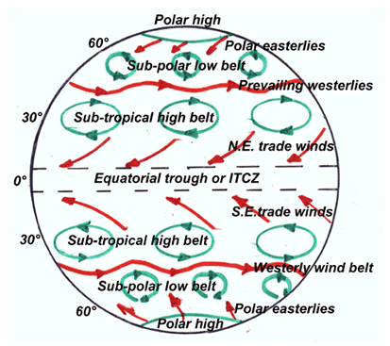
- What it __________________________
- _____________________________ _:
- Becomes _______________
- _______________ in winter
- _______________ in summer
- Moves _______________
- _____________________________ _:
- Becomes _______________
- _______________ in summer
- _______________ in winter
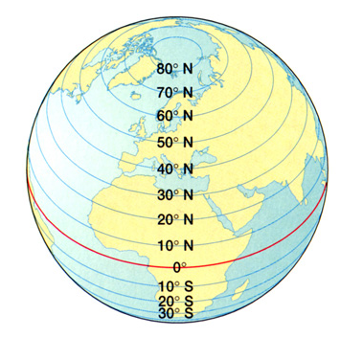

- PRESSURE BELTS
- Doldrums – _______________ – rising air – _______________ – rainforests.
- Horse latitudes – sinking air – _______________ – _______________ located here.
- ________________________ shifts due to Earth’s tilt.

- LATITUDE
Angle of sunlight:
- _______________ latitudes receive _______________ solar energy
- Seasonal ______________________________ due to Earth’s tilt.
- _____________________ near equator, ____________________ farther away.

LATITUDE AND TEMPERATURE LATITUDE AND PRECIPITATION
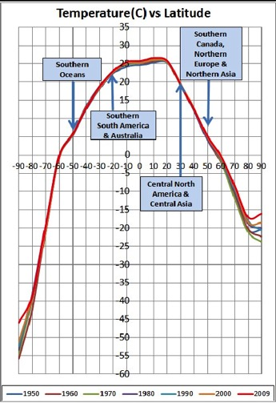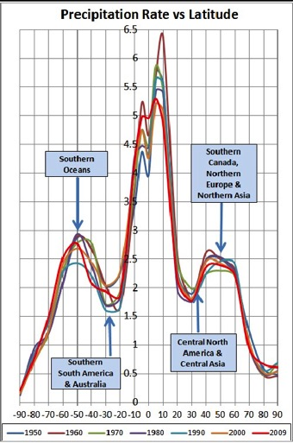

- ELEVATION
- ___________________ elevation ___________________ – ___________________ elevation ___________________
- _____________________________________ in temperature and precipitation

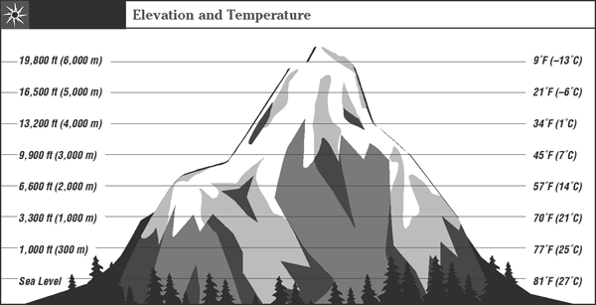
- TOPOGRAPHY
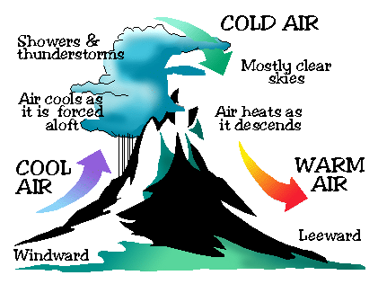
Elevation
- ________________________________ – air rises, ___________________ and drops moisture on _______________________ side – ___________________ on ___________________ side.
- ______________________________________ – ___________, ___________________ air that flows ___________________ leeward side of a mountain range

- COASTLINES
Coastal ___________________ near the ___________________ where prevailing winds are from the ocean:
- ___________________ in the ___________________ – water warms air
- ___________________ in the ___________________ – water cools air
- ___________________ precipitation all year – ___________________
- ___________________ in United States on ___________________ coast.

- CITIES
- _____________________________________ _: Pavement and buildings in cities ___________________ and ______________________________________ - causes ___________________ temperature.

- SEASONAL WINDS
- __________________________________ winds ___________________ in some parts of the world _____________________________________ _.
- Bring ___________________ climate differences.
- ________________________ to coastal sea and land breeze effect – only ___________________!

SEASONAL WINDS: MONSOONS
- ________________________ changes in the direction of the prevailing, or ________________________, winds
- ________________________ in heating and cooling of land and water
- Summer :
- ___________________ pressure over ___________________.
- ___________________ over ___________________ (water hasn’t warmed up yet)
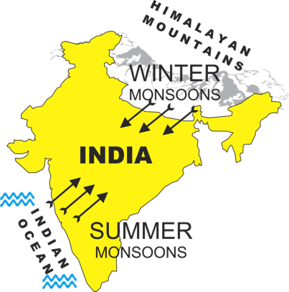
- ___________________ breeze
- ______________________________________ from ocean
- Winter:
- ___________________ pressure over ___________________
- ___________________ over ___________________ (water remains warm)
- ___________________ breeze
- ___________________ weather from land

- SEA SURFACE TEMPERATURES
- El Niño/La Niña - Southern __________________________________:
- Ocean heats ___________________.
- ___________________ water moves ___________________ and ___________________ from one side of ocean to other.
- Creates ___________________ in _______________________ due to ocean-atmosphere interactions.
- Other oceans also have oscillations: Arctic, Atlantic, etc.
- El Niño
- ______________________________________ Ocean near South America ___________________ up.
- __________________________ air ______________________________ and _____________________________ in USA.
- ___________________ winters in the _____________________________ USA.
- La Niña
- La Niña: ________________________________ Ocean ___________________ – Western Pacific near Asia warms.
- _______________________ _______________________________ and ________________________________ in USA.
- ______________________________________________ hurricane activity in the Atlantic.

