UNIT 7 NOTES: CROSS CUTTING RELATIONSHIPS
SES4. Students will understand how rock relationships and fossils are used to reconstruct the Earth’s past.
- Describe and apply principles of relative age (superposition, original horizontality, cross-cutting relations, and original lateral continuity) and describe how unconformities form.
- Interpret the geologic history of a succession of rocks and unconformities.

REVIEW
- Law of Superposition - a principle holding that in a vertical sequence of undeformed _________________________________ rocks, the ____________________________ of the rocks can be determined by their ____________________________________ - oldest at the bottom followed by successively younger layers.
- Principle of Original Horizontality - __________________ of sediment are originally _______________________________________ under the action of ___________________.
- Unconformities - ____________________ in a stratigraphic _________________________ resulting from a change.

UNIFORMITARIANISM
- The ________________________________________ that took place in the ___________ are generally ______________________ to those that occur __________.
- The ___________________________ is not really _____________________________ from most of the geological ___________________.
- The _____________________________ we see at work today are the _______________ as the ones in the ________________.
- Those _________________________ have ______________________ the ______________ we now see over a 4.5 billion year history.
- The _______________________ is the ______________ to the ________________.
- Laws of nature ____________________________________________________.
- Past events are explained and estimated by modern processes.

LAW OF LATERAL CONTINUITY
- When ___________________ of sediment are ______________________ they ____________________________________ in all directions.
- They will either ________________________ due to lack of material or hit a ____________________.
- When a _________________________________ through sedimentary layers, it can be assumed that the rocks on _______________________________ of the valley were __________________________________________.
LAW OF CROSS CUTTING RELATIONSHIPS
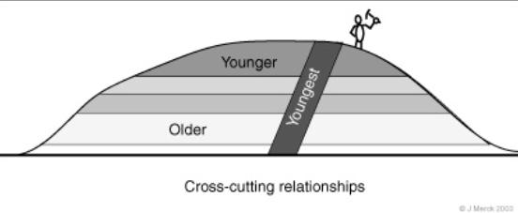
- Any feature that _________________________ a rock or layer of sediment is ______________________ than the rock or layer it cuts.
- ________________________________ - igneous rock that forms when __________________________________________ between existing rock and __________________________.
- _______________________________________________________ also follow the law of cross--cutting relationships.
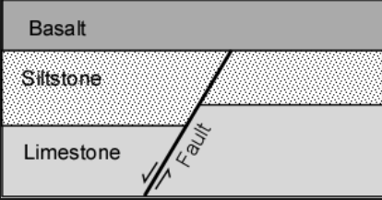
- The sedimentary rocks are _________________ than the fault which cuts them because they had to be there ______________ __________________________________________.

CONTACT METAMORPHISM
- When _____________________ rock comes in ____________________ with other rock, the heat can ________________ the rock.
- This is called ____________________________________ because hot magma changes when it contacts a small area of metamorphic rock where it touches.
- This is __________________________ on cross section diagrams with little “_________________________.”
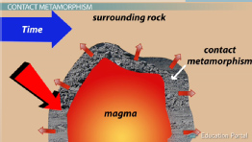
- It provides a clue – if there is contact metamorphism shown, the ___________________________________________ ___________________________ the rock it touches formed.

STRATIGRAPHY
Stratigraphy is the ________________________ of different _________________________________ through time and changing environments. The ____________________________ of both the rocks and fossils provides ___________________________ on changing environments through time.

