DIVERGENT PLATES AND TRANSFORM BOUNDARIES

DIVERGENT PLATE BOUNDARIES
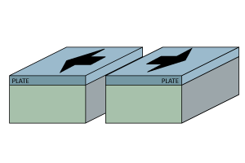
- Plate ____________________________.
- _______________________ stress
- _______________________ fault
- Landforms Created:
  - Rift Valleys
  - Fault-block Mountains
  - Mid-Ocean Ridges
- __________________________________ Force – creates new plates where magma rises.

PLATES BREAK APART
- Magma pools up under __________________.
- Heat trapped.
- Crust is _____________ and ___________________.
- Begins to pull apart.
- Fault develops as crust ____________________.
- Forms a _______________.
- Rifts make new ____________________ plate boundary.

BREAK UP OF PANGAEA
- Formed at end of Permian 225 million years ago.
- A ____________ split Pangaea from east to west during the Triassic era (200 million years ago).
- Created smaller continents Laurasia and Gondwanaland.

SUPERCONTINENT CYCLE
- Geologic cycle
- Continents merge and split __________________________.
- Continental collisions and break ups have occurred several times in Earth’s history.
  - Pangaea - 225 million years ago
  - Gondwanaland ~ 600 million years ago
  - Rodinia ~ 750 million to 1 billion years ago
  - Columbia (?) ~1.8 to 1.5 billion years ago
  - Kenorland (?) ~2.7 to ~2.1 billion years ago
  - Ur ~3 billion years ago

FUTURE EARTH
- Continents will _______________ and ______________________.
- New supercontinents will form
- Notice Great Rift Valley in Africa….

DIVERGENT PLATES CREATE NEW CRUST: MID OCEAN RIDGES
- ________________________ plates separate.
- __________ crust in center.
- Crust ________________ farther from center.
- Sediment builds up farther away from center.
- _____________________ builds up around fissure.
- Magma rises.
- Pushes __________ as it rises.
- Creates __________ sea floor.
- _______________ and moves outward from central ridge.
- Old crust collides with other plates and _______________________.

MINERALS AT RIDGES
- Ocean crust is generally ______________________ rock.
  - Heavy metals such as Iron and Manganese.
  - Manganese nodules found on the ocean floor.
- Sulfur and other minerals build up at the ridge.

LANDFORMS CREATED: RIFT VALLEYS
- ___________________________ plates separate.
- Forms ____________________________ on crust – valley.
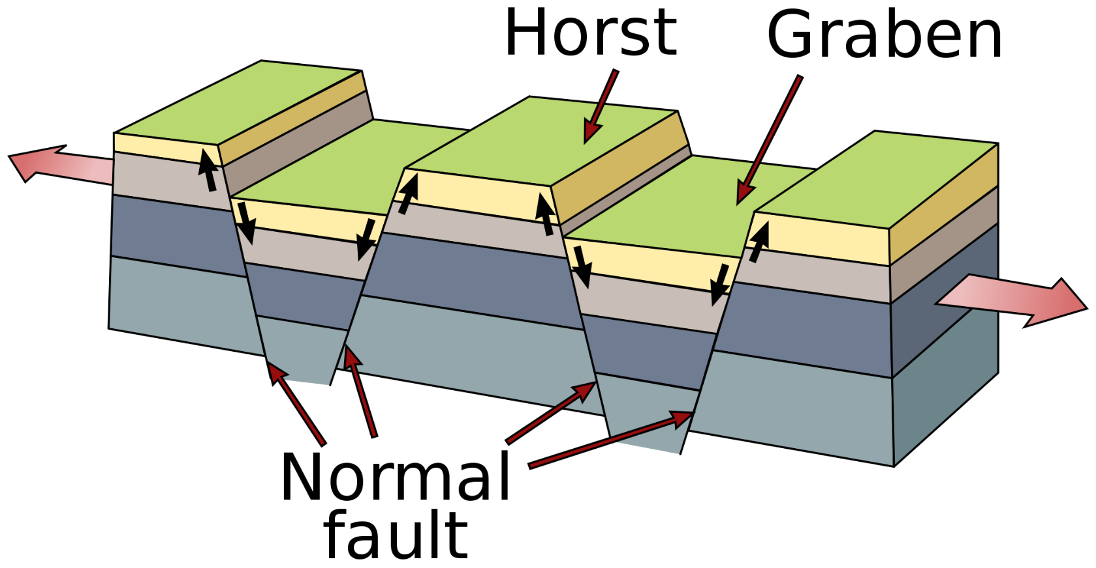
- Valleys created by ____________________________ rather than erosion.
- Can create lakes, seas, hotspots and volcanoes.
- Valleys also called grabens.
- Mountains: _______________________________
- Few continental Rift Valleys:
  - Great Rift Valley in Africa
  - Rhine Rift Valley in Germany
- Non-Example: Grand Canyon caused by river erosion - NOT a rift valley.

TRANSFORM BOUNDARIES
- Plates move ________________________ relative to each other.
- ___________________ force.
- _______________________ fault.
- Neither creates or destroys crust – _____________________.
- Landform Features
  - __________________ Geology
  - Landforms displaced laterally (_________________________________).
- Example: San Andreas Fault

