Earthquakes!
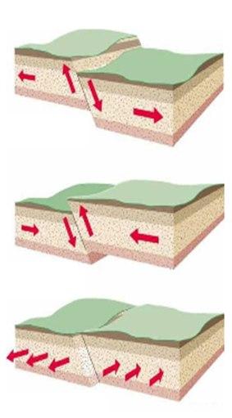
What causes Earthquakes?

Review: Faults
- They are ____________________ in rock.
- They cause ____________________ – forces that act on rock.
- Slow movement causes _________________________________ in Earth’s crust.
- Rocks along both sides of a fault are usually _________________________________together.
- ______________________________________ are common along faults.
- Three Types:
  - ______________________
  - ______________________
  - ______________________

Fault Zones
- These are ________________ of numerous, closely spaced faults.
- Some fault zones are ______________________ so there is less stress and they are less active
- There are ancient faults in Georgia - we average _________, magnitude 4+ quake every ________ years.

What are Earthquakes?
- _______________________ natural disaster
- Movement of the _____________________________
- Usually along a _____________________________
- Caused by a ________________________ release of energy
- Rocks under stress suddenly ______________________.
- ______________________________________ move in an earthquake along faults.
- ________________________________: an area along a fault where there has not been any earthquake activity for a long period of time.

Locked Rocks
- Rocks along fault are locked by __________________________.
- The lock prevents rocks from _________________________ each other.
- The stress in locked rock ______________________________.
- When stress goes past where rocks can maintain their integrity, they _________________________.
- ________________ increases, rocks along the fault ________________, trembling and vibrations result = ____________________________!
- When rocks slip into new positions, _________________ is released.

Elastic Rebound
- This is the _____________________________ of rock to undeformed shape.
- The rock under stress deforms and fractures.
- The pieces ________________________ at weakest point, then rebound.
- ______________________________ results in earthquake as rock fractures, then rebounds and springs back to __________________________ shape.

Earthquake Magnitude
- Measures the _____________________ of an earthquake.
- Related to __________________ released in the earthquake.
- ________________________ Scale:
  - Older system.
  - Used in 20th century.
  - Based on ground motion.
- ____________________________________________ Scale
  - New system
  - More ________________________
  - Based on:
    - size of the area of the fault that moves.
    - average distance that the fault block moves.
    - rigidity of the rocks in the fault zone.

Earthquake Intensity
- ___________________________: the amount of ____________________ caused by an earthquake.
- Depends on:
  - Magnitude
  - Distance from epicenter
  - Local geology
  - Infrastructure
  - Local geology
- _______________________ Scale:
- Measurement system
- Describes the ______________________ of the earthquake
- Expresses intensity in Roman numerals

