KINETICS: ENERGY IN CHEMICAL REACTIONS

- Remember that particles must ______________________ at a proper ____________________________ in order to react and particles must collide with sufficient _________________ in order to react.
- Energy is required to _________________ the bonds that hold the reactants together. The energy must be ________________ in the reacting particles ___________________ a collision.
- Most collisions are _____________________, but some collisions have enough energy to cause ____________________ in the electron cloud of the colliding molecules.
- Particles of matter have both ____________________ and __________________ energy.
  - Potential energy is __________________ energy. It is present in an atom that is ________ bonded.
  - Kinetic energy is the energy of ___________________. It is required to _______________ the bonds of a molecule. The _______________ a molecule/atom moves, the _______________ kinetic energy it has.
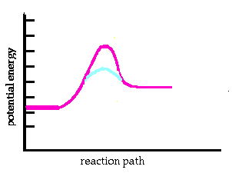
- ______________________________ – The energy required to form the activated complex is known as the activation energy. Particles must possess a certain minimum amount of energy in order to react. Even though bonding is more stable in the products than the reactants, energy is required to force the reactants up and over an energy barrier
- ___________________________ – The brief interval of bond disruption and bond formation once the reactants have enough activation energy and a place where the activated complex is formed.
- ________________________________ – The colliding molecules may form a short-lived structure. The activated complex exists along the reaction pathway at a point where the energy is the greatest - the transition state.
- _______________________________________ (ΔH or ΔE) is the energy difference between the reactants and products.
- _______________________________ reactions - the energy of the products is less than the energy of the reactants.
- __________________________ reactions - the energy of the products is more than the energy of the reactants
- _________________________ – a chemical compound that lowers the activation energy needed for the reaction by carrying the reaction along a different path.

POTENTIAL ENERGY DIAGRAM

Answer the questions by referring to the diagram of the potential energy of the reaction.

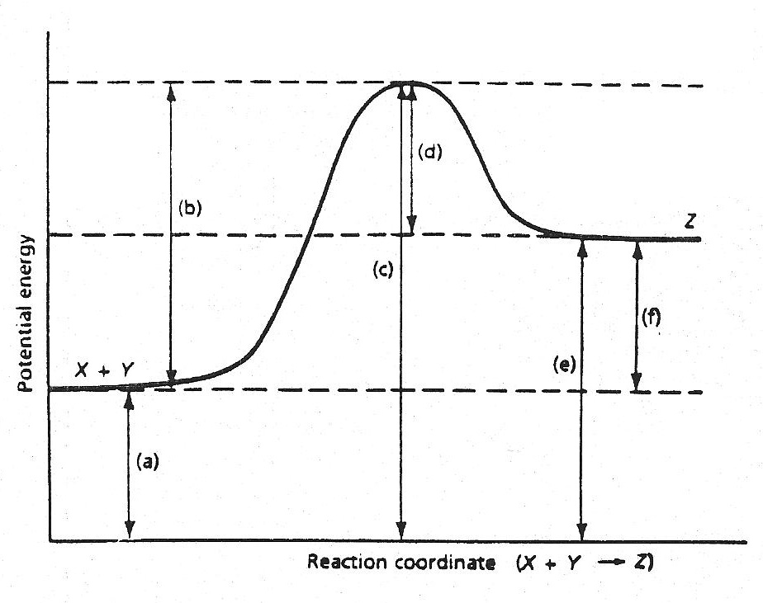

- Which of the letters (a – f) in the diagram represents the potential _________
energy of the products?
- Which letter indicates the potential energy of the activated complex? _________
- Which letter indicates the potential energy of the reactants? _________
- Which letter indicates the activation energy _________
- Which letter indicates the heat of the reaction? _________
- Is the reaction exothermic or endothermic? _________
- Which letter indicates the activation energy of the reverse reaction? _________
- Which letter indicates the heat of reaction for the reverse reaction? _________
- Is the reverse reaction endothermic or exothermic? _________
- a. If a catalyst were added, which letters, if any, would change? _________
- Would the activation energy increase, decrease, or remain unchanged? _________
c. Would the heat of reaction increase, decrease, or remain unchanged? _________

