EARTHQUAKE DEPTH

LOCATION TERMINOLOGY
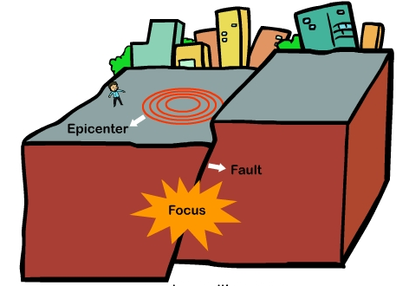
- Earthquakes occur _________ the Earth’s crust
- _______________________ location along a fault where the first motion occurs
- ______________________________ point on Earth’s surface directly above focus

EARTHQUAKE DEPTH
Earthquakes occur along three types of plate boundaries:
- Convergent, Divergent, and Transform

CONVERGENT
- Convergent boundaries occur where two plates _______________________________________ or converge.
- Associated with convergent boundaries are _____________________________ zones, where one plate dives (subducts) beneath another towards the deeper interior regions of the earth.
- ________________________________________ earthquakes are associated with this type of plate boundary.
DIVERGENT
- Divergent boundaries occur in areas where molten materials _____________ usually along extensive underwater mountain chains known as ridges and rises.
- The rising material results in the production of __________________________.
- _________________________________ earthquakes occur along these boundaries.
TRANSFORM
- Transform boundaries occur where plates _________________________________ one another.
- The classic example of this type of boundary is the __________________________ Fault, which marks the boundary between the southward moving North American Plate and the northward moving Pacific Plate.
- Transform boundaries are marked by mostly __________________________ earthquakes.

Earthquakes usually occur _______________________ the Earth’s surface.
- Shallow, Intermediate, Deep

SHALLOW EARTHQUAKES
- _____________________________ km of surface – more common.
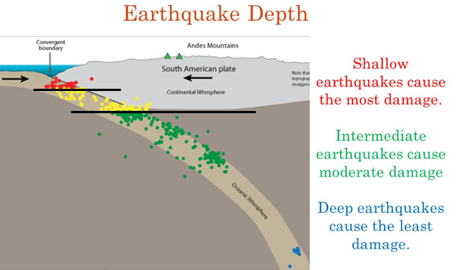
- ____________________ damage
- ________________________ to the surface.
- _____________ boundaries have shallow earthquakes.
- 1906 San Francisco earthquake was shallow.
INTERMEDIATE EARTHQUAKES
- ________________________________ km deep.
- Occur at __________________________________ boundaries.
DEEP EARTHQUAKES
- ___________________________ km
- Usually at subduction zones (_______________________________ boundaries).
- Deeper earthquakes ____________________________ energy before they reach the surface.

AMPLIFICATION
- As the earthquake travels through the lithosphere, the ______________ of material affects its intensity.
- Soft soils ______________________ ground shaking.
- Soft sandy soils can be _____________________ by strong ground motion.
- Damage usually is more severe on ______________________.

TSUNAMIS
- Formed following earthquakes in ___________________________ zones (deep).
- ________________________________________________________ formed after a volcanic eruption, submarine earthquake or landslide.

