UNIT 9 NOTES:
CLIMATE CHANGE AND EXTREME WEATHER

WEATHER REVIEW
- Molecules in the atmosphere are __________________________ by radiation from earth and _____________________ that heat.
- _____________________ heating and cooling of earth’s surface causes high and low __________________________________________
- Air flows from ____________ to _____________ pressure at surface.
- When air masses of different characteristics meet _______________________ form.
- __________________ air in low pressure _______________________ and forms __________________.
- Condensation _______________________________ in form of LATENT HEAT.
- ________________________ provides ___________________ for severe weather.

THUNDERSTORM FORMATION
- Formed by _______________________ of _____________ and __________________ air.
- Air condenses and clouds form.
- Latent heat is released.
- Thunderstorms need three conditions to form:
- ____________________
- ____________________ mechanism (rising air)
- ____________________

LIGHTNING AND THUNDER
- Electric current caused by ____________________ of _______________________ electric charges in __________________.
- A _____________________ charge also builds up on the ______________________ beneath the cloud.
- The charge coming up from these points eventually ______________________ with a charge reaching down from the clouds and - zap - lightning strikes!
- Lightning is about ___________________!
- When a lightning bolt travels from the cloud to the ground, it actually opens up a little hole in the air, called a _____________________.
- Once the light is gone, the air ___________________________ in and creates a _________________________ that we hear as ______________________.

TORNADOES
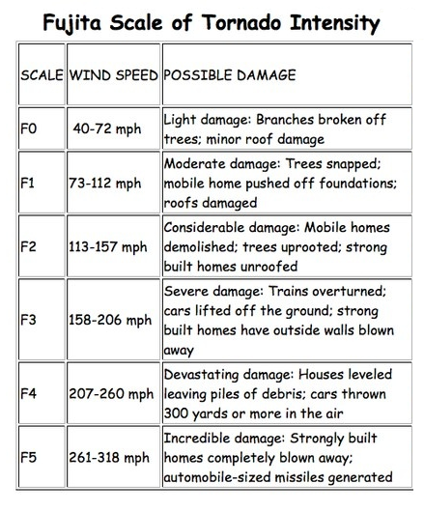
- A ____________________ is a violent _____________________ column of air extending from a thunderstorm to the ground.
- Air ____________________ because of wind shear.
- _______________ spin makes a funnel cloud.
- The funnel rotates and ______________________.
- More common in USA because _______________________ air from the Gulf of Mexico meets ______________________ air from Canada.
- Most tornadoes form in ______________________.
- __________________________ determined using _________________________ – based on damage.

WINTER STORMS
- _____________________ from the __________________ of two air masses of different temperatures and moisture levels.
- Form when an air mass of ________________________, Canadian air moves ______________ and interacts with a ___________________________ air mass moving _______________ from the Gulf of Mexico.
- ____________ pressure system – the __________________ the pressure, the ________________ the storm.

HURRICANES
- ____________ over really ___________________ ocean water- 80°F or warmer.
- __________________ from warm ocean waters, ______________ a center of ________ pressure.
- _______________________ from evaporation and condensation _________ storms.
  - __________________ temperatures, ___________ evaporation, ____________ energy!
- ___________ in ____________________ regions, north and south of the equator.
- _______________________ force creates the _____________ in the hurricane.
- Hurricanes rotate in a _________________________________________ direction (Northern hemisphere) around the _____________ pressure center called the ________________.

HURRICANE FORMATION AND MOVEMENT
- Move in generally predictable patterns.
- Generally form in the __________________________________ and move eastward.
- As they come close to __________, they tend to _________________________ the __________ and then are caught in the prevailing _______________________ winds.
- Many form from ________________ that blows westward from the ___________________ desert over the ____________________ ocean. Air rises over the ocean and a low pressure system forms.
- Hurricanes from in ____________________ and _______________________ oceans called _________________ and _________________________.

HURRICANE DAMAGE
- _________________ damage:
- Can destroy buildings and homes
- Debris (signs, roofing material, siding, etc.) become flying missiles in hurricanes.
- _________________ damage
- Torrential rains often in excess of six inches can produce deadly and destructive floods.
- _____________________________ damage:
- Accounts for ________ of all hurricane deaths
- Large dome of water often 50 to 100 miles wide that sweeps across the coastline near where a hurricane makes landfall.
- The ________________________ the hurricane and the ______________________ the offshore water, the ________________________ the surge is.

CLASSIFYING HURRICANES

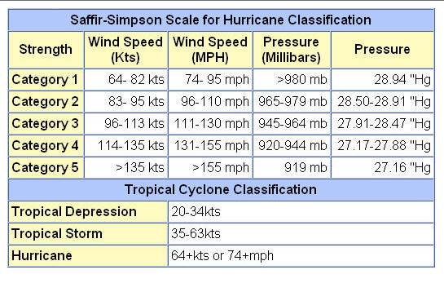

ENERGY IN THE ATMOSPHERE
- __________________ average surface temperature rose about _______ between 1906 and 2005 .
- Sources of heat:
  - _______________________________- anthropogenic or naturally occurring
  - __________________________ – increased evaporation/condensation due to increased temperature
- Increase in _____________________ provides ____________________________ for storms.

GLOBAL WARMING AND EXTREME WEATHER
- Global warming is making _______ days ______________, rainfall and flooding ______________, hurricanes ____________________, and droughts _____________________.
- This intensification of weather and climate extremes is a result of ____________________________ in the ___________________________________.
- It is also causing _____________________ changes to the landscape of our world, adding ______________ to wildlife species and their habitat.

GLOBAL WARMING AND WATER VAPOR
- _______________________ atmosphere holds ______________ water vapor.
- Water vapor is a powerful ___________________________ gas.
- More water vapor increases ____________________ and increases _______________________ (positive feedback loop).
- ________________ water vapor provides ________________ moisture for weather events
  - ________________________________ for rain and snow.
  - ______________________ number and intensity of ____________________________.
  - Precipitation shifts, _______________________________.

