FINDING THE EPICENTER

REVIEW
- ______________________________ is the measure of the strength of an earthquake.
  - Richter scale - old system based on ground motion.
  - Moment Magnitude scale - new system based on movement of fault block and rigidity of rocks.
- ______________________________ is the amount of damage caused by an earthquake.
  - Mercalli scale – uses Roman numerals to describe effects.

REVIEWING SEISMIC WAVES
- _________________ released (elastic potential) as fault blocks move.
- Energy moves in _______________________ called seismic waves.
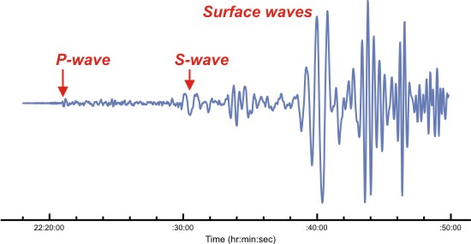
- ________________ waves:
- P waves
  - Arrive _____________; Compression waves
- S waves
  - Arrive __________________; Transverse waves
- ___________________________ waves:
- Most ___________________________ ; Rayleigh and Love waves

RECORDING EARTHQUAKES
- ________________________________ - Instrument that detects and records vibrations.
- Traces or records the vibrations.
- Can measure _______________________________ in rock movement around the faults.
- Fast moving ___________________ are first.
- Slower, secondary ____________________appear next.
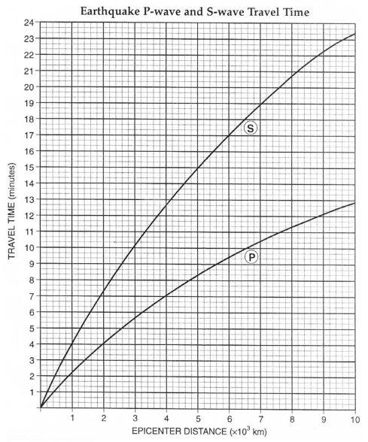
- Slowest-moving ____________________________ waves last.
- Seismic waves can be used to determine ___________________________ of epicenter.
- Longer time between P and S waves means the earthquake occurred _____________________________.
- With any one reading you can tell the ____________________________ to epicenter.

LAG-TIME GRAPH
  - A lag-time graph translates the ___________________ in arrival times of the P waves and S waves into distance from the epicenter to each _______________________.
  - You look up the _______________________________ for s and p waves on the y axis.
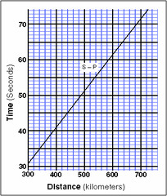
  - Then read across to where that time crosses the line.
  - Read the x axis to get the distance.

TRIANGULATING THE EPICENTER
  - Using the seismogram, calculate the distance from _____________________________ stations.
  - Once you know the distance for each station draw a ____________________ on a map that has a _________________________ equal to the distance from the epicenter.
  - The three circles will _________________________ in a point that locates the epicenter of the earthquake.
  - Just like your cell phone…
  - Triangulating the epicenter of an earthquake is just like triangulating the location of your cell phone.
  - It takes _____________________________ data points for GPS to work.
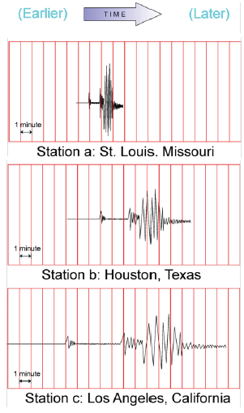
PRACTICE FINDING EPICENTER
What is the lag time for each city?
- St. Louis ____________________________________
- Houston ____________________________________
- Los Angeles _________________________________
What is the distance from each location to the epicenter?
- St. Louis ____________________________________
- Houston ____________________________________
- Los Angeles _________________________________
TRIANGULATING THE EPICENTER
- Draw ___________________ circles using a compass.
- The distance calculated is used to determine the radius of the circle.
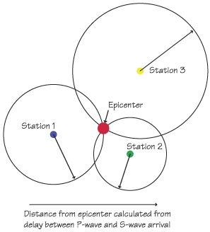
- Must have __________________ circles.
- Where they intersect is the ________________________.

