RIVERS AND FLOOD CONTROL

FLOODPLAINS
- Floodplains form alongside ___________________, meandering ___________________.
- A ___________________________ is a valley floor around rivers that floods.
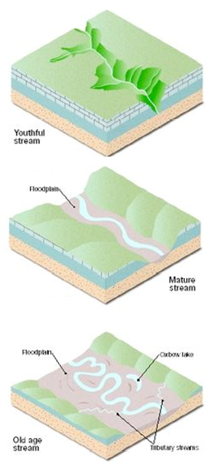
- Over time, a river changes its course.
  - ______________ changes the riverbed.
- Floodplains are formed by ________________ rivers.

LIVING ON A FLOODPLAIN
  - Advantages:
- ___________ farming
- ___________ soil
- convenient river ______________
  - Disadvantages:
- Easily _________________
- During times of ________________ precipitation, water _________________ the banks of the river, but remains confined to the floodplain.
- Area is likely to experience _________________________ flooding.

FLOOD DAMAGE
- The #1 ___________________________________ in the United States.
- Leading cause of weather-related __________________ in the United States.
- Approximately 200 deaths per year due to flooding.
- Over 50% of flood-related drownings are vehicle-related.
- 2003 to 2012, flood claims averaged nearly $4 billion per year

FLOOD CONTROL
- Direct Methods of Control:
  - _____________
  - Artificial ______________
  - Overflow ___________________
- Indirect Method of Control:
    - _______________ conservation
    - __________________ Conservation
    - __________________ Prevention
DAMS
- Holds ________________________________.
- _________________ releases the water for several days through a pipe in the dam.
- _________________ the amount of water that reaches the riverbed immediately after a rain.
Advantage of Dams
- ________________________ of water for public use.
- _________________________________ use – boating, fishing, parks.
- Stores water for ___________________________________ use.
- __________________ flooding downstream.
- Hydroelectric _________________ generation.
- ______________________ for nuclear power plants.

LEVEES
__________________________________
  - Sediment deposits along banks of a river.
  - Raised banks.
__________________________________
- Constructed for flood control.

WHEN THINGS GO WRONG:
Katrina - August 29, 2005
- Levees and flood walls failed or were breached in more than 50 locations.
- First time in history that an engineering failure has brought about the destruction or near-destruction of a major U.S. city.
- Katrina - August 29, 2005
- 80% of New Orleans was flooded to a depth of more than 3 meters (10 ft) in some neighborhoods.
- 1,118 dead people and 135 missing.

HOW PEOPLE USE RIVERS
- _______________ – electric and nuclear
- _________________________
- _______________________
- _______________ resource
- _______________ treatment
- __________________ and irrigation

