UNIT 10 NOTES:
ENERGY RESOURCES: FOSSIL FUELS

NEED FOR ENERGY
What we use energy for:
- ______________________________ 40% - consumes primary energy to generate most of the electricity consumed by the other four sectors.
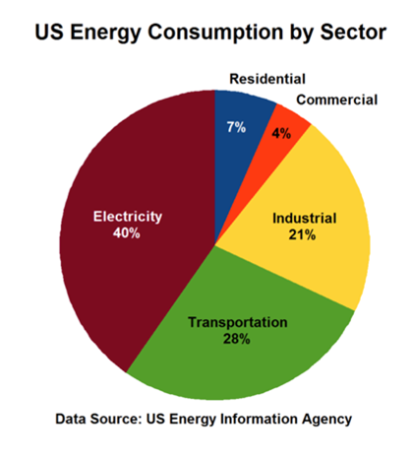
- ______________________________ 28% - includes vehicles that transport people or goods, such as cars, trucks, buses, motorcycles, trains, aircraft, boats, barges, and ships.
- ______________________________ 21% - includes facilities and equipment used for manufacturing, agriculture, mining, and construction.
- ______________________________ 7% - consists of homes and apartments.
- ______________________________ 4% - includes offices, malls, stores, schools, hospitals, hotels, warehouses, restaurants, and places of worship and public assembly.

TYPES OF ENERGY RESOURCES
Fossil Fuels
- ___________________ resources
- _____________________________________
- Cannot be replaced quickly.
- Being ________________________________ than they are forming!
Alternative
- _____________________ – energy released during nuclear fission – _______________________
- ___________________________: Can be replaced within a human life span OR as they are used. Includes:
- Geothermal, Solar, Water, Biomass, Wind

WHERE DOES OUR ENERGY COME FROM?
Fossil Fuels
- _____________________________________________ resources formed from the remains of ____________________ things (__________________________).
- Consist of _________________________ – carbon and hydrogen compounds.
- __________________ energy – _________________ breaks chemical bonds and releases energy.
- NOT from remains of dinosaurs – what we use today formed ______________________ of years before dinosaurs.
COAL FORMATION
- Coal is a _____________ fossil fuel that is formed in several stages as the buried remains of ________________________ that lived __________________ million years ago
- Formed in process of ____________________________________ – plant _________________________ in swamps or mud, becomes peat.
- Chemical reactions under right conditions – carbon becomes ________________.
- Process: ________________ – ____________ – __________________________ – ________________________________ coal (soft coal) – _______________________________.
- Highest ______________________ coal is Anthracite – metamorphic rock.

COAL GENERATES ELECTRICITY
- Burning ________________________ coal released __________ (carbon dioxide) into air.
- Coal _____________________ estimated to last _________ years.

COAL RANK
- _______________________
  - Soft, brown, carbon content more than 55%; 7000 BTU/lb; 9-17 million BTU/ton
- _________________________________
  - Dull, black carbon content 55 – 60%; 9300 BTU/lb; 16-24 million BTU/ton
  - ____________________________
  - Soft, dark, dense; carbon content 60-50%; 11-14,000 BTU/lb; 19- 32 million BTU/ton
- ____________________________
  - Shiny, hard – Metamorphic; carbon content more than 85%; 14,000 BTU/lb; 20-28 million BTU/ton; Difficult to ignite; Burns cleanly - smokeless

PETROLEUM (OIL) AND NATURAL GAS
- ______________________________ is another word for crude oil.
- Crude ______ used to produce _____________________________________________, etc.
- Formed from remains of _____________________ organisms and plants.
- ___________________________ on lake and ocean floor and _________________ by sediment.
- Heat and pressure cause _____________________________________.
- _______________________________ concerns include oil spills.
- Oil ___________________________ than other fossil fuels – less CO₂, SO₂ and NO_{x} emissions.
- Natural gas consists mostly of ____________________, along with some other gases which has ___________________________________.
- Natural gas does not contain carbon monoxide. The by-products of burning natural gas are primarily carbon dioxide and water vapor.

LOCATING GAS AND OIL
- _________________ conditions must be present for reservoirs to form:
- Hydrocarbon material ___________________________________________ for heat and pressure to have transformed it over a _______________________________ of time.
- _____________________________________ reservoir ______________ to accumulate in.
- ___________________________________________ cap rock that ___________ the deposit.

FOSSIL FUEL RESERVES
- Because the United States has so much in __________ reserves, it is _______________________ and widely used!
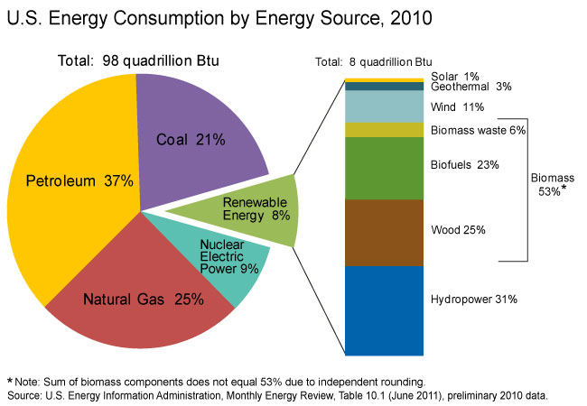
ENERGY USE IN THE UNITED STATES
U. S. Energy Consumption
- _________________________ 37%
- _________________________ 25%
- ________________ 21%
- _____________________ 9%
- _________________________ 8%
- Hydropower, wood, biofuels, biomass waste, wind, geothermal, solar

CONCERNS OVER USING FOSSIL FUELS
_______________________ and __________________________
- Land disruption from mining
- Oil Spills contaminate waterways
- Groundwater contamination
__________________________
- Coal ash contaminates land and surface water.
- Air pollution - CO₂, VOCs, SO₂ and NO_{x} – from emissions
- Greenhouse gases

