UNIT 6 NOTES:
PRINCIPLE OF FOSSIL SUCCESSION

FOSSIL RECORD SHOWS US….
- Fossil species ________________ and ____________________________ throughout time.
- ________________ fossils/rocks on __________________ – youngest on top (Law of ______________________________).
- The Geologic Time Scale is based on ________________________________ and _______________________________ of fossils.
- Geologic ___________ and __________________________________ by appearance and extinction of species.
- ____________________________ events are ___________________________ by appearances of ______________________________.
- Sequence of fossils help provide ______________ to _____________________________ and dating of rocks.
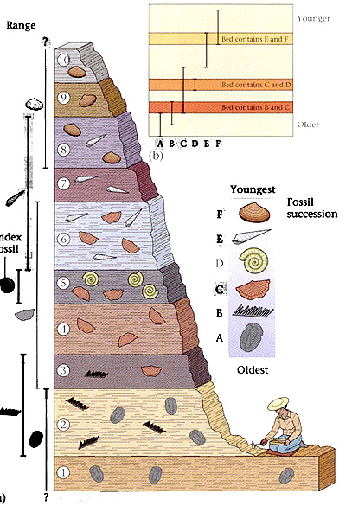

PRINCIPLE OF FOSSIL SUCCESSION
- _________________________________ of fossil organisms appear in a ______________________ __________________________.
- Oldest organisms are at the bottom – _______________ at the ______________.
- Once a fossil species _____________________________ in a sequence of strata, it ______________________________ higher in the sequence.

FOUNDATION FOR PRINCIPLE OF SUCCESSION
- Fossils represent the remains of ___________________ ______________________ organisms.
- ______________ fossils are the remains of ____________________________ organisms; they belong to species that are no longer living anywhere on Earth.
- The kinds of fossils found in rocks of different ages ______________________ because life on Earth has ________________________________________.

FOSSIL RECORD SHOWS CHANGE OVER TIME
- Animals and plants found as fossils _________________________________________________.
- Changes in Earth’s ________________________________ over time results in changes in ______________________________.
- _______________________________________ gives organisms best adapted to the environment an ______________________________.

