UNIT 7 NOTES: GEOLOGIC MAPS
SES4d: Explain how sedimentary rock units are correlated within and across regions by a variety of methods (e.g., geologic map relationships, etc.).
WHAT ARE GEOLOGIC MAPS?
Geologic maps:
- Provide ________________________________ about the _________________ that are ____________________ the earth’s _____________________________.
- Help to ___________________________ the series of ___________________________.
- Used to _______________________________ and __________________________ ____________________________ _______________________________.
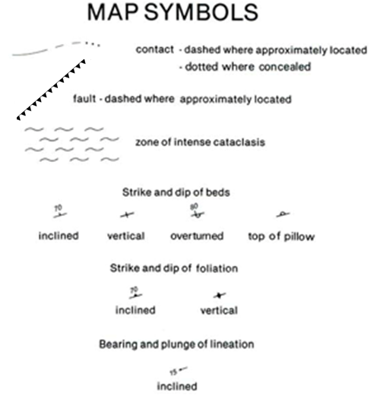
WHAT THE COLORS MEAN
- Colors often show ______________________ and ______________________________.

MAP SYMBOLS
- Symbols often show ______________________ __________________________.

STRIKE AND SLIP
- Strike and slip symbols show the ___________________________________ and ____________________________.
- The ____________________, the long line, shows the ________________________ the ____________________________.
- The __________, designated by the short line and number, indicates the ______________________________________ that the _____________ are __________ (90 degrees would mean that the rocks are completely vertical).
- Another way of remembering strike and slip is to think of the roof of a house.
- “________________” is the _____________________________________ of the house points, while “________” measures the _______________________________.

GEOLOGIC STRUCTURES:
- Syncline: a _______________ of rock layers that ____________________________ on both sides of a common low point; if it is circular,
- It is called a _________________.
- __________________ rock is in the _____________________.
- Anticline: a formation of stratified rock ______________________, by folding into a _________________________ so the layers ____________________________ on both sides of a common crest;
- If it is circular, it forms a ____________.
- _________________ rock in the __________________________.

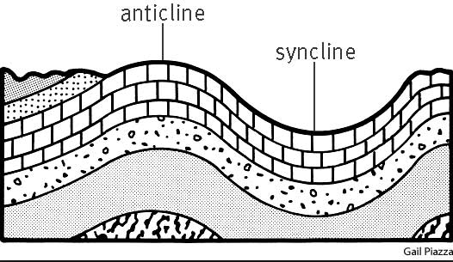

GEORGIA – SIMPLIFIED

