UNIT 6 NOTES:
GEOLOGIC TIME

FOSSILS ARE CLUES TO THE PAST
- Fossils provide the _____________________________________ to interpret past environments.
- ____________ and _________________________________ of fossils are _____________ indicators of an area’s ancient conditions and climate.

ABSOLUTE AGE: RADIOMETRIC DATING
- Radioactive Decay of isotopes.
- _____________________ age tells how __________ something is (ex: 300 million years old).
- Dating of sedimentary rocks provides information about age of fossils.
- Radioactive substances are useful for measuring age because radioactive substances undergo decay at a predictable rate.
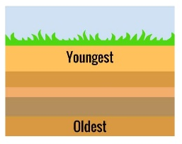
RELATIVE AGE: LAW OF SUPERPOSITION
- In an undisturbed rock column, the ____________ rocks will be on the ___________________ and the _____________________ ones on ____________.
- Oldest fossils are on the bottom; newest fossils are on the top.
- Relative age is a _______________________________ (ex: one fossil is older than another).

USING FOSSIL CLUES
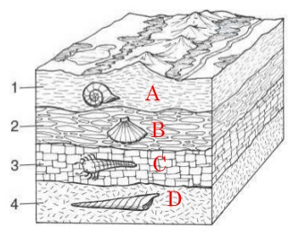
- Absolute and relative age of fossils help us construct history of Life on Earth.
- Certain fossils ____________ appear in rocks of specific ages.
- Fossils provide important ______________________________ information by revealing both the absolute and relative ages of rocks.
- Fossil record shows _______________________________ in organisms and their environments.
  - Principal of Fossil Succession - more later.

GEOLOGIC TIME
- Earth history is ____________________ into major divisions based on the __________________ ____________________.
- Rocks grouped within each time period contain __________________________ fossils.
- Beginnings and ends of Geologic eras are defined by __________________________________ in life forms based on fossil evidence.
GEOLOGIC TIME DIVISIONS
EONS:
- _________________________
  - Earth’s formation (4.5 bya) to 500 mya
  - All fossils are simple life forms.
- _________________________
  - 500 mya to today
  - _____________ of Geologic Time
  - Fossil record shows increasingly complex life forms.
ERAS:
- In Precambria:
  - _____________________________
- In Phanerozoic:
  - _____________________________
  - _____________________________
  - _____________________________
- Eras divided into _____________________.
- Periods in Cenozoic Era divided into _________________________.

PRECAMBRIAN ERA
_______________ Divisions
- _________________________ Period
  - 4.5 to 3.8 Billion Years Ago
  - Earth cooling
  - Heavy bombardment
- _________________________ Period
  - 3.8 to 2.5 Billion Years Ago
  - Continent building
  - Early life – single cell prokaryotes.
- _________________________ Period
  - 2.5 Billion To 543 Million Years Ago
  - Eukaryotic life appears.
  - Multi-cellular life.

PALEOZOIC ERA: LIFE FLOURISHES
- 8 Periods named for the location in which the fossils were first discovered
- _____________________________
- _____________________________ Period: Cambrian Explosion - most life in ocean.
- First Mass Extinction in ______________________________________ Period
- First Forests
- Second Mass Extinction in ____________________________________ Period.
- Pangaea and Appalachian Mountains formed during _______________________ Period (end of Paleozoic Era).
- Third Mass Extinction at end of Permian Period – _______________________________ – biggest mass extinction event.

MESOZOIC ERA: AGE OF REPTILES
- ___________________________ begins to break up.
- Divided into three periods.
- Early mammals but NO humans!
- Dinosaurs dominant life form during ____________________________.
- Different dinosaurs during different periods.
- First flowers in Cretaceous.
- Mass Extinction Events at end of ______________________ and _______________________. Dinosaurs die out at the end of the Cretaceous Period.

CENOZOIC ERA: AGE OF MAMMALS
- Most known about this Era.
- First primates.
- Himalayan Mountains 15MYA.
- First Humans – __________________________ Epoch.
- Human History – __________________________ Epoch.
- More divisions because more is known.

