UNIT 8 NOTES: GLOBAL CIRCULATION

SOURCE OF ENERGY: SUN
Uneven heating caused by:
- _____________________________ – sunlight spread out over larger area away from equator.
  - _____________________ has greatest effect on the angle at which the sun's rays hit Earth.
- _____________________________ causes seasonal variations in incoming solar radiation (insolation).
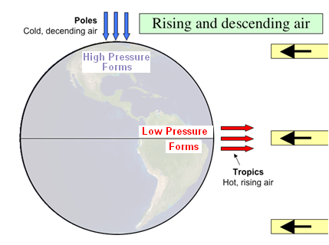
HOT AIR RISES AT THE EQUATOR
Air at the equator is heated:
- _____________________________
- _________________
- _________________ surface pressure
Air at the poles is cooler:
- Becomes ____________________________
- ________________
- ___________________ surface pressure

ATTEMPT AT EQUILIBRIUM
- Air moves from _________ to __________ pressure.
  - Surface winds _____________________ areas of low pressure (poles to equator).
  - At the _______ of the troposphere this _______________________________ from _____________________ towards the _______________.
- CONVECTION current results:
  - _____________________ near the _________________________________ .
  - It __________ as it __________.
  - It eventually ______________________ back toward Earth __________________________.

CIRCULATION BELTS
It isn’t QUITE that simple!
- Because of the size of the Earth, there are _______________ separate _______________________ ____________.
- Spaced out at about ____________________ intervals.
- Creates regions of ___________ and _______________________________.
- __________ the northern and southern ______________________________.
- Warm air __________, _____________, and ______________, in belts.
- The belts are at 30 degree intervals ___________________________ north and south from the _____________________________________________.

CORIOLIS EFFECT
- As Earth rotates, winds are ____________________________________________.
- Circulating air is deflected:
  - To the ________ in the __________________________ Hemisphere.
  - To the ____________ in the __________________________ Hemisphere.
- Similar to what is experienced when throwing a ball on a Merry-go-Round.
- Because of the Coriolis Effect, an object that _____________________________ from the equator will ________________________________.
- In general, the Coriolis Effect is noticeable only on objects that move ________________________ or ________________________________________.

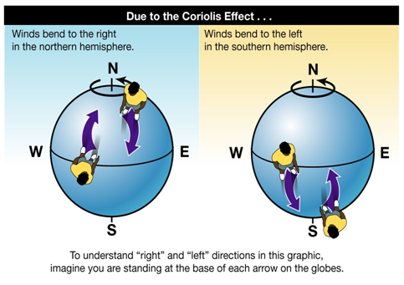

WIND BELTS
- Circulation belts are deflected.
- Equator (air rises):
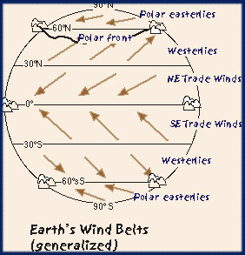
  - Winds from the __________ to the __________.
  - NE or SE ___________________________
- Mid Latitudes:
  - Air sinks at 30 degrees.
  - Rises at 60 degrees.
  - Winds from the __________ to the __________.
  - _______________________
- Northern Latitudes:
  - Air rises at 60 degrees.
  - Air sinks at poles.
  - Winds from _____________________________
  - __________________________________
- Prevailing ______________ that blow throughout the contiguous ______________________________ are called _____________________________.
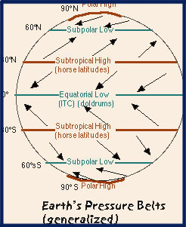

PRESSURE BELTS
- _____________________________ between the belts.
  - Air is ________________________________________ – ________ moving along ___________________________.
  - At the equator, these calm areas are referred to the _________________________.
  - Between the Trade Winds and Westerlies are called the ______________________________.

ATMOSPHERE AND OCEAN: FLUIDS RESPOND THE SAME CURRENTS AND CORIOLIS
- Ocean water also moves from ________________________________ to ___________________________ regions
- ____________________________ deflect currents.
- Also deflected due to ________________________.
- Currents in ________________________ Hemisphere flow ___________________________.
- Currents in _______________________ Hemisphere flow ________________________________.
- ____________ water carried from ____________________________________.
  - Typically __________ Coast
- ____________ water carried from ____________________________________.
  - Typically __________ Coast

OCEAN CURRENTS
- ______________________________ in ________________________________ Earth’s ___________________ by _____________________ and __________________________________.
- ______________________________ water movements.
- Currents controlled by:
  - ________________________________ – prevailing winds (Trades, Westeries, etc.)
  - ________________________________ – Coriolis creates gyres (circle motion)
  - _____________________________________________ - land masses act as barriers

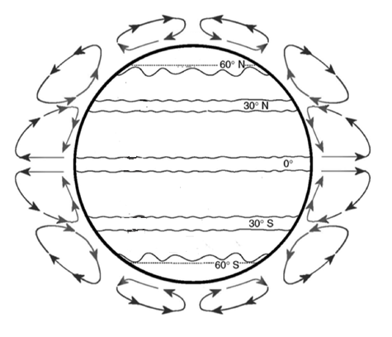

Place the letter for each on the Earth above in their correct location.
- Doldrums
- Equator
- Southern Horse Latitudes
- Northern Horse Latitudes
- Northern Polar Easterlies
- Southern Polar Easterlies
- Northeast Trade Winds
- Southeast Trade Winds
- Northern Westerlies
- Southern Westerlies

