UNIT 6 NOTES:
INDEX FOSSILS AND GEOLOGIC TIME

SPECIAL FOSSILS
- Every fossil tells us something about the____________________________________________ it's found in.
- Some fossils that tell us more because they are found exclusively in rock layers of a _________________________ geologic age.
- Called _____________________________________.

CHARACTERISTICS OF INDEX FOSSILS
- __________________________ - distributed over a wide area.
- __________________________ - large numbers within a rock layer.
- __________________________ - easy to recognize.
- __________________________ – from a short, specific geologic time span.

MORE ON INDEX FOSSILS
- Index fossils are used to establish the relative and absolute __________________________ __________________________ in which the fossils are found
- Finding a specific index fossil, you know the absolute age of the rock.
- Based on its position, you know the relative age of the rock.
- Used to date rock layers found in _______________________________________areas – can help determine age of sedimentary rock.
- In order for an organism to be used as an index fossil, the organism must have been ____________________________________________________ and must have existed for a geologically _________________________ and deposited over _________________________ !

INDEX FOSSILS: TRILOBITE
- Paleozoic Era – __________________________ to __________________________ Extinction
- Most ________________________ group of ______________________ animals preserved in the fossil record.
- Fairly large and hard-bodied.
- More than 20,000 Individual species appeared and went extinct at the end of the Paleozoic era - allows for more precise geologic dating.
- Paleozoic: Different species, different periods

INDEX FOSSILS: AMMONITES
- Appeared late __________________________ – Common during __________________________ period.
- Extinction with dinosaurs at end of __________________________.
- Predatory, squid-like creatures that lived inside coil-shaped shells.
- Sharp, beaklike jaws inside a ring of tentacles that extended from their shells to snare prey,
- Range of sizes - Some more than three feet across in size.
- Suture patterns more complex over time – used for dating as index fossil

OTHER INDEX FOSSILS
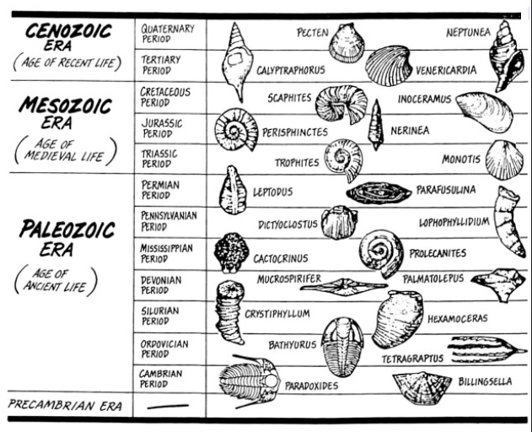
541mya – 4.6bya

252mya – 541mya

66mya – 252mya

Present – 66mya

