UNIT 8 NOTES: AIR PRESSURE AND WINDS

WIND: AIR MOVEMENT DUE TO PRESSURE DIFFERENCES
- Air moves from ___________ to __________ pressure
- Atmosphere is attempting to balance – _______________________
- __________ Pressure – down, out, clockwise
- __________ Pressure – in, up, counterclockwise

MEASURING AIR PRESSURE
- ______________________ measures changes.
- Reported in ________________________.
- Average pressure at _____________________ is _____________ millibars.
- Old system: Sea level pressure is 29.92 inches.
MAPPING AIR PRESSURE
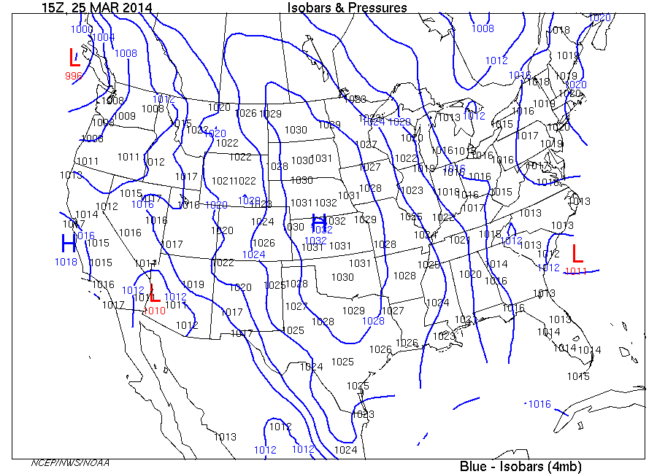
- _____________________________are lines of constant pressure.
- A line drawn on a weather map connecting points of _____________________________ is called an isobar.
- The isobars are generated from mean sea level pressure reports and the pressure values are given in millibars.
- Every place on one of those lines has the ________________ air pressure.

PRESSURE CHANGES CAUSE WIND
- Air moves _________________________ and __________________________ high pressure.
- Air moves ___________________________________ and ____________ low pressure.
- Movement of air is _____________.

PRESSURE GRADIENTS
- ______________________________________ is the _____________________ in pressure over ____________________.
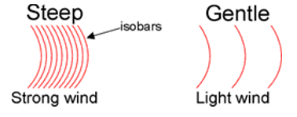
- ________________ change:
  - _______________ difference in pressure, _______________ distance, _______________ isobars, _______________ wind speed

- _______________ change:
  - _______________ difference in pressure
  - _______________ distance, _______________ isobars, _______________ wind speed

WINDS AND ISOBARS
- ____________________________________________ – steep change, fast winds.
- ____________________________________________ – low change, low winds.
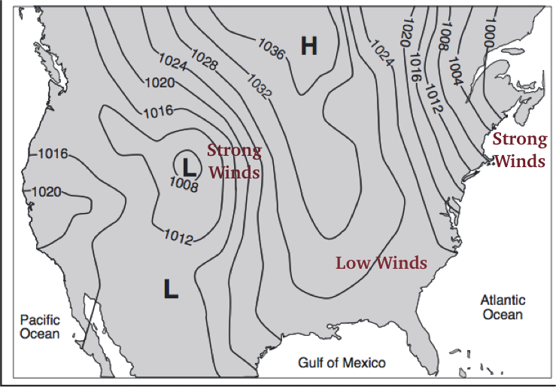

USING WIND TO PREDICT WEATHER
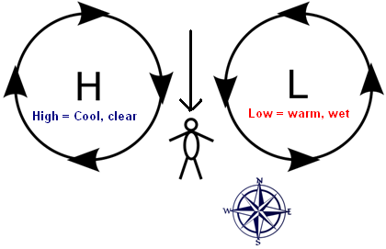
- Stand ____________________ wind.
- _________________________ area will be on your ______________.
  - _______________________________________ to your right.
  - If facing _____________, low has _________________ and cool, dry weather coming.
  - If facing _____________, Low is _______________________________.
- ________________________________ area will be on your __________.
  - ____________________________ to the left.
  - If __________ is the left, High has _______________ and warm, wet weather coming.
  - If facing __________________, High is _______________________________.
- Because:
  - Counterclockwise wind around low pressure and clockwise around highs.
  - Global Wind Belts – _________________________________________________________ – air masses come from the _________________.
  - Only works in the Northern Hemisphere – mid latitudes

