UNIT 6 NOTES:
MASS EXTINCTION EVENTS

WHAT IS A MASS EXTINCTION EVENT (MME)?
- A __________________________ for the world's living organisms.
- A __________________________ (shorter than 10,000 to 100,000 years).
- A __________________________ of all life on Earth became ____________________.
- Life forms must represent ________________________, lived in ___________________________, spread over _______________________.

CAMBRIAN EXPLOSION
- ____________________________ Era:
- Mostly bacteria, plankton, and multi-celled algae.
- Beginning about 600 million years ago in the Precambrian, the fossil record provides evidence of ________________________________.
- ________________________ period:
- Between about 570 and 530 million years ago – ________________________________ appears.
- Burgess Shale in British Columbia provides abundant evidence.
- ______________________ in atmospheric __________________ believed to have been a factor.

POSSIBLE CAUSES OF MASS EXTINCTION EVENT (MEE)
- ________________________ Impact
- ________________________
- Climate Change
- Changes in Atmosphere
- Variations in Solar output
- Changes in _________________________
- Changes in Orbit
- Changes in Magnetic Field
- Changes in solar orbit on galactic plane
- Nearby Gamma Ray bursts
- Most probably __________________________ of events….

________________ MASS EXTINCTION EVENT
- End of the Ordovician, beginning of Silurian period.
- 440 million years ago
- ____________ of all species exterminated.
- Two peak dying times separated by hundreds of thousands of years.
- Thought to have been caused by extreme ________________________________________ due to glacial formation and then rise due to melt.

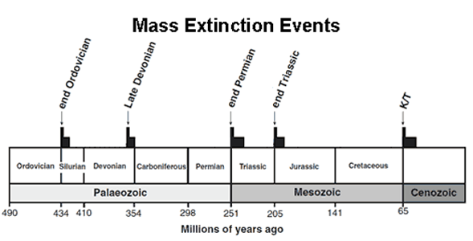

_____________________ MASS EXTINCTION EVENT
- Late Devonian period
- 365-375 million years ago.
- _____________ of all species disappeared.
- May have been a ___________________________________ over several million years, rather than a single event.
- ______________________ and ________________________ most affected.
- Possible causes include:
  - Siljan Crater - Sweden
  - Climatic and sea level changes.
  - Changes in available oxygen in the water.

__________________ MASS EXTINCTION EVENT
- _____________________________ of mass extinctions.
- ‘The Great Dying’
- End of Permian Period, Paleozoic Era.
- 250 million years ago.
- Approximately _________ species go extinct.
- Possible causes include:
  - Impact event, possibly Bedout Crater off Australia.
  - Massive volcanic activity and depletion of ocean oxygen.
  - ______________________ of super continent, __________________, caused a major disruption to the climate and habitats.

_______________________ MASS EXTINCTION EVENT
- End of the Triassic period.
- 199-214 million years ago.
- Several phases.
- ______________ of all marine species vanished; not sure about land species.
- Possible causes include:
  - Climate change
  - Volcanic Eruptions
  - Asteroid impact
_________________ MASS EXTINCTION EVENT
- Cretaceous-Tertiary mass extinction (________________________________).
- End of Mesozoic Era.
- 65 million years ago.
- ___________ species disappeared.
- ______________________ worse hit
- ________________________________________
- Possible cause – _________________________________ - Chixculub Crater, off the Yucatan Peninsula

EVIDENCE FOR K-T EXTINCTION
- _____________________ Theory:
- Rock layers dating to about 65 million years old with iridium (consistent with asteroid composition), tsunami sediments, shocked quartz, carbon soots and extra terrestrial amino acids from over 200 extinction layer sites around the world.

- _____________________ Theory:
- End of the Cretaceous was one of the most intense periods of volcanic activity in Earth's history - sulfur dioxide and carbon dioxide pumped into the air could cause catastrophic climate changes, including 'nuclear' winters, seasonal changes and global warming

AFTER A MASS EXTINCTION
- ___________________________ take over vacant habitats and resources.
- ___________________________ develop.

__________________ MASS EXTINCTION EVENT
- Holocene Extinction – _______________ caused.
- _____________________ began when the first modern _______________ began to ______________ to different parts of the world about 100,000 years ago.
- _____________________________________________________ of human migration.
- _____________________ began about 10,000 years ago when humans turned to __________________________:
  - transformation of the landscape
  - overexploitation of species
  - Pollution
  - Introduction of alien (invasive) species
  - Population increased from 1 to 10 million people on earth 10,000 years ago - now over 6 billion people (8 million by decade end).
- Current species loss of between ______________________________ species ________________.
- Estimated that half of all plants, animals and birds on the planet will ________________________ _________________

