MASS WASTING

What is Mass wasting?
- ____________________________________ is the movement of large amounts of material downhill under _____________________.
- Follows _______________ weathering.
- May be fast or slow.
- Can occur on ___________ slopes or _______________________ dipping slopes.

CAUSES
- _________________________ - The principle force tending to pull materials downslope.
2. _________________________ - resists the downslope movement of material.
3. _________________________ - the steeper the slope, the more likely that the materials will move downslope – MOST important factor (no slope = no movement).

FACTORS
- Composition of Materials
- _________________: Bedrock is generally stable = prohibits mass movements.
  - Tectonic deformation & weathering produce fractures and joints = unstable.
- ______________________________________________: cracks?
- _____________________________________: sedimentary layers and metamorphic foliation planes - those parallel to slope tend to slip easier (less stable) than those that are at right angles to the slope (more stable).
- Angle of Repose
- The ____________________________________ is the steepest angle at which a pile of unconsolidated grains remains stable.
- It is controlled by the _______________________________________________________ between the grains.
- Increases with increasing grain size:
- The ____________________ the grain size, the ______________________ the angle material will be stable.
- The ____________________ the grain size, the ______________________ the angle material will be stable.
- Angle of repose for different materials – see backside
- Water
- Can cause previously stable slopes to slide.
      - __________________ amounts can increase.
      - _________________________ = _________________________ surface tension.
- ________________________ water leads to slope ___________________________.
      - Friction and cohesion is __________________ (lubricates the slope, promotes slippage).
- When pore spaces in sedimentary rock _________ with water, the __________________ of the material increases and material becomes _______________________.

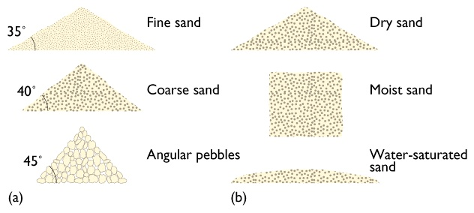

- Rock Orientation
- Slope of rock in relation to:
    - ________________ of land
    - ________________ zones
- ___________________________ rock ________ stable than ___________________ rock.
- Weak zones ________________________________ to rock slope more _______________ than ___________________ weak zones.
- Vegetation
- _____________________________, especially those with deep root networks, helps __________________ material on a slope.
- _________________________ along road cuts increases stability.
- Vegetation ______________________ by forest fires, clear cuts, people, etc. _______________________ stability.

TYPES OF MASS WASTING
Classified based on ________________ and ______________________________________ downslope.
Three Groups:
- ______________: Rockfall
- ______________: Creep and Solifluction
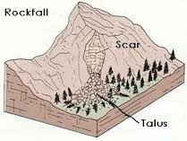
- ______________: Slump and Mudslides
ROCK FALL
- _______________________________is when a piece of rock on a steep slope becomes dislodged and falls down the slope.
- ____________________ type.
- Rock or sediment breaks free and ____________________________________ or near vertically.
- Any size of material.
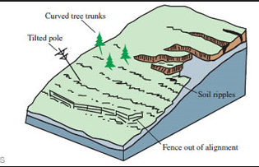
- Builds __________________ slopes.
CREEP
- ______________________ is the slowest type of flow (cm or mm per year) and is __________________________ to observe.
- Dry
- Occurs ________________________, even on gentle slopes.
- Affects only the _____________________ meters; top moves ______________________ than bottom (due to friction).
- Objects in the soil start to _________________________ – a way to positive identify creep.
SOLIFLUCTION
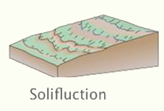
- ________________________________ is soil flow – cold wet, slow.
- Unconsolidated material.
- Occurs in ______________________ environments where surface is ___________________ to hundreds of meters.
- In summer, warm sun ______________ top meter or so of frozen ground.
- Water cannot _________________________ downward (because of permafrost), so soil gets ____________________________ and flows downslope.
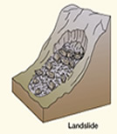
MUD or LAND SLIDE
- A _____________________ or ____________________________ is the sliding down of a mass of earth or rock from a mountain or cliff.
- A ______________ type of slide.
- ____________ – often water saturated.
- Material may be ___________, ____________, or a _________________________________ of the two.
- May _____________________________ during movement or remain ____________________.
- Includes “__________________” - rocks moves downslope along a more or less planar surface.
SLUMP
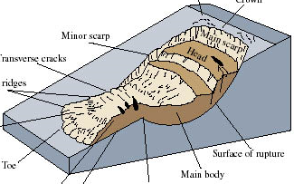
- A __________________ is a type of slide.
- Separates along a ______________________ surface.
- Material moves as a ____________________________— but sometimes has multiple blocks.
- Forms _____________________________________________ at the head where the material detached – called a scarp.
- Can be triggered by __________________________ or ________________________________.
OTHER TYPES OF MASS WASTING
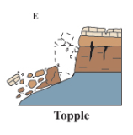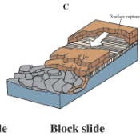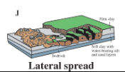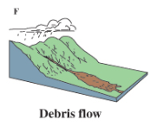
Falls:
- _______________________ – forward rotation around some pivotal point.
Slides:
- _______________________________ – large mass moves together.
- __________________________________________ –on gentle or flat slopes as a result of liquefaction of rock – possibly during earthquake.
Flows:
- _________________________________ - a combination of loose soil, rock, organic matter, air, and water mobilize as a slurry that flows downslope

Dealing with risk
________________________________________
- What type of rock?
- Slope of rock layers?
- Angle of repose?
- Rock orientation?
_____________________________________________
  - Retaining Structures – support surface material.
  - Drainage - water reduces friction.
  - Terraces – reduce slope

