UNIT 10 NOTES:
MINERAL RESOURCES AND MINING

MINERAL RESOURCES
- Minerals are a _________________________ occurring _____________ with a definite ______________________ composition and ________________________ structure that is formed through ______________________ processes.
- ________________________________________________ throughout world – some places have more of one kind or another.
- Three groups:
  - ____________________ mineral – like iron and copper
  - ___________________________ mineral – like salt and clay
  - ____________________ resources – like coal and oil

METALLIC RESOURCES
- Resources from which ductile, malleable, opaque and reflective ________________ are found that are also _____________ heat and electricity ______________________________.
- Yield ___________ products when __________________________.
- Considered ____________________________ when _________________ 0.1 % (Fe, Al, Mg).
- Considered ____________________ at ________________________ 0.1% (Ni, Cu, Zn)
- Most metallic ore deposits are a result of ___________________________________ activity.

NON-METALLIC RESOURCES
- They _________ yield new products when ______________________________.
- They are usually ____________, ____________,, or ____________,.
- They are used as ________________________ and can be ________________________________.
- They are used for:
  - _________________________ materials:
    - Sand, gravel, limestone, gypsum
  - _________________________:
    - Phosphate, nitrate, potassium
  - _________________________:
    - Rock salt, sulfur, clay, gypsum
  - __________________________________________________ products:
    - Glass sand, diatomite

ENERGY RESOURCES
- ___________________________!
- Form from remains of _______________________ things.
- Consist of _______________________________.
- Are basically ______________________ energy.
- Includes:
  - _______________ - formed in process of _________________________________ – plants debris buried in swamps or mud become peat then coal.
  - ___________________________ and _____________________________ - formed from remains of marine organisms and plants under heat and pressure.

HOW MINERALS FORM
- Minerals form in MANY ways
- Four main processes:
- _____________________________
- ______________________________
- ______________________________
- __________ and ________________________
- Sometimes evaporation and precipitation are grouped together
- Sometimes other variations referenced

MINERALS FROM MAGMA
Crystallization depends on:
- ______________________ rate
  - _________________ = _________________ crystals
  - _________________ = _________________ crystals
- __________ in magma
- ______________________ composition of magma
- ______________________ can cause differentiation based on specific heat of different minerals.
- Examples: orthoclase and quartz

MINERALS FROM SOLUTIONS
- Supersaturated solutions of _______________________ minerals
- Excess mineral solute is _______________________ on a surface or water ____________________.
- __________ can form when solutions flow through cracks.
- __________: Hot mineral solutions in cracks in rocks.
- Examples: Halite and calcite.

MINERALS FROM THE WATER CYCLE
- _____________________________ minerals can settle at bottom of ocean or lake.
- Water _______________________ and leaves behind mineral _________________________.
- ____________________________ is the major source of minerals formed by evaporation (90%)
- Examples: gypsum and salts

MINERALS FROM HEAT AND PRESSURE
- Heat and pressure can cause:
  - __________________________________
  - __________________________________
- Examples: garnet and corundum
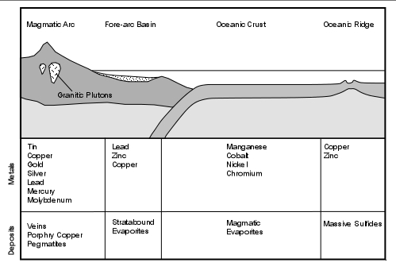

MINERALS AND PLATE TECTONICS
- Some minerals produced by _________________________ plates.
- Heat near ________________________ zones can produce:
  - Iron, Ores
  - Copper metal
  - Silver metal
  - Gold metal
  - Lead, Zinc, Tin
- Not just where plates meet _________, but in the ___________!

PEOPLE USE MINERALS
- The average person consumes or uses ___________________ pounds of minerals every year.
- Basic and raw materials in our daily lives are ___________________________, and are vital for economic, social and technological development.
- Over the course of a lifetime, ________ individual will use more than:
  - 1,050 pounds of lead and 1,050 pounds of zinc
  - 1,750 pounds of copper and 4,550 pounds of aluminum
  - 91,000 pounds of iron and steel and 360,500 pounds of coal
  - one million pounds of industrial minerals such as limestone, clay, and gravel.

ORES
- Mineral resources mined for _____________________.
- A ___________________ in the Earth’s crust of one or more ________________________ minerals.
- ______________________ Ores: ____________ veins and deposits – often rich in sulfur. Deeper ores are expensive to mine and process
- ___________________________ (supergene) ores – weathered ____________________________, sulfur leached out – cleaner and cheaper to mine and process – in a contaminated layer.

MINING OF ORES
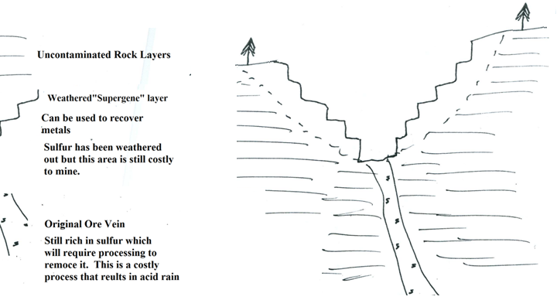
Primary Ores
Weathered Ores
- ___________________ is a problem especially in coal because it contributes to acid rain!

MINING PROCESS
- Start by _________________________ the overburden.
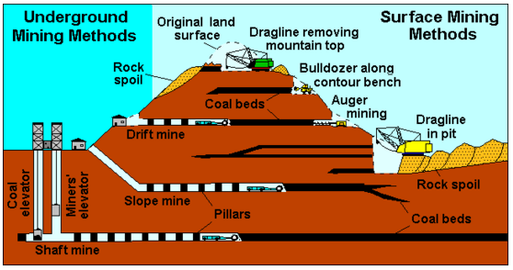
- ____________________________ is material that lies above an ore area.
- Must be removed prior to ____________________ mining.
- May be _______________________ after mining.

WASTE MATERIAL
- _____________________:
  - _________________________ leftovers; Surrounds or is mixed with mineral or ore; Has other minerals mixed with it.
- _____________________:
  - _____________ of waste left behind after extraction; Contains gangue.

METHOD: OPEN-PIT MINING
- ________________________ dig __________ and remove ores, sand, gravel, and stone.
- ______________ groundwater can accumulate at the _________________________.

METHOD: AREA STRIP MINING
- Earth movers ______________ overburden and giant shovels __________________ mineral deposit.
- Often leaves highly ____________________ hills of rubble called ________________________.

METHOD: MOUNTAINTOP REMOVAL
- Machinery ____________________ the __________ of mountains to expose minerals – often used for coal.
- Heavy equipment used to ______________ overburden ______________________ during the mining of coal.
- The resulting waste rock and dirt are dumped into the streams and valleys below.

METHOD: SUBSURFACE MINING
- Include
- Drift 2. Slope 3. Shaft
4. Hard Rock 5. Borehole 6. Fracking

MINING RECLAMATION
- The word reclamation comes from “reclaim” - meaning to _________________________________.
- The __________________ of returning land to its original or better condition before mining.
- Without reclamation, habitats are permanently ___________________ and _____________________ increases.

