FOSSILS AND NATURAL SELECTION

FOSSIL RECORD SHOWS CHANGE
- Ordovician trilobites ________________ from Devonian trilobites.
- Silurian and Devonian fish __________________ from Jurassic and Cretaceous fish.
- Mesozoic mammals ____________________ from Cenozoic mammals.
- Whole groups of organisms that were ______________________________________, such as trilobites, have become ___________________________.

GRADUAL CHANGE
- Fossil evidence shows life becomes _____________________________________ over time.
- _______________________ change occurs in most species.
- Some organisms go ________________________.
- Changes explained by _________________________________________.
- Natural Selection first proposed by ______________________________________ based on data.

WHAT IS NATURAL SELECTION?
- __________________________________.
- Organisms that are __________________________________ to the environment most likely to _________________ and ______________________ their genes (traits).
- Organisms with ___________________________________ traits _____________ to survive and/or pass on their genes.
- Biological traits become either _____________________________ common in a population.
- This is a result of inherited traits and interactions with the environment.

LIFE RESPONDS TO ENVIRONMENTAL CHANGES
- Environmental change is any change in an environment ________________________________ ____________________________________.
  - Can be _______________________, ex: mountains form
  - Can be _______________________, ex: floods volcanoes
- Environmental change _______________________ the organism to adapt .
  - Genetic variations best suited to the environment ______________________.
  - Traits least suited to the environment _____________________________.
  - ___________________ changes occur across multiple generations.
  - Some changes are ____________________________ – ex: antibiotic resistant strains of bacteria.
  - Changes don’t occur at the _________________________________ level – but rather across ______________________________ generations.

FOSSIL EXAMPLE: HORSE
- Fossil record spans over _______ million years.
- Earliest ancestors were __________________, lived in rainforests.
- Early fossils show ________________________ feet, adapted for walking across the forest floor.
- ____________________________ hooves are more suited for running over open country.

COMPARING ANATOMICAL DIFFERENCES
- Clues to changes in organisms over time can be found in structural anatomy.
- ________________________________ FEATURES
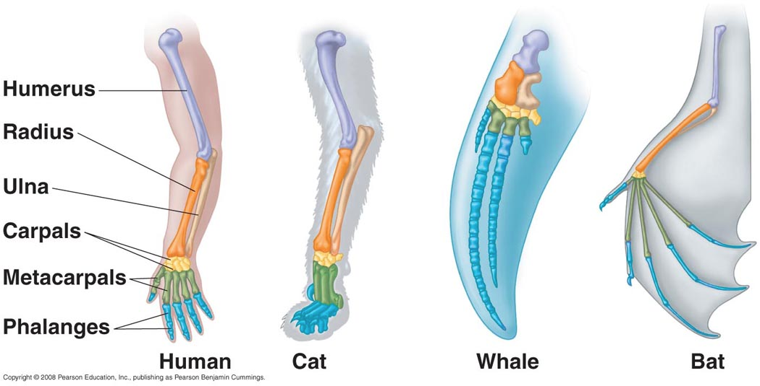
- Similar STRUCTURE
  - Often different functions
- COMMON ancestor
  - Divergent evolution
- ________________________________ FEATURES
- Similar FUNCTION.
- Different structures
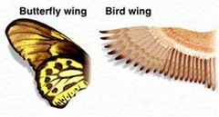
  - Different solutions to same problem.
- Evolved independently.
- NOT RELATED – not from common descent.
- ________________________________ STRUCTURES
- Features that serve ____________________________________.
- Serve a function in a related species.
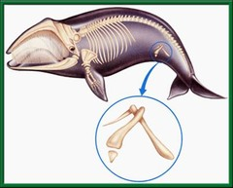
- Likely served purpose in ancestors.
- Provide _____________________ to ancestry.
- Example: Whale pelvis
  - Pelvis transfers weight to hind legs.

FOSSIL RECORD
- Fossilization is ______________ – most organisms extinct.
- _________________________ of fossils exist.
- Shows a _________________________ of incremental development from one species to another.
- __________________________________ of newer organisms often appear to be ____________________ forms of characteristics of ________________________ organisms.
- __________________ patterns appear ____________________________.
- Forms complete picture of change over time.
- Much of the ________________________________________________ of life-forms on Earth has been obtained by examining fossils preserved in rock layers.
- Changes in fossil record provide evidence for Evolution and are _____________________________ by Natural Selection.

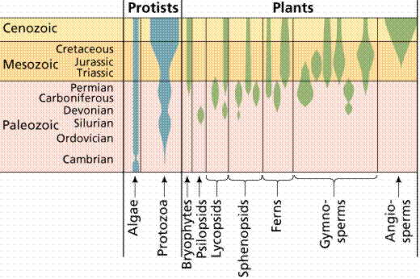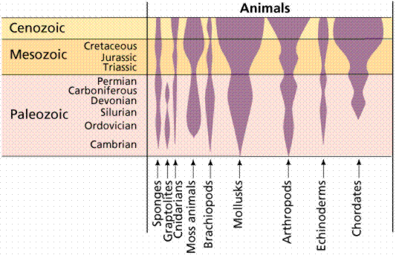

EXAMPLE: WHALE EVOLUTION
Philip Gingerich, paleontologist
- Pakicetus (pack-eh-SEA-tus)
  - About 48.5 mya – Pakistan.
  - Resembles ______________________________________________.
  - Wolf-like skull, whale-like ear bones.
- Rodhocetus (row-deh-SEA-tus)
  - “Barely walking whale”.
  - About 46.5 million years ago – Pakistan.
  - Features of _____________________________ and ____________________________ - all in the same skeleton.
- Protocetus (pro-toe-SEE-tuss)
  - “_______________________________”.
  - About 45 million years ago – Egypt.
  - Classification as whale based on:
  - General shape of the skull.
  - Position of the nose/ blowhole.
  - Position of the ears.

