EARTH’S OCEAN NOTES

TERRESTRIAL WORLDS
- ___________________________________: outer layers compress inner layers – produce heat.
  - Dense metals sink to core - iron density 7.86 g/cm³
  - Lighter rock material rises to form crust - average rock density 3.5 g/cm³

SURFACES OF TERRESTRIAL PLANETS
_______________________________________
- Heavy bombardment period ended 3.8 billion years ago.
- Older surfaces have more craters.
- Newer surfaces “erased”.
_____________________________
_____________________________
- Earth is side to side plate movement
- Venus is up and down plate movement
______________________________
- Earth - wind and water.
- Mars - wind, water in past.
- Venus - wind and sulfuric acid rain.

EARLY EARTH
- Formed _____________________________ years ago.
- Too __________________ for water to change form a gas to a liquid (condense).
- Molten surface.

CURRENT HYDROSPHERE
- ___________ of the planet's surface is covered by ocean. Of that:
  - ______________ of Earth’s water is found in the oceans.
  - ______________ are Glaciers and Ice Sheets.
  - ______________ is liquid Freshwater.
- Oceans formed about 3.8 billion years ago
- Source of initial oceans:
- ________________________________ from volcanoes.
- Water-heavy ________________________.
- First oceans were ________________ water, _____________ salty. Salt came later

WHERE DID THE SALT COME FROM?
From _____________________ that carried ____________________________________ to the oceans!
- ___________________________________________________ - Mineral salts from:
  - Weathering & erosion of rock
  - Dissolved minerals
  - Volcanic ash
- ___________________________________________________________ from marine plants and animals.
- Shells, Crustaceans, Foraminiferas (one cell animals), Plankton, Diatoms
________________________ and _____________________________ salinity increases over time.

CURRENT COMPOSITION OF OCEANS
Dissolved gases:
- __________________, N₂; ______________________, O₂; ________________________, CO₂
Dissolved solids (sea salts)
- _______________ (35 ppt) of Cl, Mg, S, Ca, K, Na
- Sources: volcanoes, erosion, weathering, chemical reactions between salt water and rock.
- Spread evenly over the Earth's land surface it would form a layer more than 500 feet thick

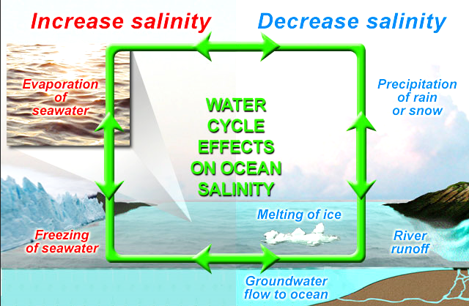
http://aquarius.umaine.edu/images/ov_water_cycle.jpg

