UNIT 6 NOTES:
FOSSILS AND PAST ENVIRONMENTS

FOSSILS AND THEIR ENVIRONMENTS
- Fossils show how organisms have ______________________________________________.
- Can also be useful for telling us about the ________________________________ they lived in.
- The _________ and ____________________________ of fossils is the ___________________ ___________________________________ of an area's ancient environmental conditions and climates!
- Clues about their environment include:
- ___________________________ to the nearest living relative
- ___________________________ (ex: fins? wings?)
- ___________________________ of certain fossils
- Plants:
- Leaf analysis
- Pollen
- Tree rings

LIVING RELATIVES AND ADAPTATIONS
APPEARANCE:
- Some fossils ___________________________ living organisms.
- Some fossils are ________________________ of living organisms.
STRUCTURE:
- ________________________________ fossils more often live in ________________ water; ________________________________ fossils are more common in _____________________ water.
- ____________________ are typically grow in ____________________________ water.
ADAPTATIONS:
- _______________________________ would be found in ________________________ water rocks, because they are ___________________________________ and need sunlight to grow.

CLUES FROM PLANTS
- Usually found on land.
- ________________________:
- Abundance – lots? Little?
- Ratio of pollen types
- Similar structures and adaptations:
- ________ regions – ________________ leaves
- ________ areas – ________________ leaves
- Pine needles - shape and coating _____________________________________________.
- ___________________ coating on leaves (cuticle) __________________________ against water loss.
- Plants in very _______________ conditions have a ___________________________ of pores (stomata), but are pores are ___________________.

LEAF MARGIN ANALYSIS
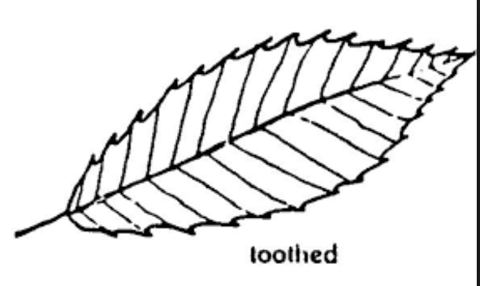
- A way of telling average temperature by looking at the shape of leaves:
- _______________________ tropical areas have a higher PERCENT of plants with _______________________ edges.
- _______________________ environments have a higher PERCENT of plants with leaves with more __________________ edges.

- Why?
- ____________________________________ (margins) increases ____________________________________, allows for more transpiration and greater photosynthesis.
- _____________________ climates have _____________________________________ seasons – need greater ability.
- _____________________ climates – same structures lead to _______________________, need less ability.

COMPARISON

Greater percentage of smooth leaves = warmer temperatures

